**L’ionosphère du côté nuit de Mars dévoilée par MAVEN**

**The nightside Martian ionosphere unveiled by the MAVEN mission**

Going deep down to the origin of suprathermal electron depletions

‘*A scientist in his laboratory*

*Is not a mere technician: he is also*

*A child confronting natural phenomena*

*That impress him as though they were fairy tales.*’

Marie Curie

# Acknowledgements

I would like first to thank MAVEN, which achieved with success its insertion around Mars and records for more than two years wonderful data without which this PhD would not have occurred. We began our scientific life together and I hope it will last much longer. Through this acknowledgement I obviously want to thank the operation and instrument teams, as well as the science team which welcomed me among them. Among others I would like to thank Bruce Jakosky, Janet Luhmann, Dave Mitchell, Dave Brain, Rob Lillis, Laïla Andersson, Jasper Halekas, Jared Espley, Jim McFadden, and Jack Connerney for the help they gave me all along this PhD.

[to complete]

# Abstract

The nightside ionosphere of Mars still remains an unfamiliar and mysterious place. Nightside suprathermal electron depletions are typical features of this region which have been observed at Mars by three spacecraft to date: Mars Global Surveyor (MGS), Mars EXpress (MEX) and the Mars Atmosphere and Volatile EvolutioN (MAVEN) mission. Their study enables the observation of the nightside ionosphere dynamic as well as the specific Martian magnetic topology and possible conduit for atmospheric escape in cusp-like regions. Structures as different as magnetic cusps, current sheets or the EUV terminator can be investigated through suprathermal electron depletions, due to the processes leading to their presence on the nightside of Mars.

The main goal of this PhD has been to use the complementarity of these three missions to understand the creation mechanisms of suprathermal electron depletions and their implication on the structure and the dynamic of the nightside ionosphere.

In this context, three simple criteria adapted to each mission have been implemented to identify electron depletions from 1999 to 2017. This statistical study reveals a transition region near 170 km separating the collisional region where electron depletions are mainly due to electron absorption by atmospheric $CO_{2}$ and the collisionless region where they are mainly due to closed crustal magnetic field loops. Study of electron depletions also enable us to estimate the location of the EUV terminator, based on the observation that no electron depletions are expected above its location. It appears to be raised on average by ~120 km above the location of the geometrical terminator, though this location is likely to be different between the dawn and dusk terminator and to vary throughout the different Martian seasons.

[The statistical study of their distribution highlighted two main processes leading to electron depletions, whose predominance depend on the altitude.]

# Résumé

L’ionosphère du côté nuit de Mars reste encore à ce jour une zone mystérieuse et peu connue. Les déplétions d’électrons suprathermiques sont des structures typiques de cette région de l’environnement martien. Elles ont été observées jusqu’à présent par trois satellites : Mars Global Surveyor (MGS), Mars EXpress (MEX) et Mars Atmosphere and Volatile EvolutioN (MAVEN). Leur étude permet aussi bien l’observation de la dynamique de l’ionosphère du côté nuit que celle de la topologie magnétique martienne, ainsi que l’étude de l’échappement atmosphérique au niveau des « cornets magnétiques». Des structures aussi différentes que des cornets magnétiques, des couches de courants ou encore le terminateur EUV peuvent être examiné à travers les déplétions d’électrons suprathermiques, de par les mécanismes à l’origine de leur présence du côté nuit de Mars.

Le but principal de cette thèse a été de tirer parties des trois jeux de données offerts par ces trois satellites pour mieux comprendre les mécanismes à l’origine des déplétions d’électrons observées du côté nuit ainsi que leur impact sur la structure et la dynamique de l’ionosphère du côté nuit.

Dans cette optique, trois critères simples adaptés à chaque mission ont été développés pour identifier les déplétions d’électrons dans une base de données allant de 1999 à 2017. Cette étude statistique a révélé la présence d’une région de transition autour de 170 km séparant la région collisionnelle dans laquelle les déplétions d’électrons sont principalement dues à l’absorption des électrons par le $CO_{2}$ atmosphérique, et la région non-collisionnelle dans laquelle elles sont principalement dues aux boucles fermées de champs magnétique d’origine crustale. L’étude des déplétions d’électrons nous a aussi permis d’estimer la localisation du terminateur EUV, sachant qu’aucune déplétion d’électrons n’est supposée être observée au-dessus de celui-ci. Le terminateur est situé en moyenne ~120 km plus haut que le terminateur géométrique, bien que cette location soit susceptible d’être différente entre le côté soir et le côté matin, et de varier en fonction des saisons.

**Table of Contents**

Acknowledgements 4

Abstract 5

Résumé 6

Introduction 10

Introduction 13

1. The Martian environment 16

1.1. Interaction of the solar wind with the different bodies of the Solar System 16

1.1.1. The solar wind 16

1.1.2. The four different classes of interaction 18

1.2. The Martian obstacle 25

1.2.1. Mars today 25

1.2.1.1. Atmosphere - Exosphere - Ionosphere: who is who? 25

1.2.1.2. The Martian magnetic field 30

1.2.2. Back at the history of Mars 33

1.2.2.1. A magnetic field history 34

1.2.2.2. A Mars’ volatile and climate history 36

1.3. The interaction of the solar wind with Mars 40

1.3.1. The steady-state interaction 43

1.3.1.1. The bow shock and the upstream region 43

1.3.1.2. The magnetosheath 46

1.3.1.3. The Magnetic Pile-up Boundary and the Magnetic Pile-up Region 47

1.3.1.4. The ionopause and the Photo Electron Boundary 48

1.3.1.5. The ionosphere 49

1.3.1.6. The wake and the magnetotail 50

1.3.2. Dynamics of the Martian interaction with the Sun 52

1.3.2.1. Magnetic topology 52

1.3.2.2. Pressure balance 54

1.3.2.3. Variability of the boundaries 55

1.3.3. Focus on the nightside ionosphere 57

2. Instrumentation, data and analysis tools used 61

2.1. Exploration of Mars 61

2.1.1. Mars Global Surveyor 64

2.1.1.1. Scientific objectives 64

2.1.1.2. Orbitography 65

2.1.1.3. Instruments 66

2.1.1.4. Main discoveries 67

2.1.2. Mars Express 68

2.1.2.1. Scientific objectives 68

2.1.2.2. Orbitography 69

2.1.2.3. Instruments 70

2.1.2.4. Main discoveries 72

2.1.3. MAVEN 73

2.1.3.1. Scientific objectives 73

2.1.3.2. Orbitography 74

2.1.3.3. Instruments 76

2.1.3.4. Main discoveries 77

2.2. Instrumentation 79

2.2.1. Mars Global Surveyor 79

2.2.1.1. The magnetometer: MAG 79

2.2.1.2. The Electron Reflectometer: ER 79

2.2.2. Mars Express 81

2.2.2.1. Electron Reflectometer: ELS 81

2.2.2.2. The ion spectrometer: IMA 83

2.2.3. MAVEN 84

2.2.3.1. The ion spectrometer: STATIC 84

2.2.3.2. The Magnetometer: MAG 87

2.2.3.3. The Electron spectrometer: SWEA 88

2.2.3.4. The Langmuir probe: LPW 90

2.2.4. Contamination 92

2.3. Data coverage 95

2.4. Analysis tools 97

2.4.1. AMDA and 3D view 97

2.4.2. CL 98

2.5. Frames 99

2.5.1. The Mars-centric Solar Orbital (MSO) frame 99

2.5.2. The $IAUMars$ frame 99

2.5.3. Definition of the altitude 99

2.5.4. Definition of the nightside 100

2.6. Model of crustal magnetic field: the model of *Morschhauser et al.* [2014] 101

3. Identification of suprathermal electron depletions in the nightside ionosphere 103

3.1. A story of depletions 103

3.1.1. Discovery of electron depletions 103

3.1.2. On the origin of plasma voids 107

3.1.3. Global properties of the plasma voids observed by MGS and MEX 109

3.2. Global properties of suprathermal electron depletions as observed by MAVEN: case studies 111

3.2.1. Plasma voids or suprathermal electron depletions? 111

3.2.2. Plasma composition 114

3.2.2.1. Ions characteristics 114

3.2.2.2. Electrons characteristics 115

3.2.3. The border of suprathermal electron depletions 115

3.2.4. Flux Spikes 115

3.2.4.1. Injection of ionospheric plasma 115

3.2.4.2. Energy-time dispersed electron signature 117

3.2.4.3. Current sheet 119

3.2.5. Really related to crustal fields? 121

3.3. Automatic detection of suprathermal electron depletions: definition of the criteria 124

3.3.1. MAVEN 124

3.3.2. MEX 126

3.3.3. MGS 126

3.4. Application of the criteria 128

3.4.1. Application to MGS 128

3.4.2. Application to MAVEN 129

3.4.2.1. Application of criterion (1) 129

3.4.2.2. MAVEN coverage 131

3.4.3. Application to MEX 133

3.4.3.1. Unrestricted application 133

3.4.3.2. Restricted application 134

4. Determination of the processes at the origin of suprathermal electron depletions 137

4.1. Geographical distribution maps of electron depletions 137

4.1.1. The vision from above 250 km altitude 137

4.1.1.1. MGS 137

4.1.1.2. MEX 139

4.1.1.3. MAVEN (above 250 km) 142

4.1.2. Going down to 125 km altitudes with MAVEN 143

4.1.2.1. From 250 to 170 km 143

4.1.2.2. From 170 to 110 km 145

4.2. Pressure balance 146

4.3. Composition 146

4.3. Altitude distribution 147

4.4. Discussion 151

5. Physical processes: Interaction plasma/neutrals 153

5.1. Observation of electron depletions on the dayside 153

5.1.1. An altitude issue 153

5.1.2. A spacecraft charging issue 153

5.2. Observation of the EUV terminator 155

5.2.1. Definition of the nightside 155

5.2.2. Observation of the UV terminator with LPW 157

5.2.3. Distribution of the electron depletions regarding the SZA 158

5.2.4. Average altitude of the EUV terminator 159

5.2.4.1. Distribution on one Martian year 160

5.2.4.2. Methodology 160

5.2.5. Evolution of the EUV terminator with seasons/dawn vs dusk 161

5.2.5.1. Model of Rob Lillis 161

5.2.6. Latitude dependence 162

5.2.6.1. Models 163

5.2.6.2. Results at the equinox 163

5.2.6.3. Neutral profiles 163

5.3. Desert of suprathermal electron depletions 163

5.3.1. Different type of orbit with no depletions 163

5.3.2. Location 163

5.3.3. Evolution of the exobase with the SZA 163

5.3.4. Gravity waves 163

Conclusions 164

Conclusions 165

Table of figures 166

Table of tables 170

Bibliography 171

# Introduction

The nightside ionosphere of Mars is a poorly investigated area compared to the dayside one. One of the main observational properties of this region is the presence of recurrent structures characterized by significant depletions in electron fluxes and hence called “nightside suprathermal electron depletions” (hereinafter referred to as electron depletions). The first observations of these structures were obtained during the 400 km mapping orbit of Mars Global Surveyor (MGS) by the Electron Reflectometer instrument that detected on Mars’ optical shadow pronounced decreases of the electron count rates up to 3 orders of magnitude at all energies [*Mitchell et al.*, 2001]. The same structures were then detected by the Mars Express (MEX) Electron Spectrometer [*Soobiah et al.*, 2006]. The statistical analysis of their geographical distribution suggested a strong correlation with crustal magnetic field in both hemispheres [*Mitchell et al.*, 2001; *Soobiah et al.*, 2006; *Soobiah*, 2009]. Studies on electron depletions made with MGS and MEX were both restricted in altitude and instrumentation. They cannot observe the phenomenon at altitudes below 250 km with a complete suite of plasma instruments.

On September 21, 2014, a new spacecraft get inserted around Mars to complement the Martian fleet: the Mars Atmosphere and Volatile EvolutioN (MAVEN) mission. It is designed to study the structure, composition, and variability of the upper atmosphere and ionosphere of Mars, its interaction with the Sun/solar wind, and the atmospheric escape [*Jakosky et al.*, 2015]. For this purpose it carries onboard a complete suite of plasma and field instruments, including a magnetometer, two ion and one electron spectrometers. The spacecraft since then reached its mapping orbit which is a highly elliptical precessing orbit with a nominal periapsis at 150 km, a period of 4.5 h and an inclination of 75°. This periapsis can periodically be lowered down to 125 km for 5 days periods known as “deep-dips”, which allows measurements of suprathermal electron depletions at previously unsampled altitudes.

During most MAVEN periapsis passages on the nightside ionosphere, suprathermal electron depletions are currently detected, even in regions with nearly no crustal magnetic field. Hence, MGS and MEX only observed the tip of the iceberg. Other processes than the interaction with crustal magnetic fields must occur for suprathermal to be observed. This observation is the starting point of the work carried out during this PhD.

Suprathermal electron depletions are interesting structures as they are recurrently observed on the nightside ionosphere and can be used to characterize its structure and dynamic. *Mitchell et al.*, 2007 and *Brain et al.*, 2007 for example used electron depletions to determine the magnetic topology of Mars thanks to electron spectrometers. However, a clear comprehension of the processes at their origin is needed to carry out such studies.

In this work we want to take advantage of the different datasets offered by MGS, MEX and MAVEN so as to better understand the structure and dynamic of the nightside ionosphere. MGS data are therefore used from 1999 to 2006 so as to take advantage of the mapping circular orbit at a roughly constant altitude (~400 km) of the spacecraft, allowing observations of the phenomenon every 2 h over the whole range of possible latitudes [-90°, 90°]. MEX data are used from 2004 to 2014, which gives us an unparalleled long-term view of the phenomenon at both relatively low (down to ~250 km) and high altitudes. Finally, MAVEN data are used from October 2014 to March 2017. During this time period the spacecraft covered both hemispheres except the poles, but due to this short duration and MAVEN orbital parameters, all latitudes are not yet covered at all possible altitudes. Even though the coverage and duration of this data set are much lower than those of MGS and MEX, MAVEN reached during this time period altitudes down to 125 km, which are unsampled by MGS nor MEX. Added to MAVEN instrument suite, this coverage enable a finer study of the structure of suprathermal electron depletions. This huge data set gathering observations made over 18 years by different instruments reaching different altitude regimes enables us to compare events observed in similar conditions (several spacecraft in the same region) and enrich this joint vision with new observations closer to the surface (with MAVEN).

So as to present the work carried out during this PhD, this manuscript is divided into five chapters:

* In **Chapter 1** we describe the global environment of Mars: what characterize the Martian obstacle, how it interacts with the solar wind, what are the boundaries we are likely to encounter when looking at plasma data, to finally focus on the nightside ionosphere and its suprathermal electron depletions.
* In **Chapter 0** we describe the different datasets used in this PhD: we browse the different missions and their associated orbitography and instruments, the analysis tools that have been used to process the data, the frames and definitions that will be used in the rest of the manuscript and the model of crustal magnetic field that have been chosen.
* **Chapter 3** is dedicated to the identification of suprathermal electron depletions. These structures have already been identified by several spacecraft and instruments but the MAVEN payload offers highlights on their properties. This enable us to create criteria able to automatically detect suprathermal electron depletions in electron spectrometer data.
* In **Chapter 4** we use the catalogs obtained after application of the criterion to determine the different processes at the origin of suprathermal electron depletions in the nightside ionosphere of Mars. Geographical and altitudinal distribution are used in association with pressure balance and plasma composition analysis.
* In **Chapter 5** we focused on some plasma/neutral interactions that can be observed thanks to suprathermal electron depletions. The location of the UV terminator, and its variability with seasons and dusk/dawn side is first investigated. [to complete]

# Introduction

L’ionosphère du côté nuit de Mars est une partie assez peu connue de l’environnement martien, comparée à l’ionosphère du côté jour. Une des principales caractéristiques observationnelles de cette région est la présence de structures récurrentes caractérisées par une déplétion significative du flux d’électrons. Elles sont pour cela appelées « déplétions d’électrons suprathermiques du côté nuit » (nous les appellerons par la suite déplétions d’électrons pour ne pas alourdir le texte). La première observation de ces structures a été réalisée par le satellite Mars Global Surveyor (MGS) dont l’orbite était circulaire à ~400 km. Son spectromètre à électrons détecta de fortes diminutions du taux de comptage d’électrons jusqu’à trois ordres de grandeur à toutes les énergies quand le satellite passait dans l’ombre de la planète [*Mitchell et al.*, 2001]. Le même type de structures a ensuite été détecté par le spectromètre à électron du satellite Mars Express (MEX) [*Soobiah et al.*, 2006]. Une étude statistique de leur distribution géographique suggéra une forte corrélation entre leur observation et la présence de sources de champ magnétique d’origine crustale dans les deux hémisphères [*Mitchell et al.*, 2001; *Soobiah et al.*, 2006; *Soobiah*, 2009]. Les études menées sur les déplétions d’électrons à l’aide des données de MGS et de MEX sont restreintes à la fois en altitude et en instrumentation. Ces satellites ne peuvent en effet observer ce phénomène qu’à des altitudes supérieures à 250 km, avec une instrumentation ne permettant qu’une observation partielle de ses caractéristiques.

Le 21 Septembre 2014 un nouveau satellite est entré en orbite autour de Mars, complétant ainsi la flotte martienne : la mission Mars Atmosphere and Volatile EvolutioN (MAVEN). Cette mission a pour but d’étudier la structure, la composition et la variabilité de la haute atmosphère et de l’ionosphère martienne, leurs interactions avec le Soleil et le vent solaire ainsi que l’échappement atmosphérique [*Jakosky et al.*, 2015]. Dans cette optique, MAVEN a embarqué un ensemble cohérent d’instruments plasma, dont deux magnétomètres, deux spectromètres à ions et un à électrons. Le satellite est sur une orbite fortement elliptique, précessant naturellement, avec un périapse nominal à 150 km, une période de 4,5 h et une inclinaison de 75°. Ce périapse peut être périodiquement baissé pour atteindre une altitude de 125 km pendant une période de cinq jours appelée « deep dip ». Ces périodes permettent d’effectuer des observations de déplétions d’électrons à des altitudes jamais atteintes précédemment.

Jusqu’à présent, des déplétions d’électrons ont été observées avec MAVEN au cours de tous ses passages à basses altitudes du côté nuit, sauf quelques rares exceptions, et ce même dans les régions où le champ magnétique d’origine crustale est très faible. Ainsi, il semble que MGS et MEX n’ont observé que la partie émergée de l’iceberg. L’interaction du plasma avec le champ magnétique crustal ne peut pas être le seul mécanisme à l’origine de la création de déplétions d’électrons. Cette observation est le point de départ du travail mené au cours de cette thèse.

Les déplétions d’électrons sont des structures intéressantes de par leur observation récurrente dans l’ionosphère du côté nuit. Elles peuvent ainsi être utilisées pour caractériser sa structure et sa dynamique. *Mitchell et al.*, 2007 et *Brain et al.*, 2007 les ont par exemple utilisés pour déterminer la topologie magnétique de Mars à l’aide des spectromètres à électrons. Cependant, une bonne compréhension des processus à l’origine de la formation des déplétions d’électrons est nécessaire pour mener de telles études.

Nous voulons ici tirer au maximum profit des différents jeux de données offerts par MGS, MEX et MAVEN dans le but de mieux comprendre la structure et la dynamique de l’ionosphère du côté nuit de Mars. Dans cette optique, les données de MGS ont été utilisées de 1999 à 2006, de sorte à tirer profit de son orbite circulaire, permettant une observation du phénomène toutes les deux heures sur toute la gamme de latitude possible [-90° ; 90°]. En ce qui concerne MEX, nous avons utilisé les données obtenus entre 2004 et 2014, ce qui nous donne une vue à long terme du phénomène, à la fois à relativement basses altitudes (jusqu’à ~250 km) et à hautes altitudes. Finalement, les données de MAVEN ont été utilisé d’Octobre 2014 jusqu’à Mars 2017. Pendant cette courte période le satellite a couvert les deux hémisphères à l’exception des pôles. Cependant, cela n’est pas encore suffisant pour couvrir toutes les latitudes à toutes les altitudes possibles. Bien que la couverture et la période étudiée soit bien plus faible que pour MGS et MEX, MAVEN est descendu pendant cette période jusqu’à des altitudes de 125 km, altitudes non couvertes ni par MGS ni par MEX. Cette couverture associée aux capacités instrumentales de MAVEN permet une étude fine des déplétions d’électrons suprathermiques. Cette immense base données regroupant plus de 18 années d’observations par différents instruments couvrant différentes gammes d’altitudes nous permet de comparer des événements observés dans des conditions similaires (plusieurs satellites dans la même région) et d’enrichir cette vision commune avec de nouvelles observations plus proches de la surface (avec MAVEN).

Afin de présenter le travail mené pendant cette thèse, ce mémoire a été divisé en cinq parties :

* Dans le **Chapitre 1** nous décrivons l’environnement global de Mars : ce qui caractérise l’obstacle martien, comment celui-ci interagit avec le vent solaire, quelles sont les frontières que nous sommes susceptibles de rencontrer en étudiant les données des instruments plasma, pour finalement nous focaliser sur l’ionosphère du côté nuit et ses déplétions d’électrons suprathermiques.
* Dans le **Chapitre 0** nous décrivons les différents jeux de données utilisés au cours de cette thèse : nous parcourons les différentes missions avec leur orbitographie et leurs instruments qui leur sont spécifiques, les outils d’analyse de données qui ont été utilisés, les repères et différents définition qui seront utilisés par la suite et le modèle de champ magnétique crustal qui a été choisi.
* Le **Chapitre 3** est dédié à l’identification des déplétions d’électrons suprathermique. Ces structures ont déjà été identifié par différents satellites et instruments mais MAVEN et se suite d’instruments nous a offert un nouvel éclairage sur leur propriétés. Cela nous a permis de créer trois critères capables de détecter automatiquement les déplétions d’électrons suprathermiques au sein des données des spectromètres à électrons.
* Dans le **Chapitre 4** nous utilisons les catalogues obtenus après application des critères pour mettre en évidence les différents processus physiques à l’origine de la présence de déplétions d’électrons suprathermiques dans l’ionosphère du côté nuit de Mars. Nous avons pour cela étudié les distributions géographiques et en altitude des déplétions d’électrons suprathermiques, conjointement à une analyse de l’équilibre de pression et de la composition du plasma contenue dans les déplétions d’électrons suprathermiques.
* Dans le **Chapitre 5**, nous nous focalisons sur des interactions plasma/neutre qui peuvent être observées à l’aide des déplétions d’électrons. La localisation du terminateur UV and sa variabilité avec les saisons et le côté soir ou matin sera d’abord étudié. [to complete].

# The Martian environment

Mars is a fascinating planet, sometimes called ‘twin planet of the Earth’ due to its neighborhood and its history. It is hence one of the most visited objects of the solar system since humanity achieved escaping Earth’s gravity. However, the Martian environment, patterned by the interaction of Mars with the solar wind, is not yet fully understood. It lays between the Earth one, whose atmosphere is shielded by a strong internal magnetic field, and the Venus one, which has no proper magnetic field but a very dense atmosphere, and it even has common features with comets.

The different types of interactions existing between the solar wind and the several objects of the solar system is discussed in a first part (1.1). We then focus on the nature of the Martian obstacle in the second part (1.2). Finally, the current knowledge of the interaction of Mars with the solar wind is developed in a third part (1.3).

## Interaction of the solar wind with the different bodies of the Solar System

All the bodies present in the Solar System, from the biggest planets to the smallest dust particles, are immersed in the solar wind. All these objects interact with the solar wind, but each of these interactions is unique as each object has its own specificities. However, the interactions with the solar wind can be gathered into categories, which are detailed (1.1.2) after a short description of the solar wind (1.1.1).

### The solar wind

The solar wind is a flow of ionized solar plasma particles carrying a frozen-in magnetic field - a remnant of the solar magnetic field - which streams outward through interplanetary space [*Kivelson and Russel*, 1995]. This ejection of plasma is due to the difference of gas pressure existing between the solar corona and the interplanetary space, which is large enough to balance the solar gravity. The existence of the solar wind was conjectured in the 50s and it has directly been observed by space probes in the mid-60s.

The composition of this plasma is the same as the one of the solar corona: 95% of **hydrogen** ($H^{+}$), 4% of **helium** ($He^{++}$), and 1% of heavy ions. The solar wind is very **tenuous** ( $\sim 10 amu.cm^{-3}$ near the orbit of Mercury and $\sim 0.1 amu.cm^{-3}$ near the orbit of Pluto), **supersonic** ($\sim 250-800 km.s^{-1}$), and **dynamic**. It typically travels a Mars diameter in 15-20 seconds and changes on timescales as short as minutes.

Embedded in this plasma is a weak magnetic field oriented in a direction nearly parallel to the ecliptic plane (the plane of the Earth’s orbit around the Sun). It is called the Interplanetary Magnetic Field (**IMF**). However, due to the radial movement of the particles and the rotation of the Sun, the magnetic field lines form the Parker spiral [*Parker*, 1958], as sketched in Figure 1. Hence, the IMF reaches Mercury with an angle of ~20° with respect to the planet-Sun line, ~45° for the Earth, and ~56° for Mars [Brain et al., 2006].

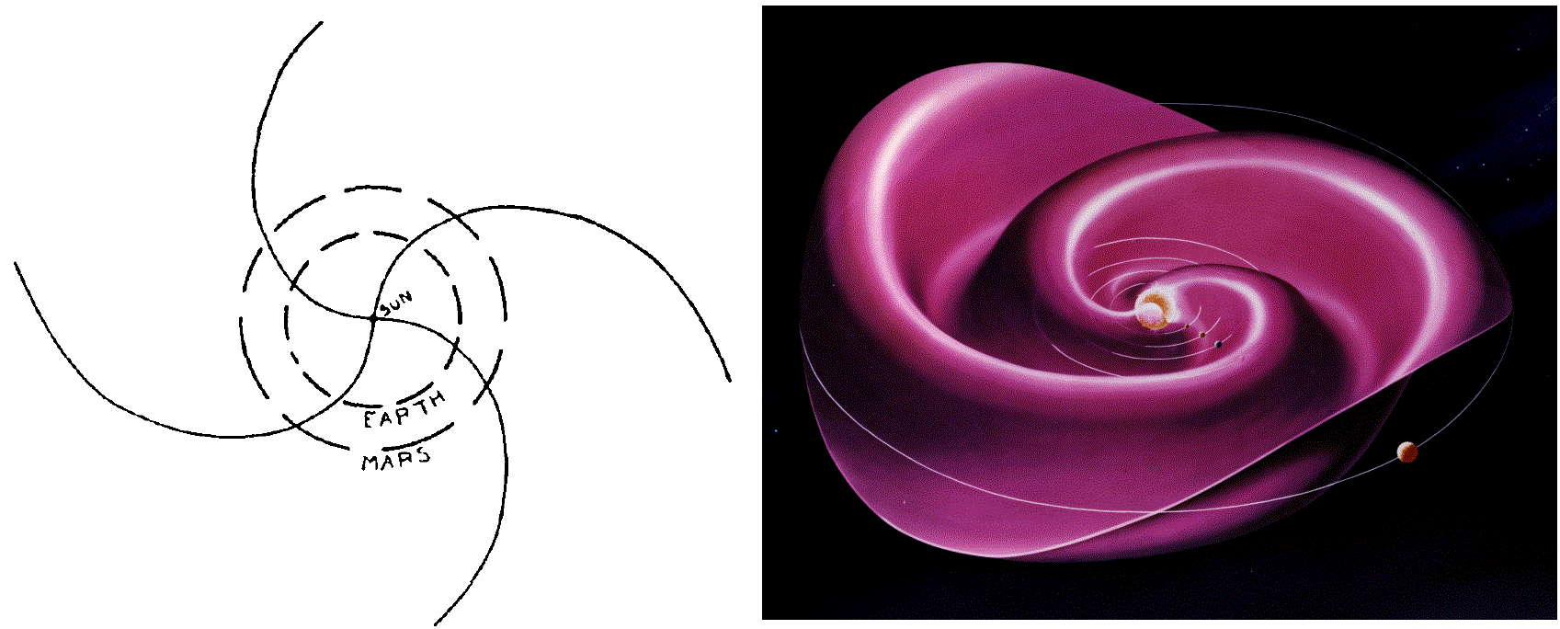

Figure 1. Illustration of the Parker spiral.

*On the left is the sketch from [Parker, 1958], representing the Parker spiral and the orbit of the Earth and Mars. On the right is a 3D representation of the Parker spiral with the orbit of Mercury, Venus, the Earth, Mars and Jupiter.*

As it expands into the solar system, the solar wind evolves in terms of density, temperature, and strength of its IMF, so that the incident plasma at Mars has properties intermediate between those experienced by inner and outer planets. Several properties of the solar wind at the average distance of the Earth [*Kivelson and Russel*, 1995], and of Mars [*Brain*, 2006; *Fränz et al.,* 2007], from the Sun are gathered in Table 1. The average distance of the Earth from the Sun is defined as 1 Astronomical Unity ($1 AU\sim 150×{10}^{6} km)$. Mars is at an average distance of 1.5 AU from the Sun.

|  |  |  |
| --- | --- | --- |
| **Property** | **Earth orbit (1 AU)** | **Mars orbit (1.5 AU)** |
| **Proton density** | 6.6 $cm^{-3}$ | $$1-3 cm^{-3}$$ |
| **Flow speed** | $$450 km.s^{-1}$$ | $300-400 km.s^{-1}$ |
| **Proton temperature** | $$10 eV$$ | 10-20 eV |
| **Electron temperature** | $$12 eV$$ | 2-10 eV |
| **Magnetic field** | $$7 nT$$ | $$2-4 nT$$ |

Table 1. Typical observed properties of the solar wind at the orbit of the Earth [Kivelson and Russel, 1995] and at the orbit of Mars [Brain, 2006; Fränz et al., 2007]

The different bodies embedded in the solar wind are all obstacles on its course toward the limits of the solar system. The solar wind plasma flow is then modified in the vicinity of the planets, satellites or comets which slow down its progression. The environment of the bodies are in return shape by the passage of the solar wind.

### The four different classes of interaction

Though the different bodies present in the solar system possess various characteristics, it is possible to sort their interaction with the solar wind into different categories. These interactions depend mostly on the presence or absence of an atmosphere, and therefore of an ionosphere, and on the presence or absence of an intrinsic magnetic field strong enough to deflect the solar wind flow. These characteristics set which kind of obstacle interacts with the solar wind (solid body, ionosphere, intrinsic magnetic field…) and hence the kind of the resulting interaction. There are many different ways of sorting these interactions and the sorting presented below is one among others. However, it allows to get a good idea of the different interactions and what makes them different.

The four general classes presented here are the following: (1) magnetospheres, (2) cometary and Moon-like interactions, (3) induced-magnetospheres, and (4) mini-magnetospheres. These different groups are showing up in the M-B diagram presented in Figure 2 (adapted from *Barabash*, [2012]). On this figure is compared the total mass of the neutral gas present around an object (**M**) and the magnetic field (**B**) at this object. For the bodies lacking of an intrinsic magnetic field, B corresponds to the value of the interplanetary magnetic field at the distance of the body from the Sun.

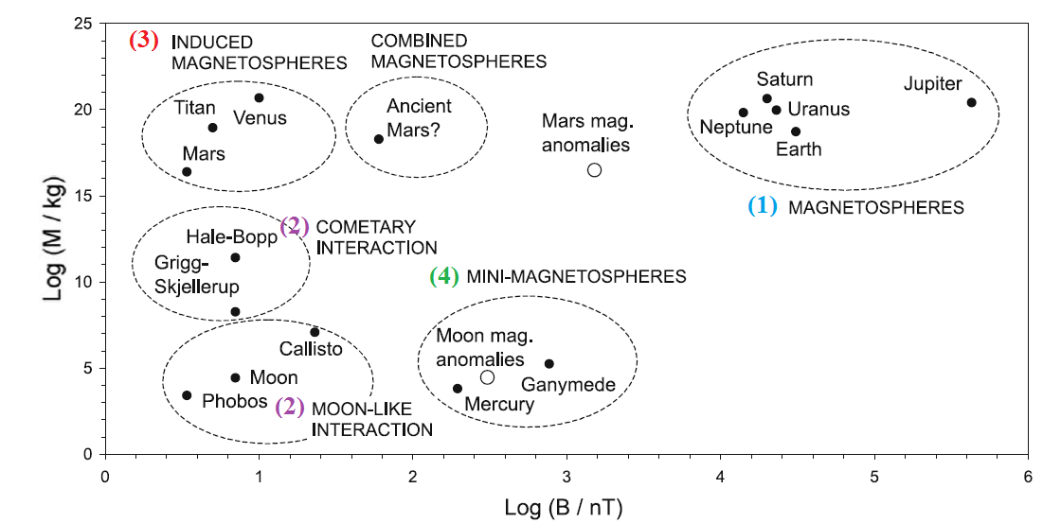

Figure 2. M-B diagram [Barabash et al., 2012].

*M corresponds to the total mass of the neutral gas present around an object and B corresponds to the magnetic field at this object (intrinsic or interplanetary magnetic field).*

* **(1) Magnetosphere** (Saturn, Neptune, Uranus, Earth, Jupiter)

This is the most familiar interaction with the solar wind. The bodies concerned are those which own a strong intrinsic magnetic field. This planetary magnetic field provides here the effective obstacle to the solar wind plasma. A simplified sketch of the Earth magnetosphere is drawn in Figure 3 [*Luhmann et al.*, 1991].

The solar wind pressure compresses the internal magnetic field lines on the dayside, distorting and confining them inside a magnetospheric cavity. As the solar wind is supersonic, this encounter creates a shock upstream the planet, called the **bow shock**. The solar wind is then slowed down and reaches a subsonic speed in a region called the **magnetosheath**. The magnetosheath acts like a buffer region between the interplanetary medium where the solar wind plasma is dominant and the near planetary environment where the planetary plasma is dominant. Hence, this transition region is filled with shocked, deflected, heated and high density solar wind plasma with its draped, frozen-in magnetic field (the drapping of the IMF is discussed in more details in section 1.3.1.2)

As the solar wind is a conductive fluid, a current layer called the **magnetopause** exists to isolate the magnetic field of the planet from the IMF. The magnetopause is the outer boundary of what is called the **magnetosphere**, which is defined as the region of space where the magnetic field lines have at least one end connected to the source of the internal field. Only a small amount of solar wind particles finally go through the magnetopause, particularly in the polar cornet, more or less sporadically.

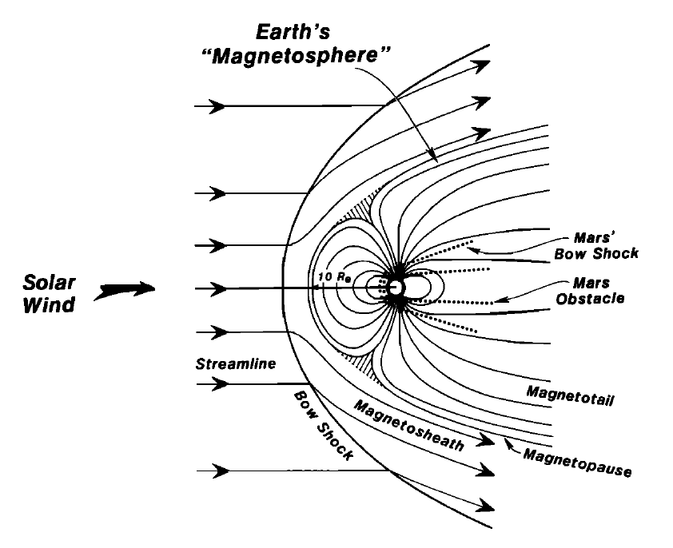

Figure 3. Illustration of the general features of the interaction of the solar wind with the Earth magnetic field [Luhmann et al., 1991]. Superimposed in dotted lines are the main features of the Mars-solar wind interaction.

*The sizes of the planets have been normalized for the purpose of comparison.*

Though on the dayside the planetary magnetic field lines are compressed by the solar wind pressure, on the nightside they are pinched by the solar wind pressure into a long **magnetotail**. The magnetotail is composed of two lobes, of opposite polarity depending of the inner magnetic field polarity, and extending in the anti-solar direction. They are isolated from each other by a **plasma sheet**, at which the radial component of the magnetic field reverses.

* **(2) Cometary and Moon-like interactions** (Callisto, Moon, Phobos, comet, …)

The bodies concerned in this category do not possess an internal magnetic field nor a consistent atmosphere (the active comets at small heliocentric distances being excluded from this category). In this case, the obstacle to the flow of the solar wind is an incompressible conducting body, such as an iron core or a salt-water ocean. The solar wind particles then travel without being disturbed until they reach the surface of the obstacle, where they are absorbed. This creates a **plasma-absorption wake** left in the plasma behind the body, which is characteristic for this interaction. At the same time, the IMF diffuses into the low conducting outer layers of the obstacle at a rapid rate, so that it is barely perturbed from its upstream orientation. Contrary to different configurations (such as the magnetosphere detailed previously), neither the magnetic field nor the particles accumulate on the dayside.

An illustration of this interaction at the Moon is presented on the left side of Figure 4, adapted from *Luhmann et al.*, [2004]. We clearly see that the IMF is hardly affected by the passage of the obstacle but that a wake cavity is formed downstream. In the case of the Moon, there is no bow shock upstream the body because the diversion of the magnetic field occurs inside the absorbing body.

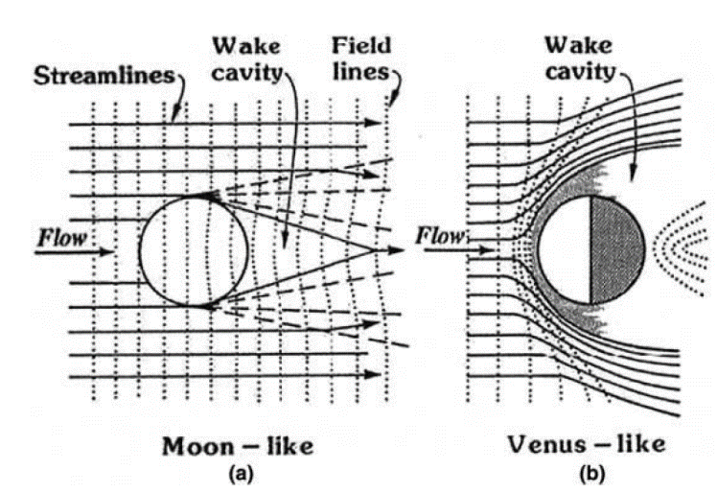

Figure 4. Illustration of two different interactions of the solar wind with unmagnetized obstacles [Luhmann et al., 2004].

*On the left, the Moon interacts mainly with the solar wind plasma, while le IMF is hardly disturbed. On the right, in the case of Venus, the presence of a substantial ionosphere produces a relatively impenetrable obstacle.*

* **(3) Induced-magnetosphere** (Titan, Venus, Mars)

This class of interaction contains the bodies that do not possess an intrinsic magnetic field at large scale but that possess a dense atmosphere. The word ‘induced’ used here refers to the general process of creating an effective magnetic obstacle through plasma interactions [*Luhmann et al.,* 2004]. The induced magnetic fields include the field perturbations resulting from electromagnetic induction, but also from the flow interaction.

In this case, the atmosphere of the bodies is partially ionized by the ultraviolet solar photons which create an ionosphere (see section 1.2.1.1 for more details). The obstacle to the solar wind is then an electrically conducting, compressible ionospheric shell which balances the external plasma pressure at a boundary generally called **ionopause**. As in the case of the magnetospheres, the solar wind slows down upstream the obstacle and becomes subsonic when it crosses the bow shock upstream the body. At the same time, the interplanetary magnetic field lines pile up in the front of the obstacle and drape around it, as shown on the right side of Figure 4 for the case of Venus. The so-formed induced magnetosphere also includes a magnetosheath and an induced tail which is essentially the extension of the magnetosheath into the wake.

In Figure 5 is shown a simplified scenario of the creation of an induced magnetosphere. The intrinsic neutral environment of a planet (step 1) is ionized through different processes by the ultraviolet solar photons (step 2). The so-formed ionosphere is a conductor (step 3). The incoming magnetic fields generate induced currents in the ionosphere that keep the IMF from penetrating through the body by generating a canceling field (step 4). This situation persists as long as the external magnetic field keeps changing its orientation and/or magnitude [Luhmann, 1995].

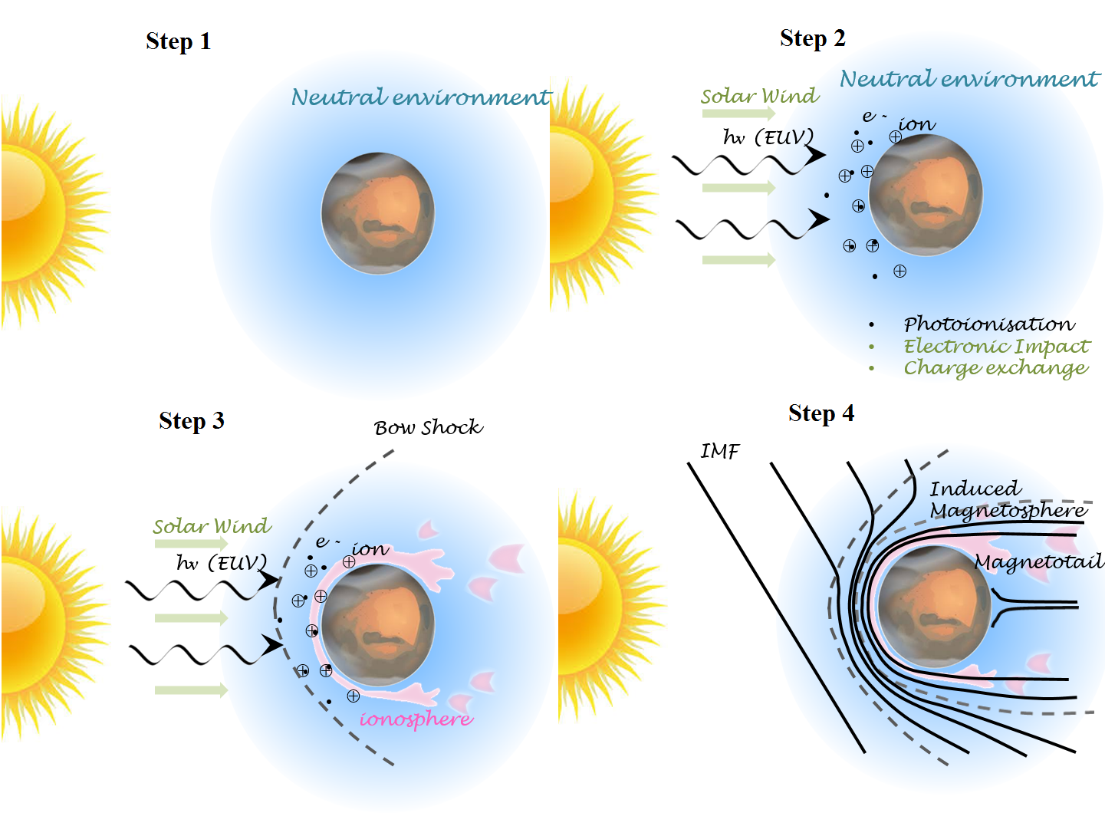

Figure 5. Illustration of the steps leading to the formation of an ionospheric obstacle in the solar wind flow. Adapted from Kivelson and Russel [1995].

The induced magnetosphere interaction will be discussed in more details in section 1.3.1, for the specific case of Mars.

* **(4) Mini-magnetosphere** (Ganymede, Mercury)

This last class gathers bodies with no significant atmosphere but with a magnetic field (intrinsic or remnant) 2 or 3 orders of magnitude weaker than in the magnetosphere class. This class appears like an intermediate case between bodies with low or no magnetic field and planets with strong intrinsic magnetic fields.

The solar wind plasma directly interact with the surface of the body, as for the Moon, since no atmosphere can shield it. This interaction leads to the creation of a thin atmosphere, like an exosphere (see section 1.2.1.1), whose composition reflect the composition of the surface. In addition, there is a magnetosphere-like interaction with the formation of a magnetosphere, a magnetopause, cusps, a magnetotail, etc. However, there is no coupling with an ionosphere, with creation of ionospheric currents like for the Earth, but there is a coupling with the core. An illustration of the magnetosphere of Mercury is given in Figure 6.

Much remains to be discovered about these kind of magnetospheres and future missions, such as Bepi-Colombo at Mercury or Juice at Ganymede, will help understanding this kind of interaction.

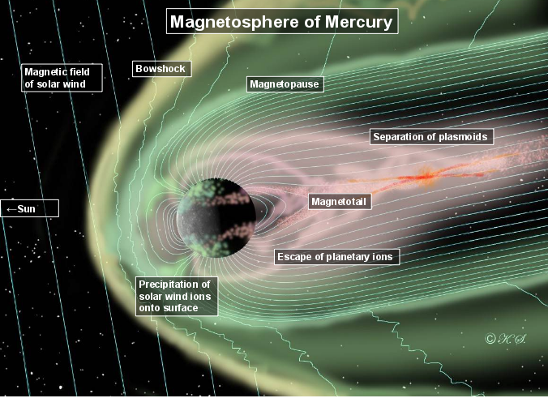

Figure 6. Illustration of the magnetosphere of Mercury. The solar wind comes from the left side.

As observed in Figure 2, the Martian interaction with the solar wind cannot be restricted to one category, due to its magnetic and atmospheric history. The global interaction can be similar to some extent to those of induced magnetospheres, such as Venus or Titan, but the presence of strong crustal magnetic sources induces localized mini-magnetospheres. Understanding the Martian interaction with the Sun hence begins by understanding the nature of the Martian obstacle. The current atmospheric and magnetic environment of Mars are described respectively in section 1.2.1.1 and 1.2.1.2. We then propose in section **Erreur ! Source du renvoi introuvable.** an overview of the Martian history, which enable a better understanding of the current observations. This finally leads us to the description of the Martian interaction with the solar wind in section 1.3.

## The Martian obstacle

Mars is the fourth planet of our solar system and the last telluric one. It orbits around the Sun on an elliptic orbit with a maximum distance to the Sun (aphelion) of 1.67 AU and a minimum distance to the Sun (perihelion) of 1.38 AU, which imply an eccentricity of 0.0935, much higher than the Earth one (0.0167). Mars inclination on its orbital plane is $25,19°$, which is comparable to the Earth ($23,44$ °) and implies the presence of seasons.

The length of the day on Mars is quite comparable to the Earth one: $\sim 24h37min$, and the planet makes a revolution around the Sun in ~687 days, a little less than two Earth years. With an average radius of $3386,2 km$, Mars is twice as small as the Earth and the gravity at its surface is three times smaller. The temperature at its surface can vary from -3°C to -133°C.

### Mars today

Mars has been visited by more than twenty spacecraft - landers - rovers to date (see section 2.1 for more details). These in-situ measurements have allowed a better knowledge of the Martian object, its current atmosphere (1.2.1.1) and magnetic field (1.2.1.2), which both are important to understand the interaction of Mars with the Solar wind.

#### Atmosphere - Exosphere - Ionosphere: who is who?

**Atmosphere**

Based on the nomenclature used for the terrestrial atmosphere, the Martian atmosphere can be divided into several layers according to the mechanisms involved (turbulence, molecular diffusion, photoionization, heating by absorption of UV rays). Taking the collisional point of view, the atmosphere can be divided into two parts: the barosphere and the exosphere. These two layers are characterized by a dimensionless number, the Knudsen number ($Kn$):

$$Kn=\frac{λ}{H}$$

The mean free path $λ$ can be defined as follow, in the case of a gas composed of a single species, where n is the density of the species, and $πσ^{2}$ the cross section :

$$λ=\frac{1}{πnσ^{2}\sqrt{2}}$$

The scale height **H** - corresponding in every point to the altitude to be raised for the pressure to be decreased by a factor of $e$- can be defined as follow:

$$H=\frac{k_{B}T}{Mg}$$

Where M is the mean molecular mass, g the local acceleration of gravity, $k_{B}$ the Boltzmann constant and T the medium temperature.

Regarding the Knudsen number, the barosphere and the exosphere can be defined as follows:

* The **barosphere** is a region of low Knudsen number ($Kn≪1)$. This is the inner part of the atmosphere, with the highest density. The dynamic is dominated by collisions between molecules and atoms, which result in a collisional medium, dominated by diffusion processes.
* The **exosphere** is a region of high Knudsen number ($Kn≫1)$. It corresponds to the external layer of the atmosphere and hence the less dense. The dynamic is here dominated by external forces, especially gravitation. It is characterized by a very high Knudsen number, which means that there are very few collisions, and that the trajectories of the particles are essentially ballistic. The exosphere is an exchange area between the lower atmosphere and the interplanetary medium.

The transition between the collisional and non-collisional medium is called the **exobase**. It has been estimated at 250 km by *Anderson and Hord* [1971], after Mariner 6 and 7 observations.

The barosphere can be divided into two layers, regarding the mixing of the atmospheric components: the **homosphere** and **thermosphere**. The homosphere and thermosphere are separated by a layer called the **homopause** (located at ~125 km mean altitude on the dayside).

* The homosphere is the lower layer, characterized by atomic and molecular constituents which are well mixed by winds and dissipative turbulence [*Stewart,* 1987; *Bougher* 1995; *Bougher et al.*, 2000; 2009; 2014]. The relative proportion of each species stays quasi-constant, no matter the molecular mass.
* The thermosphere corresponds to the region where the atomic/molecular diffusion dominates. Individual species begin to separate according to their unique masses and scale heights. The low mass species have higher scale height and will then be more abundant at higher altitude regarding heavier species whose density will decrease more quickly with altitude. The first in situ measurements obtained in the thermosphere were obtained by the Viking 1 and 2 entry probes in 1976 [*Nier and McElroy*, 1976; *Nier et al.*, 1976]. The measurements obtained along the descent of the lander highlighted the presence of $CO_{2}, N_{2}, {}_{ }^{40}{Ar}, O_{2}, NO$ and maybe CO in the Martian atmopshere.

More recently, measurements made with the MAVEN spacecraft down to the homopause improved our knowledge of the composition of the atmosphere and its variation with altitude. On the left panel of Figure 7 is plotted the neutral composition obtained during one orbit down to 133,8 km near the equator at noon, and on the right panel is plotted the average vertical neutral profiles obtained at 45° solar zenith angle [*Mahaffy et al.,* 2015]. We clearly observe that the lower atmosphere is dominated by $CO_{2}$ whereas the higher atmosphere is dominated by O, with significant amount of $O_{2}, N_{2}$ and N.

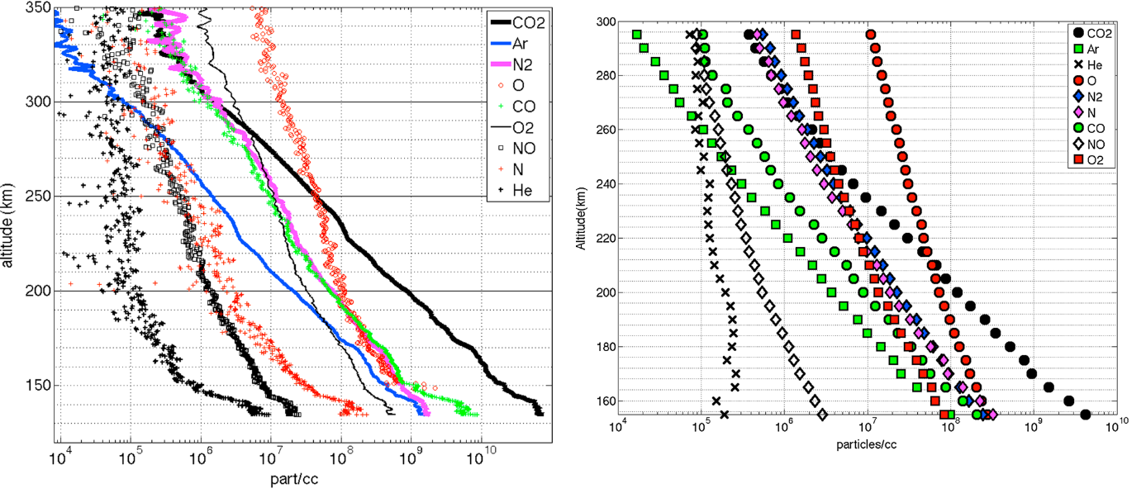

Figure 7. Neutral profiles obtained with the NGIMS instrument on MAVEN [Mahaffy et al., 2015].

*On the left is an example of the variation with altitude of nine atomic and molecular species during a passage down to 125 km. On the right is the average vertical profiles for nine upper atmosphere species at 45° solar zenith angle.*

**Ionosphere**

The upper neutral atmospheric region includes the thermosphere and the exosphere (also sometimes referred to as the corona). The upper neutral atmosphere interacts directly with the solar wind particles and photons, modifying the plasma neighboring the planet and creating an **ionosphere** (i.e. a part of the atmosphere that is ionized). While the thermosphere extends from ~100 to ~250 km altitude, the ionosphere can extend from ~100 to ~400 km altitude [*Bougher et al.*, 2014].

The process of ionization involving photons is called photoionization, and the process involving energetic-particles is often called impact ionization. While photons mainly come from the Sun, the ionizing particles can come from the Sun, but also from the galaxy (cosmic rays), or from the ionosphere itself. The only requirement for the photons and energetic particles to ionize the neutral atmosphere is that their energy exceed the ionization potential or binding energy of a neutral. In nature, atmospheric ionization is usually attributable to a mixture of these various sources, but one often dominates.

The three predominant ionization processes at Mars are the following (but there are several other mechanisms which play an important role in the dynamic and the escape of the ionosphere, see section 1.2.2.2):

* Photoionization:

Solar photons arriving on Mars mainly interact with O and $CO_{2}$ by the following mechanisms:

$$CO_{2}+hν→CO_{2}^{+}+e^{-}$$

$$O+hν→O^{+}+e^{-}$$

These two reactions are both associated with an ionization threshold near $90 nm$: $91,1 nm$ for oxygen and $89,9 nm$ for carbon dioxide. This means that only photons with lower wavelengths can photoionize O and $CO_{2}$. This corresponds to solar photons in the “extreme” ultra-violet (EUV) and ultraviolet (UV) wavelength range. Photoionization is the most important ionization process at Mars, in particular to create the dayside ionosphere.

* Ionization by electronic impact:

It corresponds to the interaction of electrons coming from the solar wind or magnetosheath with the atmospheric neutrals thus producing ions. This process is the dominant ionization process producing the nightside ionosphere. Following is an example of such ionization by electronic impact with a neutral (M):

$$e+M→M^{+}+e+e$$

* Charge exchange reactions

The plasma of the solar wind or of the induced magnetosphere interacts with the neutrals of the atmosphere. The incident ions can extract an electron from the atmospheric neutrals and transfer them their positive charge, thus producing a new ion and an energetic neutral atom. This process plays an important role in the production of ions (and associated cyclotron waves) at high altitudes in the Martian corona, due to the solar wind incident protons. Following is an example of such charge exchange reaction:

$$H^{+}+O→O^{+}+H$$

In Figure 8 are plotted the main ion profiles obtained by *Benna et al.,* [2015] during the first eight months of the MAVEN mission in 2014-2015. We can observe that the dominant ion is ${ O}_{2}^{+}$ below 300 km, with a smaller but significant amount of $O^{+}$ and $CO_{2}^{+}$, depending on the altitude.

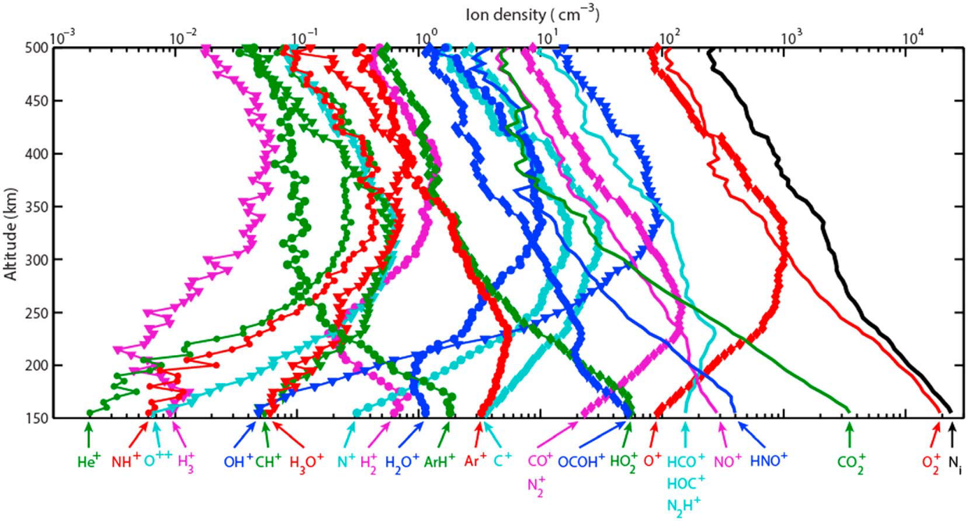

Figure 8. Altitude profiles of the averaged density of ionospheric ions measured by NGIMS at a solar zenith angle of 60° at altitudes between 150 and 500 km Benna et al. [2015]. The vertical profile of the total ion density $N_{i}$ is also plotted in black.

The altitude profile of ion production shows a peak at some altitude (the so-called Chapman layer), because the rate of ionization depends on both the neutral density (which decreases with altitude) and the incoming solar photons or precipitating plasma intensity (which decreases towards the surface due to absorption by the atmosphere). The altitude of this peak is specific to each ionization source. Hence, we usually observe three peaks on the Martian ionospheric profiles on the day-side: one for the EUV-UV, one for the X-ray and one for the meteoroids. Those peaks are different on the nightside.

#### The Martian magnetic field

The question of the Martian intrinsic magnetic fieldremained unanswered until the end of the 90s, when it was proved that at the present time, Mars does not possess any global magnetic field generated by an internal dynamo.

The first observations of the Martian magnetic field in the near Martian environment had been made by the Mariner 4 spacecraft in 1965 when it passed within 13200 km of the planet. The lack of detectable magnetic field signature attributable to Mars led to the conclusion that the Martian magnetic moment could not exceed ${3×10}^{-4}$ that of the Earth dipole moment, equivalent to an equatorial field of less than 100 nT [*Smith et al.,* 1965]. Additional measurements were made by Mars 2, 3 and 5 in the early 1970s and by Phobos 2 is 1989. Even the Phobos 2 spacecraft, which reached the lowest altitudes at 850 km from the surface, did not measure any magnetic field providing evidence of an intrinsic magnetic field. The scientific community was then divided between those claiming the presence of a small intrinsic dipole moment [*Dolginov and Zhuzgov*, 1991; *Slavin et al.,* 1991; *Verigin et al.,* 1991; *Möhlmann et al.,* 1991] and those claiming the absence of any intrinsic magnetic field [*Russell et al.,* 1995; *Gringauz et al.,* 1993].

Mars Global Surveyor (MGS) was the first spacecraft to obtain magnetic field observations beneath the ionosphere (~170 to 200 km) in 1997-1998. It provided 83 periapsis passes with altitudes between 100 and 170 km. This region is particularly interesting since it is shielded from the confounding effects of the solar wind interaction with the Martian atmosphere and ionosphere. The induced magnetic fields resulting from this interaction can reach levels similar with those arising from a planetary field of internal origin (see 1.3.1.3 for example). *Acuña et al.* [1998] showed that on several orbits reaching the underside of the ionosphere, relatively weak magnetic fields ($≤5nT$) were observed. They hence conclude that Mars does not possess a global intrinsic magnetic field on a large scale, and therefore no dynamo at present.

However, on some other orbits, like the one shown in Figure 9, the magnetometer recorded large magnetic fields near the periapsis. The amplitude of the magnetic field plotted in the right panel is projected on the MGS orbit in the left panel, so that the highest amplitude of the magnetic field (~400 nT) is observed at the closest point of the spacecraft orbit, while no magnetic field can be observed on the remaining part of the orbit. For these kind of orbits, it was found that the observed magnetic fields were restricted to a segment of the spacecraft trajectory that passed closely over the Mars crust. Hence, the observed magnetic signatures were not of global scale, as it would necessarily be if it was generated in the deep interior, for example by a dynamo. It was thus discovered that the magnetic field of Mars is dominated by intensely magnetized sources distributed, non-randomly, in its crust [Acuña et al., 1998, 1999].

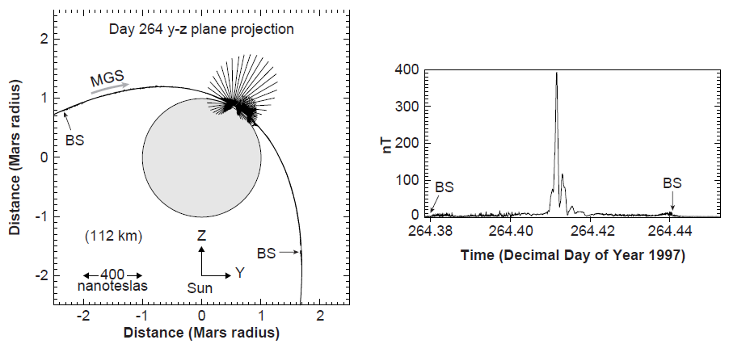

Figure 9. Illustration of the measurement of the crustal magnetic field by MGS [Acuña et al., 1998].

*On the left is the projection of the MGS spacecraft trajectory and observed magnetic field onto a plane perpendicular to the Mars orbit plane and the Mars-Sun line for a specific periapsis. The field observed along the trajectory at 3-s intervals is represented by a scaled vector projection of B originating from the position of the spacecraft at such times. Field vectors are scaled to $400 nT = 1 R_{Mars}$. On the right panel is plotted the magnitude of the observed magnetic field as a function of time for the time interval represented in the left panel.*

Compiling the data obtained by MGS during two full Mars years of its 400 km-mapping altitude, *Connerney et al.*, [2005] presented a global map of the magnetic fields due to remnant magnetism in the crust of Mars. Figure 10 is an updated version of this map [Connerney et al., 2015]. It is a global map of the filtered radial magnetic field ($∆B_{r}$), color contoured over two orders of magnitude variation in signal amplitude. The map is superimposed on the Mars Orbiter Laser Altimeter shaded topography map.

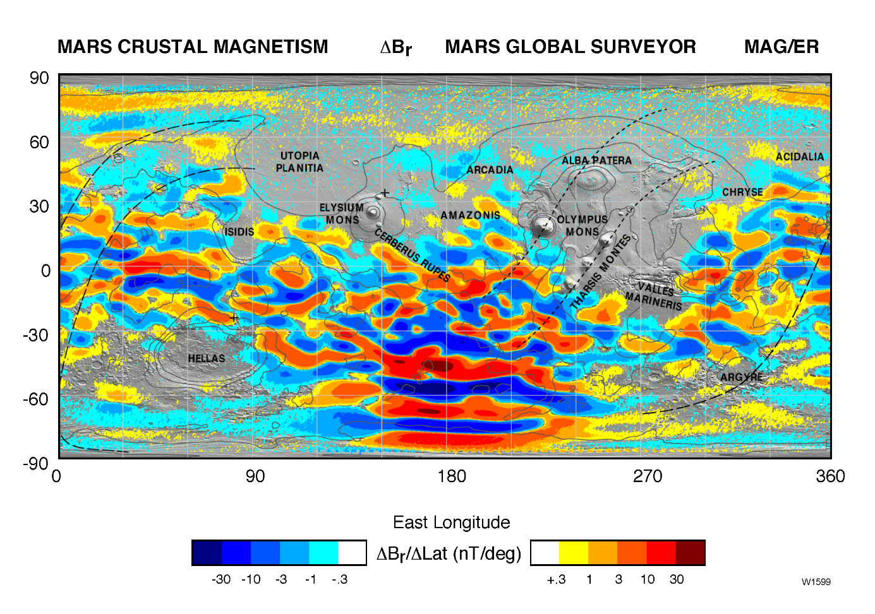

Figure 10. Map of the magnetic field of Mars observed by the Mars Global Surveyor satellite at a nominal 400 km altitude.

*Each pixel is colored according to the median value of the filtered radial magnetic field component observed within the ½° by ½° latitude/longitude range represented by the pixel. Contours of constant elevation (-4, -2, 0, 2, 4 km elevation) are superimposed (after Connerney et al., 2005).*

The crustal magnetic sources, mainly located in the southern hemisphere, can be considered as small dipoles located under the Martian crust. They form closed magnetic field loops (see section 1.3.2.1), which extends beyond 120 km altitude over 70% of the surface, and can extend up to 1500 km altitude over the strongest southern sources. The crustal magnetic field can reach intensities exceeding 200 nT at 400 km in the Southern hemisphere [*Acuña et al.*, 2001]. The largest crustal magnetic field strength measured at Mars is ~1600 nT near 100 km altitude. This value can be compared to the strength of the Earth’s global field and magnetic anomalies measured at 400 km: 26000 nT and 10 nT respectively.

The Martian obstacle to the Sun is then composed of the **ionosphere**, together with the **crustal magnetic sources**. Both form magnetic fields that divert the plasma around the planet. Crustal magnetic fields contribute to the deflection in some regions of Mars (mainly in the Southern hemisphere), creating ‘mini-magnetospheres’. In other regions, the IMF carried by the solar wind induces currents (via Faraday’s Law) in the conducting ionosphere that generate magnetic fields (via Ampere’s Law). The shielding magnetic fields then deflect solar wind particles around the obstacle (via the Lorentz’s law).

The interaction of Mars with the Sun will be extensively discussed in section 1.3, after a brief incursion in the Martian history.

### Back at the history of Mars

Mars is currently an arid planet, with a thin atmosphere, having an atmospheric pressure of 636 Pa (0.006 bar), compared to the ${10}^{5}$ Pa (1 bar) atmospheric pressure we currently have on the Earth. However, several missions (see section 2.1) showed the presence on the Martian surface of geological features (riverbeds, fluvial networks, hydrated minerals) revealing the ancient flowing of liquid water on Mars. Water was then stable at the surface of Mars several billion years ago. However, as it can be observed on the water phase diagram reminded in Figure 11, the current temperature and pressure conditions at the surface of Mars prevent the presence of ‘permanent’ liquid water, even if transient liquid water has already been observed (*Martin-Torres et al.*, [2015] for example). The leading idea for explaining these observations is the occurrence of a different climate during these early periods, with a denser atmosphere and warmer temperatures to sustain the flowing of liquid water at the surface of Mars. Warmer temperatures could be obtained by the presence of more greenhouse gases, such as $CO_{2}$. As for the denser atmosphere, it could have been possible thanks to the presence of an intrinsic magnetic field strong enough to shield the atmosphere from the solar wind.

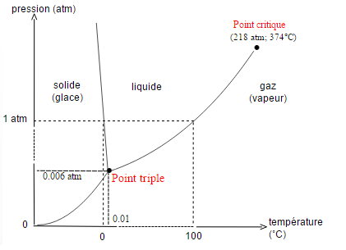

Figure 11. Phase diagram of water

Liquid water on Mars is currently a hot topic, and consequently its disappearance too. As its disappearance seems to be strongly linked to the disappearance of the atmosphere and a change in the climate and the inventory of volatiles through time, NASA sent in 2013 a mission dedicated to the study of such phenomenon: the MAVEN mission (see section 2.1.3 for more details about the mission).

#### A magnetic field history

The result obtained with the MGS spacecraft showed that Mars does not possess any global magnetic field at the present time, and therefore no dynamo at present. However, the presence of crustal magnetic sources strongly suggest that Mars had a dynamo in the past, when the crust acquired intense remnant magnetization.

It is likely that a molten iron core formed early, after or during hot accretion, 4.5 or 4.6 billion years ago. A substantial global magnetic field may then had been generated for at least a few hundred million years by dynamo action in the core. During this time period, the planetary magnetic field must have been recorded in certain kind of rocks, as we can observe it on Earth (Figure 12).

**Geological interlude**

Igneous rocks, when they cool down, can acquire a thermoremanent magnetization from the Earth’s field thanks to some of their component, such as iron-titanium oxide minerals in basalt. When their temperature decreases below their Curie temperature, they record in their structure the orientation and magnitude of the ambient magnetic field. The record can last for billion years, unless the rock is heated to temperature higher than its Curie temperature. The study of the remnant magnetic field on Earth allow a better understanding the continental drift and the way oceanic ridges work (alternation of layers of opposite magnetization on each side of the ridges as the Earth dipole polarity reverses and the oceanic plateau moves forward).

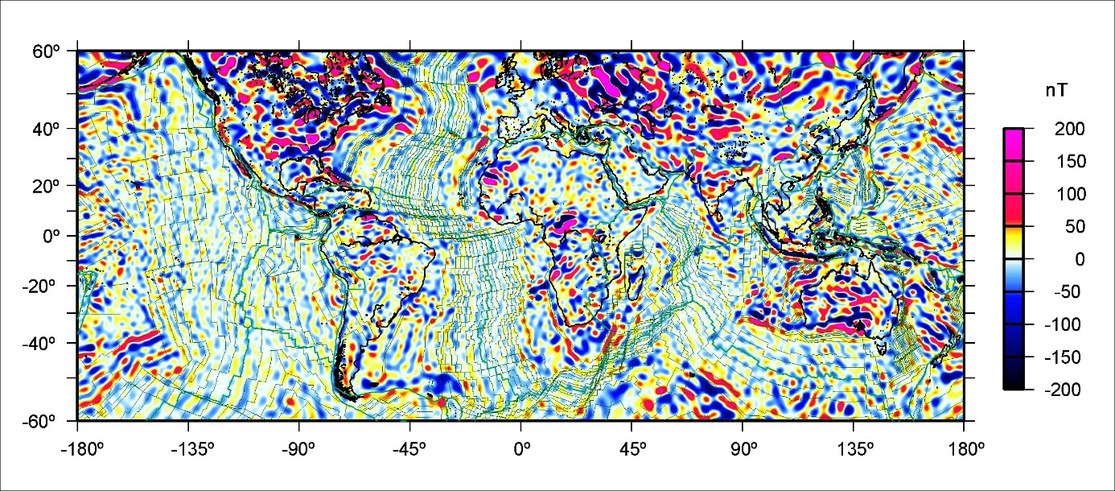

Figure 12. Vertical component of the MF6 model crustal magnetic field at the Earth surface, overlain with the isochrones of an ocean-age model and plate boundaries, http://geomag.org/models/MF6.html

Regarding the distribution of the Martian crustal magnetic fields, which are mainly coincident with the oldest terrains, *Acuña et al.,* [1998; 1999] proposed that the dynamo stopped early in the Martian history, prior to the last great impact (~4 billion years ago). During this time, the entire crust acquired a magnetic imprint via crustal heating - implying the presence of an iron-rich magma (intrusive, impact or thermal event) - and cooling in the presence of a reversing dynamo [*Connerney et al.,* 2005]. This mechanism allowed the crust to acquire a permanent remnant field that records the orientation of the global Mars magnetic field at that epoch. The large erasure of this imprint, which can be observed in the northern hemisphere for example, occurred when the crust was melted above its Curie temperature (thermal demagnetization) when no more ambient magnetic field was present, as during the last great impact for example. This left the large unmagnetized basins in the crust. The extinction of the dynamo would then leave the anomalies that are not obliterate by subsequent thermal events as permanent record of the paleofield and crustal evolution. This view has been supported by more complete analysis on the large impact basins [*Lillis et al.,* 2008; 2013a]. It appears that dynamo generation of the global magnetic field was extinguished before the formation of Hellas and Utopia basins approximately 4.0-4.1 Ga ago. A review of the different mechanisms supposed to be implied in the creation of the current Martian crustal magnetic field is reported in *Connerney et al.,* [2015].

Knowing that Mars had a substantial global magnetic field billions of years ago, the atmosphere may have been protected against the solar wind for a geologically significant period. In the dynamo era, Mars may have retained a warm and dense atmosphere. When the dynamo stopped, there was no more protection against the solar wind and the planet lost most of its atmosphere.

#### A Mars’ volatile and climate history

As the atmosphere of Mars was not any more protected from the solar wind by a magnetic shield as the one of the Earth, it was directly subjected to atmospheric erosion. Atmospheric loss may have contributed significantly to the evolution of the Martian climate over time. At the first times of the Martian history, the main mechanisms of atmospheric erosion were [*Brain and Jakosky*, 1998]:

* Catastrophic degassing by meteoritic bombing: impact erosion;
* Hydrodynamic escaping. It occurs when a light species escapes in abundance to space (usually enabled by high solar EUV flux or another form of heating) and drags heavier species along with it through collisions;
* Absorption and storage in the regolith of the surface and sub-surface;
* Escape into space. It is a result of a set of physical processes that provide particles in the thermosphere, ionosphere and exosphere with sufficient energy to escape the planet.

Hydrodynamic escape should have been significant for Mars during the first few hundred million years after its formation [*Zahnle and Kasting*, 1986]. When it ceased, impact erosion was a dominant loss mechanism, then decreasing as the impact flux declined over time [*Melosh and Vickery*, 1989]. The impact of these two escape processes on the atmosphere and climate of Mars are reviewed by *Jakosky and Phillips,* [2001]. The two remaining loss process were then exchange with the surface (as polar caps) and sub-surface (as carbonate deposits within the crust) and escape to space. As the first is largely reversible, escape to space permanently removes particles from the atmosphere. The latter is likely to have been the dominant permanent loss process over the last 3.8 billion years, and therefore a main contributor in the change of climate inferred to have occurred between present and 3.5-4.0 billion years ago.

Escape to space removes both neutral and ionized species from three atmospheric reservoirs: the thermosphere, the exosphere and the ionosphere, described in section 1.2.1.1. Most of the escape occurs between the homopause and the exobase, typically between 190 and 210 km [*Krasnopolsky et al.*, 1993]. A neutral or an ion escapes from Mars when it acquired the required escape velocity. The escape velocity $v_{L}$ is a ratio between the gravitational potential energy of a given particle and the kinetic energy required to overcome it, which does not depend on the mass of the particle. However, the necessary energy to reach this velocity is mass dependent.

$$v_{L}=\sqrt{\frac{2GM}{r}}$$

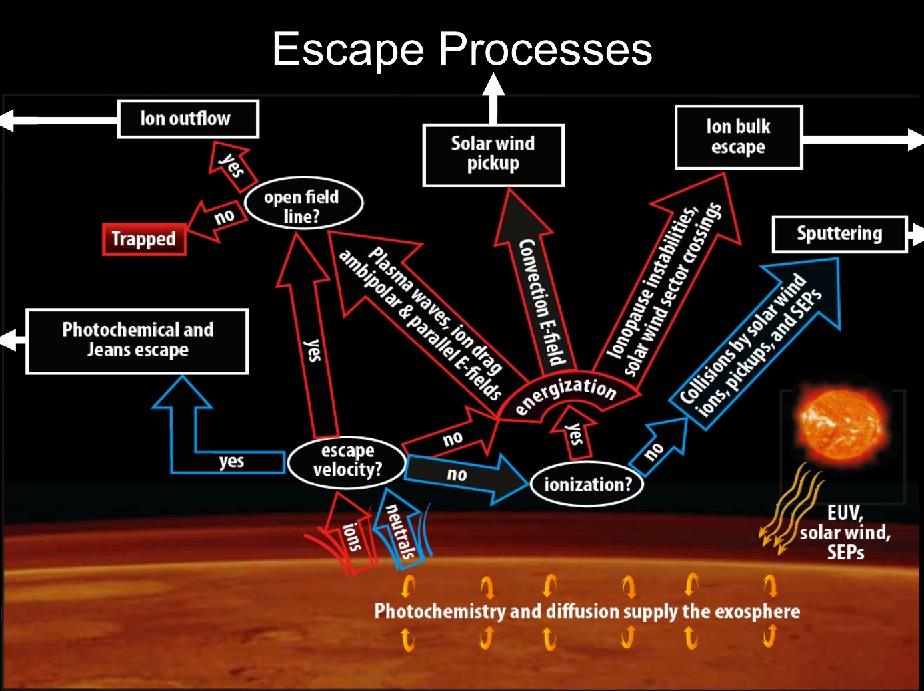

Figure 13. Schematic of contemporary escape processes (rectangular boxes) relevant for atmospheric neutrals and ions, presented in a ‘decision tree’. Solar inputs shown at the lower right contribute to the energization of atmospheric particles [Brain et al., 2014].

The different escape processes are gathered in Figure 13. Three main escape processes have been identified for neutrals:

* **Jeans (or thermal) escape**: a portion of the thermal distribution for an atmospheric species exceeds the energy necessary for escape. Only species with small mass (H, D and He) can escape significantly via this mechanism;
* **Photochemical escape**: exospheric chemical reactions (such as dissociative recombination of an ionized molecule with a nearby electron, resulting in two fast neutral atoms) provide atmospheric species with sufficient velocity to escape. Photochemical loss can be significant for O, N and C;
* **Atmospheric sputtering**: energetic incident particles (including ionospheric particles accelerated by the solar wind) can collide with particles of the thermosphere and ionosphere near the exobase and the momentum and energy exchange between particles carried out during the collision can lead to the ejection to space of the target particle. The incident particles can be solar wind protons or pickup ions.

When an atmospheric particle is ionized above the exobase, it can be accelerated, usually antisunward, by ambient electric fields. Most of the ions return to the atmosphere by precipitation while a certain amount is expected to escape. The ion escape processes are:

* **Ion pickup**: an ionized neutral particle is accelerated away from the planet by a motional electric field ($E= -v×B$) induced by the solar wind plasma and its IMF [*Luhmann et al.*, 1991]. It occurs primarily for ionized exospheric neutrals;
* **Ion outflow**: acceleration of low energy particles out of the ionosphere via plasma heating and outward directing charge separation electric field;
* **Bulk escape**: any process for which coherent portions of the ionosphere are detached via magnetic and/or velocity shear processes and accelerated away from the planet.

MAVEN data enable the identification of three escaping planetary ion populations [*Dong et al.*, 2015]: strong **plume** fluxes over the MSE (Mars-Sun-Electric field) North polar region, strong antisunward ion fluxes in the tail region, and weak but energetic upstream pickup ion fluxes observed mostly on the dayside. The presence of such a plume have been conjectured before MAVEN, but previous measurements did not allow to set the permanent nature of this feature. The study of *Dong et al*. [2015] illustrates the permanent presence of a substantial plume with strong ion fluxes widely distributed in the MSE northern hemisphere above the MPB, which gradually transition to tailward fluxes on the nightside without any significant boundary, as observed in Figure 14. On this figure are plotted the $O^{+}$ fluxes and velocities for energies greater than 25 eV, projected in the MSE X-Z plane. At the time of this paper, the plume escape for $O^{+}$ was estimated at 30% of the tailward escape, a number which have then been revised at 50% when more data were available. This escape varies with the solar wind density, dynamic pressure and EUV fluxes. It is the highest for low EUV flux and high solar wind pressure.

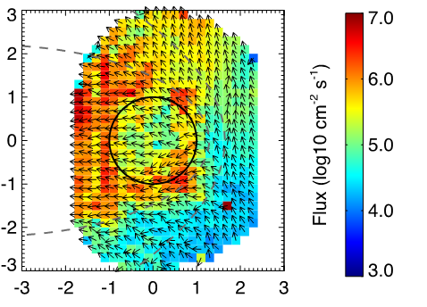

Figure 14. $O^{+}$ fluxes and velocities for energies greater than 25 eV projected on the MSE X-Z plane. The arrows show flux and velocity directions, while the colors label the magnitudes. The two grey dotted lines set the approximate position of the bow shock and the MPB. Adapted from [Dong et al., 2015].

The data recorded by the numerous spacecraft orbiting around Mars enable us to better understand the physical processes that drive escape today. This knowledge then allows us to extrapolate to earlier conditions, when the drivers where enhanced and escape would have been more rapid.

## The interaction of the solar wind with Mars

The exact nature of the interaction of the solar wind with Mars has been elucidated only around twenty years ago when MGS revealed the absence of intrinsic magnetic field at Mars but also showed the presence of crustal magnetic field sources. Before MGS, the bow shock and the magnetosheath had already been explored by Mariner 4, Mars 2, 3 and 5 and the tail had been observed by Phobos 2. Two models for the Martian interaction with the solar wind were opposed. On one hand, a model of magnetospheric interaction, proposed by *Dolginov et al.*, [1973] and *Gringauz et al.,* [1976], which claimed that the magnetic field of Mars controls the interaction of the solar wind with the planet. Their arguments were that they found more similitudes in the interaction of the solar wind with the Earth and Mars than between Mars and Venus, which was already known for not having any intrinsic magnetic field. Those conclusions were opposed to those of *Vaisberg et al.*, [1973] and *Russell et al.,* [1984] who proposed that the interaction with Mars was controlled by the Martian atmosphere, like the unmagnetized planet Venus. The different arguments are summarized by *Vaisberg* [1992].

The MGS magnetic measurements supported the proposition that the solar wind interacts with the extended atmosphere and ionosphere of Mars, creating a magnetospheric cavity, but also with the small-scale crustal magnetic fields. This interaction hence contrasts with the plasma interactions at any other solar system bodies. The obstacle that faces the solar wind is a combination of a global atmospheric obstacle (like for Venus or the comets) punctuated by many smaller-scale obstacles formed by strong crustal magnetic fields (somehow similar to the Earth or the Moon to a lesser extend).

The main features of the Martian global plasma interaction are summarized in carton form in Figure 15. Solar wind particles, coming from the left side, and the associated IMF, represented in yellow, induce magnetic fields in the conducting Martian ionosphere. This induced magnetosphere-like interaction forms a variety of different plasma regimes and boundaries that can be distinguished using spacecraft particle and field measurements.

So as to show how the different regions and boundaries of the Martian environment are observed by plasma instruments, the data recorded by several instruments of the particle and field package of the MAVEN spacecraft during one orbit in October 2016 are plotted in Figure 16 (see section 2.2.3 for more details about MAVEN instruments). On the first panel is plotted the energy-time spectrogram of omnidirectional electron energy flux (JE) measured by SWEA. On the second and third panel are plotted the energy-time and mass-time spectrogram of omnidirectional ion energy flux (JE), respectively, measured by STATIC. On the fourth panel are the electron (**red**) and ion (**black**) density measured by SWEA and SWIA respectively. The density of SWIA is not trustworthy below the magnetosheath as it does not record ions with energy below a dozen of eV. On the fifth panel is plotted the in-situ magnitude of magnetic field (**black**) measured by MAG, superimposed with the calculated magnitude of the crustal magnetic field (**red**), from the model of *Morschhauser et al.* [2014] (see section 2.6 for more details). Finally, the altitude and the position of the spacecraft regarding Mars are plotted on panel 6 and 7 (see section 2.5 for more details about the frames). The approximate location of the different boundaries discussed in next subsections are represented by the brown vertical lines. On this orbit, the spacecraft entered in the Martian induced magnetosphere on the dayside southern hemisphere, then traveled toward the northern hemisphere and the nightside it reached at ~17:15 UT.

Figure 15 and Figure 16 will be used together in section 1.3.1 to describe the different regions and boundaries forming the Martian interaction with the Solar wind, from the incoming solar wind down to the ionosphere.

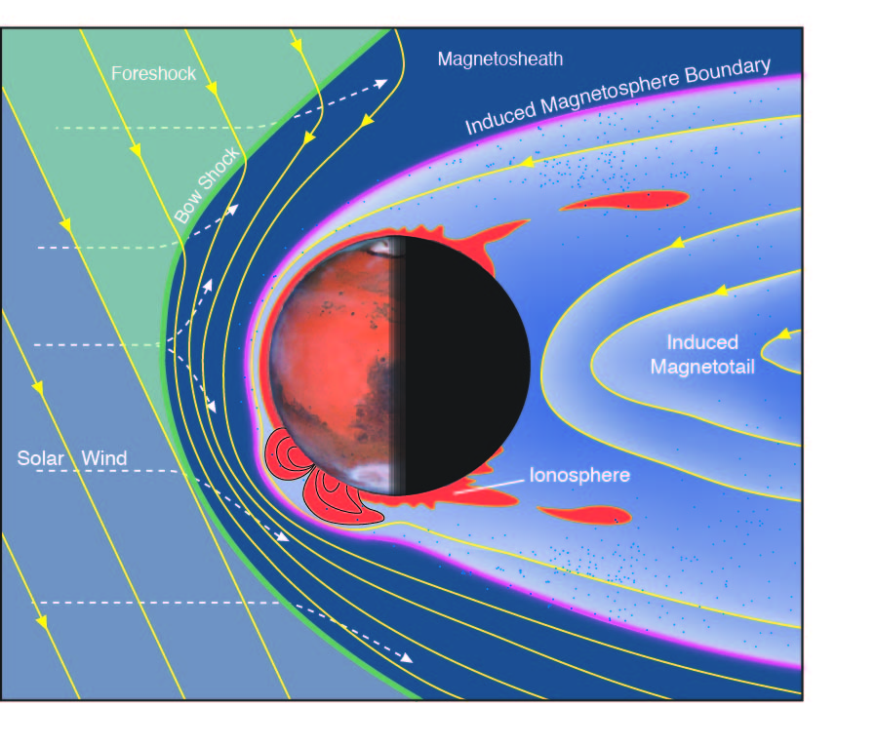

Figure 15. Schematic of the Martian plasma interaction regions [Brain et al., 2014].

*The solar wind carries with it the IMF (yellow) as it streams (dashed lines) toward the bow shock (green) upstream of Mars. Intense crustal magnetic field (orange) impose structures throughout localized regions of the upper atmosphere and ionosphere.*

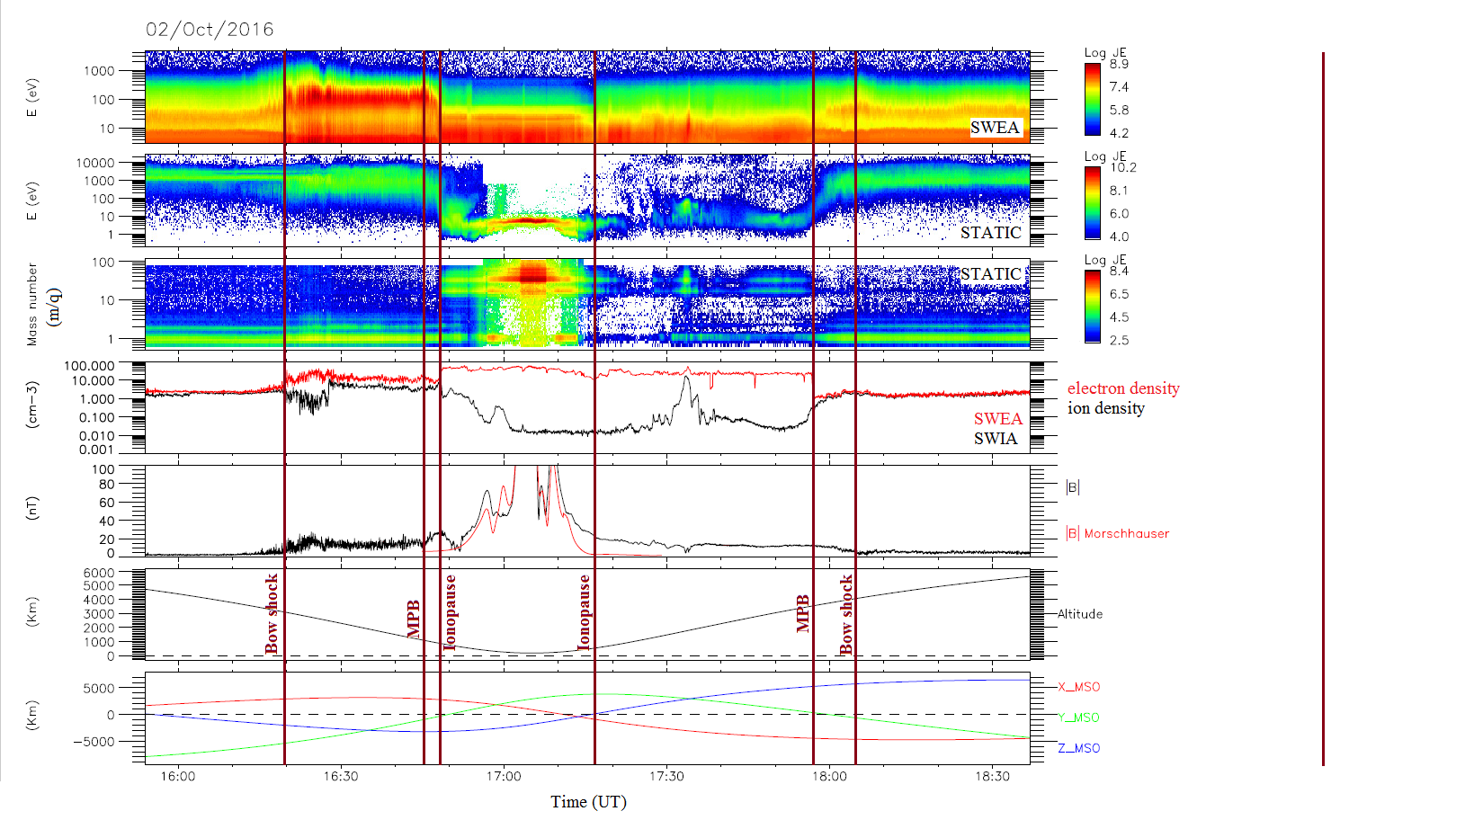

Figure 16. Example of a MAVEN passage in the plasma environment of Mars with a periapsis on the dayside.

Panel 1: SWEA energy-time spectrogram of omnidirectional electron energy flux. Panel 2: STATIC energy-time spectrogram of omnidirectional ion energy flux (C0 mode). Panel 3: STATIC mass-time spectrogram of omnidirectional ion energy flux (C6 mode). Panel 4: Electron density measured by SWEA (**red**) and ion density measured by SWIA (**black**). Panel 5: Magnetic field intensity (measured by MAG in **black** and calculated from the model of *Morschhauser et al.* [2014] in **red**) versus time. Panel 6: Altitude versus time. Panel 7: Coordinates of the spacecraft in the MSO frame (see section 2.5). The vertical lines highlight the main boundaries of the Martian environment described in section 1.3.1.

Models are also important tools for placing spacecraft measurements in context, and for probing causes and effects in the physics underlying the plasma interaction. Most of the models employ either Magneto-hydrodynamic (MHD) or hybrid assumptions. MHD models implement equations for the motion of electrically conducting fluids subject to electromagnetic forces, while hybrid models strive to include ion kinetic effects by considering the individual ion motion (still treating the electrons as a neutralizing massless fluid). The fluid models are particularly well suited for reproducing characteristics of the interaction with the solar wind, while the hybrid models may better describe kinetic effects. Comparison of several models have been made by *Brain et al.,* [2010], *Kallio et al.,* [2011], and *Ledvina et al.,* [2008]. Some individual model results will be discussed throughout this section, where appropriate.

We first describe the solar wind interaction with Mars as a steady-state interaction (1.3.1). We then discuss time-dependent effects on the location of the boundaries and the different regions (1.3.2). We finish on a focus on the nightside ionosphere (1.3.3), which is the main region that has been studied throughout this PhD.

### The steady-state interaction

The characteristics of the solar wind interactions with weakly magnetized, or unmagnetized bodies, are in some regards similar to the flow around a magnetized planet [*Luhmann et al.*, 1992, *Brain 2006*], but for the lack of a global scale magnetosphere within which the motion of charged particles is governed by an intrinsic planetary magnetic field. At Mars, the disturbance caused by the presence of the planet is much smaller compared to the size of the planet that at the Earth (see Figure 3). The distance of the obstacle “nose” at the Earth is ~10 Earth radii upstream while the nose of the obstacle at Mars is only a few hundred kilometers above the surface.

Due to the absence of magnetic obstacle at Mars, the solar wind interacts directly with the upper atmosphere and ionosphere and induces a magnetosphere by the pile up of the IMF. The solar wind transitions from supersonic to subsonic as it crosses the bow shock (1.3.1.1) and enters into the magnetosheath (1.3.1.2). Few solar wind protons are observed downstream a boundary sometimes called the Magnetic Pile-up Boundary (MPB) (1.3.1.3). Below the MPB is the Magnetic Pileup Region (MPR). The ionopause/Photo Electron Boundary (1.3.1.4) separates the planetary ionosphere (1.3.1.5) from the MPR. A two-lobed induced magnetotail (1.3.1.6) forms on the night side, with a current sheet carrying planetary ions between the two lobes [see *Nagy et al.,* 2004 for a review of the distinct plasma boundaries and regions resulting from the interaction].

#### The bow shock and the upstream region

When the solar wind, which is supersonic, encounters on its way a conductive obstacle such as Mars, a bow shock forms upstream of the planet (green line in Figure 15). Due to the geometry of the planet, the shock is detached. The solar wind is then heated, deflected, and slowed down when it passes the shock so that it becomes subsonic. In Figure 16 the bow shock can be observed at ~16:20 UT on the inbound part of the orbit. This first boundary separates two regions:

- The upstream one which is characterized by solar wind plasma (mainly protons with a kinetic energy greater than 1000 eV), a low plasma density and temperature (the ion beam is rather narrow on panel 2), a low magnetic field (< 5nT), and a supersonic flow (not shown). The typical shape of the electron flux spectrogram in the solar wind is plotted in **red** in Figure 17. The left part for energies below 10 eV should not be taken into account as it is due to the potential of the spacecraft (see section 2.2.4);

- The downstream one, called magnetosheath, which is characterized by a more intense magnetic field and density, a subsonic flow (not shown) and a higher temperature (the ion beam is larger on panel 2). The typical shape of the electron flux spectrogram in the magnetosheath is plotted in **dark red** in Figure 17 and will be discussed in the next section.

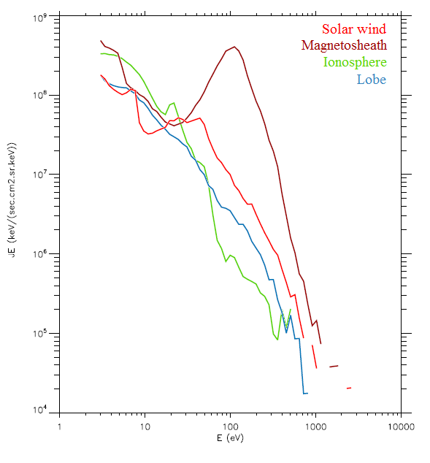

Figure 17. Electron energy spectra measured by SWEA in the **solar wind**, **magnetosheath**, **ionosphere** and the **lobe** on the orbit showed in Figure 16.

Due to the low gravity of Mars and the absence of intrinsic magnetic field, the bow shock is close to the surface of the planet (~2000 km at the subsolar point, ~5500 km at the terminator), so an important part of the exosphere is located well out of the shock and can interact directly with the incident solar wind. The interaction of Mars with the solar wind hence starts several planetary radii away from the planet, where the exospheric neutrals are ionized, mostly by photoionization and charge exchange. The resulting ions keep the same temperature as their neutral parents (a few eVs), but gain a small amount of energy during the process of photoionization. The new born ions, heavier but colder than the native ions of the solar wind, are accelerated by the electrical fields associated to the incoming flow, which tend to restore the thermodynamic equilibrium. These ions are called ‘**pickup ions**’. As the solar flow approaches Mars, an increasing number of cold exospheric newborn ions are created and lead to a significant **massloading** of the solar wind [*Bertucci et al., 2011**]*, which decelerates the flow by ~5% [Kotova et al., 1997]. The term ‘mass-loading’ refers to a situation where slow-moving mass is added to a flowing plasma, decelerating it via conservation of momentum.

Thanks to the several shock crossing of MGS, the altitude of the shock has been observed to increase from the subsolar point away to the tail, roughly forming a hyperboloid of revolution. Calculations of the bow shock shape have been made by *Vignes et al.* [2000, 2002], based on MGS crossings, and *Trotignon et al.* [2006], based on MGS and Phobos data, and *Edberg et al.* [2008], based on MEX data. Comparison of the results of these three models are presented in Figure 18 [*Edberg et al.,* 2008]. The bow shock is the outer boundary and the three fits can be observed to be globally in good agreement, slightly less at the subsolar point.

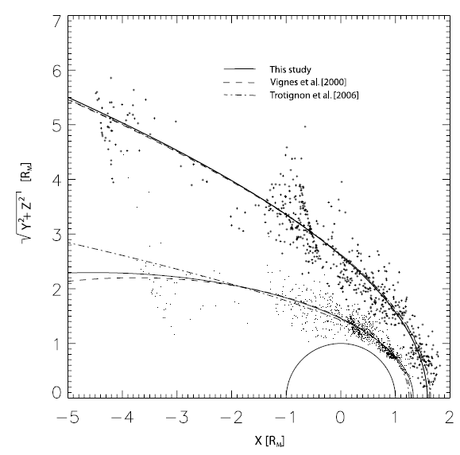

Figure 18. Comparison of the location of the bow shock and MPB calculated by Edberg et al., [2008] (plain line), Vignes et al., [2000] (dashed line) and Trotignon et al. [2006] (dashed-dotted).

*All MPB and bow shock crossings found from the pre-mapping phase of MGS are plotted as dots and plus signs, respectively, in 4° aberrated cylindrical MSO coordinates [Edberg et al., 2008].*

#### The magnetosheath

After the crossing of the bow shock, we can see in Figure 16 that the spacecraft enters into a region with the same ion population as in the solar wind (mainly protons and $He^{++}$ ions), at approximately the same energy, but with a much higher temperature. The electron and ion densities are larger than in the solar wind and the magnetic field is also greater than in the solar wind but shows much more fluctuations. Moreover, if we observe the electron energy spectra of this region in Figure 17 (**dark red** one), we can see that the electron population is at higher energy than in the solar wind, and is warmer. These characteristics are typical of the magnetosheath.

The magnetosheath is the region standing between the solar wind and the effective obstacle (dark blue region in Figure 15). It acts like a buffer between a region dominated by the solar wind dynamic pressure and the planetary induced magnetosphere dominated by the planetary pressure. It is populated by shock-heated, dense and turbulent solar wind plasma. Indeed, the solar wind plasma is slowed to velocities lower than $100 km.s^{-1}$, compressed by up to several times its original density, and heated to temperature up to ~4 times higher than upstream. The flow is also deflected from its original antisunward motion. The flow continues to slow down as it travels deeper into the magnetosheath.

As the plasma slows, the magnetic field increases, by up to ~4 times the upstream value. The magnetic field is compressed, distorted and “**draped**” as the plasma in which it is embedded is compressed and diverted around the obstacle. The understanding of the draping of magnetic field lines around a planet is based on the work of *Alfvèn et al.,* [1957] who first talked about this phenomenon. Indeed, as Mars is a conductive obstacle, the IMF cannot penetrate inside the planet. As the IMF is frozen in the solar wind plasma, when the plasma is slowed down upstream the planet, the magnetic field lines pile-up upstream the planet. However, as the IMF continues to be convected by the unperturbed solar wind flow around the planet, the magnetic field lines bend around the planet to form the magnetotail downstream. The IMF is wrapping around Mars.

The magnetosheath can be observed in two places in Figure 16: on the outbound part of the orbit in between ~16:30 UT and ~16:45 UT and on the outbound bound from ~18:05 UT to the end of the plot. On both cases, the dominant ions are protons with high energy and temperature (wide beam) and the quite low magnetic field is highly fluctuating. This characteristics are more visible on the inbound part, which is located on the dayside, than on the outbound aprt, which is located in the tail.

#### The Magnetic Pile-up Boundary and the Magnetic Pile-up Region

The region which separates the magnetosheath from the ionosphere is still controversial. It has proven difficult to determine whether there is a single outer boundary of the induced magnetosphere or several that are physically distinct. In the two following section we discuss about several of the boundaries commonly used to describe this transition region.

As the spacecraft plunges deeper in the magnetosheath in Figure 16, we can see around 16:45 UT that the energy of the electrons and of the ions begins to fall, at the same time as the magnetic field begins to strongly increase. These lower boundary of the magnetosheath is usually called the Magnetic Piled-up Boundary (MPB) [*Bertucci et al.*, 2004] and is represented as the purple line in Figure 15.

The MPB is a controversial boundary, which has also been called the Induced Magnetosphere Boundary [Brain et al., 2014], Induced Magnetopause, planetopause [*Riedler et al.*, 1989], magnetopause [*Rosenbauer et al.,* 1989; *Lundin et al*., 1989], protonopause [*Sauer et al.*, 1994], or the ion composition boundary [*Breus et al.*, 1991], depending on the observed parameters. The chosen name of the boundary, MPB, arbitrarily emphasizes the behavior of the magnetic field. The other names emphasizing other plasma components, or an instrument- neutral designation, would also have been correct, but after long, and surely animated, discussions, the MPB terminology has been adopted [*Nagy et al.,* 2004].

Despite the different names and plasma signatures associated with this boundary, it seems clear that it results from the interaction of the shocked solar wind with planetary heavy ions. The MPB clearly separates two very different regions:

* The magnetosheath with low amplitude and turbulent magnetic fields;
* A region of high piled-up fields, the Magnetic Pile-up Region (**MPR**), where the solar wind magnetic field is piled up and drapes around the ionosphere. The MPR marks the transition between plasma dominated by ions of solar wind origin (mainly protons) and plasma dominated by ions of planetary origin (mainly $O^{+}$ and $O_{2}^{+}$). The two types of ions are usually distinguished regarding the ion mass spectrometry (third panel).

Several sharp changes of the plasma and field parameters can be observed at the crossing of the MPB, like: the rotation of the magnetic field direction, a strong and sharp jump observed on the magnetic field amplitude (the draped IMF at Mars typically reaches strengths of 30-60 nT), a reduction of the field’s directional variability, an increase in the field draping, and a strong drop of the suprathermal electron fluxes (energies > 10eV) by often more than one order of magnitude [*Acuña et al.,* 1998; *Bertucci et al.,* 2003]. There is also a drastic change of ion composition: the proton density decreases, commensurate with an increase of planetary ions density. A sharp increase in electron density, and a decrease in the electron temperature can also be observed. Several of these features can be observed in Figure 16. However, all these characteristics are not always observed at each MPB crossing so that it is not yet understood which signatures help to form or maintain the MPB and which result from its existence.

As for the bow shock, the MPB is usually approximated by a paraboloid of revolution about the planet-Sun line. Its shape has been fitted using Phobos data [*Trotignon et al.*, 1996], MGS data, [*Vignes et al.*, 2000], a combination of Phobos and MGS data [*Trotignon et al.*, 2006], and MEX data [*Edberg et al.,* 2008]. The last three models are superimposed to MGS crossings in Figure 18. They are in rough agreement except for the far nightside. From the model fit, the MPB is situated on average at ~850 km altitude near the subsolar point, and at ~1500 km altitude near the terminator.

#### The ionopause and the Photo Electron Boundary

Between the MPR and the ionosphere is a boundary, sometimes called **ionopause**, sometimes called Photo Electron Boundary (**PEB**) and which delimits the magnetospheric cavity that is almost void of solar wind plasma. The ionopause name is inherited from Venus, where it corresponds to the upper boundary of the ionosphere. It is defined as the location where ionospheric electron density increases rapidly or as the location where ionospheric thermal pressure is balanced by the magnetic pressure in the induced magnetosphere [*Phillips et al.,* 1988]. At Mars, the ionospheric thermal pressure is typically insufficient to balance magnetic pressure and so the field penetrates into the ionosphere, dominating the pressure there [*Dubinin et al.*, 2008a] (pressure balance will be discussed in more details in section 1.3.2.2).

The PEB is considered as the boundary above which magnetosheath-like solar wind electrons are located and below which ionospheric photoelectrons are located [*Mitchell et al.,* 2001]. The PEB can be observed as the location between regions where photoelectrons are present and where they are not, in particular the photoelectrons at 20-30 eV induced by the strong 30.4 nm line of the solar spectrum. [*Nagy et al.*, 2001].

In Figure 16 the ionopause/PEB can be observed mainly on the electron spectrogram, where the electron flux at energies greater than 100 eV decreases dramatically and the line at 20-30 eV begins to be observed. On the ion spectrogram, the ion energy drops from ~1000 eV to less than 10 eV, and planetary ions begin to be observed. The decrease in the magnetic field value that can be observed just below the ionopause/PEB at ~16:52 UT is also a typical feature of this boundary.

In some cases, the PEB and the ionopause coincide but it is still not clear if the ionopause and the PEB are collocated or not [*Han et al.*, 2014]. The ionopause can usually be found at an altitude of ~450 km on the dayside [*Brain et al.*, 2014], and at increasing altitude toward the terminator.

#### The ionosphere

The lowest region that can be observed in Figure 16 (at the periapsis), is the ionosphere. It is represented in orange in Figure 15. The ionosphere is a region of low energy planetary plasma, with relatively cold, heavy ions. It can be easily detected thanks to the spectral lines of photoelectrons on the electron spectrometer. The photoionization of atmospheric $CO_{2}$ and atomic O produces electrons with specific energies (two peaks at 21-24 eV and 27 eV) [*Mitchell et al.*, 2000]. However, the individual peak cannot be resolved by SWEA and on the electron spectra corresponding to the ionosphere in Figure 17, we can only observe one peak at ~20 eV. The presence of photoelectrons is then used as a tracer of the ionosphere [*Mitchell et al.,* 2000; 2001; *Dubinin et al.,* 2006; *Frahm et al.*, 2007 and Garnier et al., coming soon]. The ionosphere is also characterized by a decrease of the flux of electrons having an energy greater than ~30 eV. This decrease can reach one order of magnitude for ~100 eV electrons [Mitchell et al., 2001].

If no crustal magnetic fields are present, the magnetic field measured in the ionosphere should reach a minimum, presenting a shape of an ionospheric cavity. Such a cavity is presented on Figure 19. On the first panel is plotted the electron energy-time spectrogram measured by SWEA, on the second panel the ion energy-time spectrogram measured by STATIC, on the third panel is plotted the amplitude of the in-situ magnetic field (**black**) superimposed with the magnitude of the magnetic field calculated from the model of *Morschhauser et al.*, [2014] (**red**). The position of the spacecraft is plotted on the last two panels. We can observe on the modeled crustal field that no significant crustal magnetic sources are present during the passage of the spacecraft in the ionosphere and a minimum of the magnetic field is visible at the periapsis, at ~23:25 UT. Browsing plasma data, ionospheric cavity appears to be quite a rare structure.

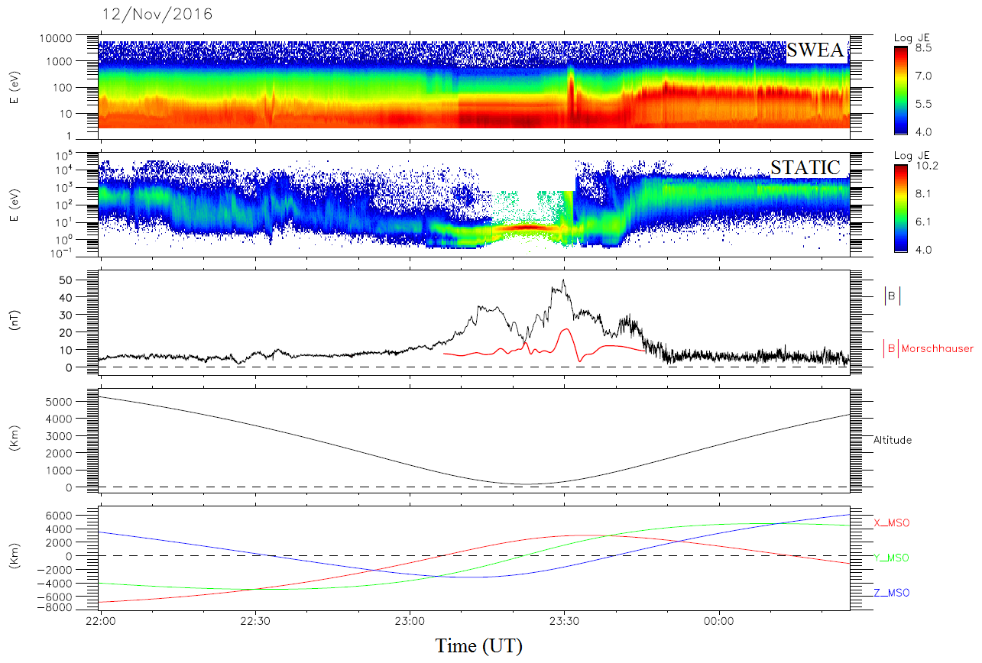

Figure 19. Example of an ionospheric cavity observed by MAVEN.

*Panel 1: SWEA energy-time spectrogram of omnidirectional electron energy flux. Panel 2: STATIC energy-time spectrogram of omnidirectional ion energy flux (C0 mode). Panel 3: Magnetic field intensity (measured by MAG in* ***black*** *and calculated from the model of Morschhauser et al.* [2014] *in* ***red****) versus time. Panel 4: Altitude versus time. Panel 5: Coordinates of the spacecraft in the MSO frame (see section 2.5).*

#### The wake and the magnetotail

If we follow the MAVEN spacecraft going away from its periapsis in Figure 16, it exits the ionosphere at ~17:15 UT and enters a new region on the nightside of Mars. It corresponds to the lobes of the induced magnetotail (Figure 15). The IMF magnetic field lines draped around Mars extend well downstream in the anti-sunward direction, and form the magnetotail by analogy with the magnetotail that forms downstream a magnetic planet. A magnetic planet imposes a geometry and a polarity on the magnetic field in its magnetotail, whereas the magnetotail formed downstream an unmagnetized body changes direction in response to changes in the direction of the IMF. *Yeroshenko et al.* [1990] found that the magnetic field in the Martian magnetotail can be organized into two tail lobes with two opposite magnetic field polarities: ‘to’ and ‘away’ from the Sun directions, separated by a thin magnetic neutral sheet. The plasma sheet consists primarily of planetary ions which are accelerated up to keV energies by the magnetic field tensions [*Dubinin et al.,* 1993]. Well-defined current sheets are sometimes evident as low as ~400 km. The magnetic field in the tail is weak (~10 nT), though it is still stronger than the unperturbed IMF.

The two lobes of the magnetotail can be observed in Figure 16 from ~17:15 UT to ~17:55 UT with the current sheet at ~17:35 UT. The magnetic field is quite steady in the lobes, apart from the current sheet passage, where there is a drop in the amplitude of the magnetic field and an inversion of the three components of the magnetic field (not shown). The presence of planetary ions can also be observed so as a little enhancement in the electron energy. The boundaries separating the wake from the magnetosheath could be called the wake boundary, as an extension of the MPB to the nightside. A typical electron spectra that can be observed in the lobes is plotted in **blue** in Figure 17.

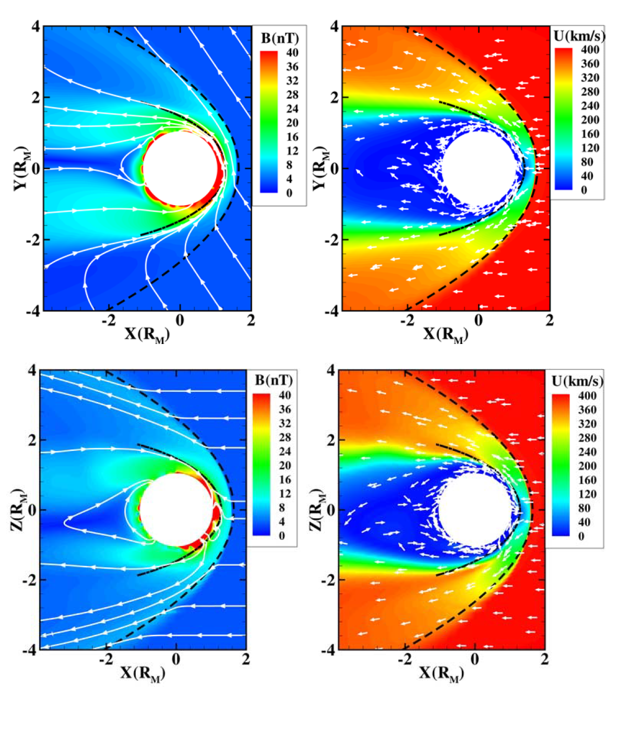

Figure 20. Calculated magnetic field (left) and velocity (right) in the equatorial plane (up) and in the meridional pane (bottom) of Mars. The color plots show the magnitudes, the white lines marked with arrows indicate the vector direction of the magnetic field and the arrows show the direction (not the magnitude) of the velocity. The dashed lines represents the mean bow shock and the dash-dot line is the mean MPB locations from Vignes et al. [2000]. Adapted from Ma et al., [2004]

All the boundaries and regions described in the previous sub-sections can be observed in Figure 20, on which the Martian environment is plotted after the results of simulation of *Ma et al.,* [2004]. The upper panels correspond to the calculated magnetic field (left) and velocity (right) in the equatorial plane while the lower panels corresponds to the same parameters in the meridional plane. The bow shock is clearly visible in both velocity and magnetic field results, and its position corresponds quite well with the model of *Vignes et al.* [2000], plotted in black dashed line. The draping of the IMF is also clearly observed, especially in the equatorial plane, as well as the pile-up region. The presence of mini-magnetosphere in the Southern hemisphere is clearly observed on the meridional plane, and we can observe that their presence has a significant impact on the draping of the IMF. We can observe that in the ionosphere, the flow pattern is toward the terminator on the dayside, while on the nightside the flow is partially outward through the tail, contributing to the escape flux. The inward part of this flow contribute to the maintaining of the nightside ionosphere (section 1.3.3).

### Dynamics of the Martian interaction with the Sun

The description of the Martian magnetosphere proposed in section 1.3.1 is a steady-state description, which does not take into account neither the presence of crustal magnetic field (which visibly has an impact on the location of the MPB as observed on Figure 20) nor the variation of the external drivers (such as the direction of the IMF or the EUV flux).

#### Magnetic topology

Due to the presence of crustal magnetic sources, the magnetic field lines in the vicinity of Mars can be of three kind [*Nagy et al.*, 2004; *Bertucci et al.,* 2003; *Brain et al.*, 2007], gathered on the left side of Figure 21:

* **Closed**: magnetic field lines are connected at both ends to the crust (‘a’ configuration);
* **Open**: one end of the magnetic field line is connected to the crust and the other end to the IMF (‘b’ configuration);
* **Draped/Unconnected**: both ends of the magnetic field lines are unconnected to the crust and connected to the IMF (‘c’ and ‘d’ configuration).

The closed magnetic field lines are due to the presence of crustal magnetic sources in the Martian crust. If the magnetic field is strong enough, as in the Southern hemisphere, the closed magnetic field lines should shield the upper atmosphere from magnetized charged particles and from intrusion of the magnetosheath plasma. There is hence formation of regions that act in many respects like small-scale version of the terrestrial dayside magnetosphere [*Fränz et al.*, 2006], as plotted on the right side of Figure 21.

Crustal fields can be strong enough to dramatically alter the nature of the interaction with the solar wind, as it can be seen in the multi-fluid magnetohydrodynamic simulation of *Ma et al.* [2004] presented in Figure 20.

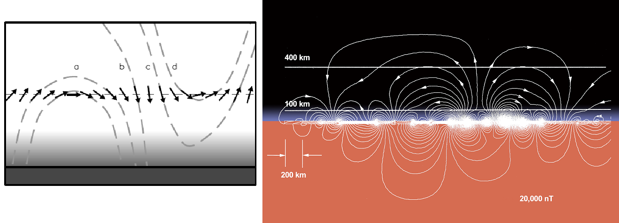

Figure 21. Left. Possible magnetic field topologies [Brain et al., 2007]. The Mars Global Surveyor Magnetometer and Electron Reflectometer (MGS MAG/ER) measures the local vector magnetic field near 400 km altitudes (arrows). Electron pitch angle distributions can be used to help identify whether the field angle is closed (curve a), open (curve b) or draped (curve c) in the ionosphere/atmosphere, or draped above the ionosphere/atmosphere (curve d). Right. Plane projection of the magnetic field geometry above the intensely magnetized southern highlands [Connerney et al., 2015] based on the crustal magnetic field model of Connerney et al. [1999]. This figure illustrates the field geometry that would be encountered during periapsis passes along a line of constant longitude (near 150° East) and centered at 50°S. Similar ‘mini-magnetosphere’ may be encountered above much of the magnetized crust, depending on spacecraft altitude and solar wind conditions.

Open field lines can be found at the edge of closed crustal magnetic field lines, and form cusp-like regions, analogous to terrestrial magnetospheric cusp regions. Such regions can provide a conduit for energy and particle exchange between the solar wind and the ionosphere [*Krymskii et al.*, 2002]. Open field lines between closed field lines can be confused with the signature of current sheets. Indeed, *Halekas et al.,* [2006] showed that the non-uniform geographic distribution of the current sheet at 400 km in the nightside suggests that crustal fields may play some role in their presence at low altitude. This interpretation has been supported by simulations [*Ma et al.,* 2002].

These three topologies have been encountered at Mars and can be detected thanks to the electron pitch angle distribution (PAD). The electron pitch angle corresponds to the angle between the electron velocity and the magnetic field vector. These distributions have been mapped geographically at 400 km by *Brain et al.,* [2007] and on a wider range of altitude by *Xu et al.*, [2016]. The results of these studies will be discussed in more details in section 3.1.2 and 4.4, respectively.

#### Pressure balance

Each boundary in the interaction of Mars with the Sun is the result of an equilibrium of pressure. Upstream from the planet the solar wind is dominated by dynamic pressure ($\sim {ρv}^{2}$). The thermal plasma pressure (~*nkT*) then becomes dominant in the magnetosheath. The dominant pressure term in the MPR is the magnetic pressure (~*B2/2μ0*) from induced magnetic field. In the ionosphere the plasma pressure (~ $nkT$) finally becomes dominant. In a steady-state situation, the force of the solar wind against the magnetosphere and the force of the magnetosphere against the solar wind are in balance, and an equilibrium is struck so that the total pressure at any location in the Martian system is conserved.

For example at the MPB, as sketched in Figure 22, the magnetospheric magnetic field and the ionospheric plasma exert an inward pressure: $nk_{B}T+B^{2}/2μ_{0}$. On the other side, the magnetosheath plasma and the draped magnetic field exert an inward pressure: $nk_{B}T+ ρv^{2}+B^{2}/2μ_{0}$. These two forces find an equilibrium at the MPB [*Luhmann et al.*, 1991].

However, the Martian environment is embedded in the solar wind, whose properties are highly variable. Hence, these boundaries are moving, adjusting their location regarding external and internal drivers (section 1.3.2.3). When the solar wind blows harder, the magnetosphere shrinks, and when it decreases, the magnetosphere expands.

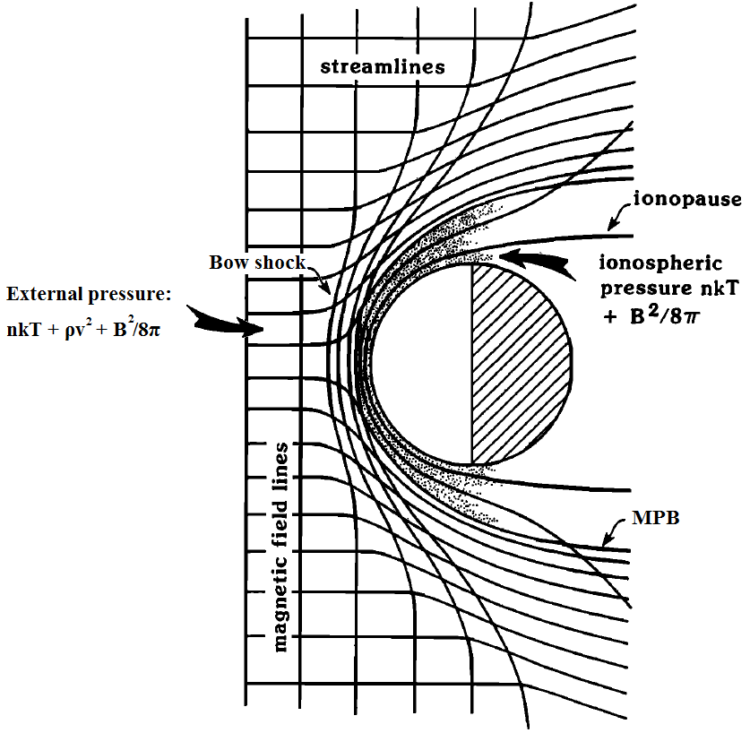

Figure 22. Illustration (not to scale) of how the interplanetary magnetic field may penetrate into the Martian ionosphere (stippled). The stream lines of plasma flow are those that are diverted around the planetary obstacle, while the cross-flow lines are magnetic field lines. Adapted from [Luhmann et al., 1991].

#### Variability of the boundaries

The location of the different boundaries and hence the extension of the different regions depend on the intensity of the external drivers (solar wind plasma, solar UV photon flux, and IMF direction), but also the internal drivers in the case of Mars (crustal magnetic sources and their orientation with respect to the Sun).

**Influence of the crustal magnetic sources**

The orientation of Mars with respect to the Sun would not be a major factor in controlling variability in its plasma environment if it lacked crustal magnetic fields. However, the crustal fields rotate with the planet every ~24.6h. They are strong enough to influence the altitude of all the major plasma boundaries on timescales associated with Mars’ rotation [*Brain et al.*, 2003, 2006].

The crustal fields add magnetic pressure to the Martian system at ionospheric altitudes, which helps to counter the pressure of the solar wind. Crustal fields replace the need for induced ionospheric shielding currents in some locations. The pressure from the crustal magnetic fields alters the shape of the obstacle to the solar wind, perturbing various plasma boundaries upward locally [*Crider*, 2004; *Fränz et al.*, 2006] as illustrated in Figure 15 and in Figure 20 for the MPB, though their influence on the bow shock is relatively weak [Mitchell et al., 2001; Crider et al., 2002; Edberg et al., 2009; Duru et al., 2010].

**Influence of the solar EUV photon flux**

The solar EUV flux determines the ionospheric thermal pressure, which ultimately balances the incident pressure of the solar wind. The altitude of the MPB and of the bow shock have been successfully correlated with EUV flux [*Edberg et al.*, 2009], though attempts to correlate the ionopause/PEB with EUV flux have been unsuccessful [*Mitchell et al.,* 2001].

**Influence of the solar cycle**

As the EUV flux is more important during solar maximum, one can think that the solar cycle has an impact on the position of the different boundaries of the Martian environment. However, *Modolo et al.*, [2005] simulations showed that the position of the bow shock and the MPB hardly depend on the solar cycle, in agreement with the observations made by *Vignes et al.* [2000].

**Influence of the IMF direction**

Variation in the direction of the IMF changes considerably the position and the shape of the shock and the MPB. Indeed, the shape of the bow shock and the MPB is asymmetric with respect to the IMF direction [Acuña et al., 1998, Dubinin et al., 1998, Vignes et al., 2002]. This effect can be observed in Figure 20 on which the shock position on the dawn side is closer to the planet than at the dusk side. Hybrid simulations by *Modolo et al.*, [2012], using time-dependent input conditions demonstrated that a rotation of the IMF causes the entire interaction region to rotate in response, with a ‘lag’ of as much as two minutes in some regions. The orientation of the IMF directly influences the organization of the wake.

**Influence of the parameters of the solar wind flow**

The solar wind density and velocity determine the incident dynamic pressure at Mars. Since there is a pressure balance throughout the dayside interaction region, the density and velocity play a large role in determining the size and position of the different plasma boundaries, the plasma temperature in the magnetosheath, and the strength of the magnetic field in the induced magnetosphere [Brain et al., 2014].

The speed and the temperature of the solar wind flow modify the sound speed and consequently the Mach number. This influence the shape of the shock. The position and the shape of the MPB is partially affected by the speed of the solar wind [Modolo et al., 2005].

Simulations are especially well-suited to study the effects and relative importance of the individual drivers. See for example: *Brecht and Ledvina* [2006]; *Harnett and Winglee* [2006]; *Modolo et al.*, [2006]; *Ma and Nagy* [2007]; *Kallio et al.*, [2008]; *Fang et al.*, [2010]; [*Najib et al.*, 2011]](#_Bibliography)*.*

### Focus on the nightside ionosphere

The Martian ionosphere is mainly due to photoionization of atmospheric oxygen and carbon dioxide. As the recombination of the electrons and ions resulting from this interaction back into neutrals is rapid and there is no nightside photoproduction, the ionosphere is generally a daytime phenomenon.

The presence of a nightside Martian ionosphere is made possible by local production processes and transport processes from the dayside. Impact ionization by precipitating magnetosheath electrons is one of the main process in nightside ionospheric production [Fillingim et al., 2010; Lillis et al., 2011; Lillis and Brain, 2013b]. Transport of the dayside ionosphere to the nightside can be achieved by winds, by the co-rotation of the ionosphere with the planet itself or by horizontal transport of plasma from dayside to nightside along draped magnetic field lines [*Ulusen and Linscott*, 2008; *Fränz et al.*, 2010]. In Figure 20 we can observe that the flow pattern in the nightside ionosphere is partially downward, which help maintaining the nightside ionosphere.

Despite the several spacecraft which have already visited Mars, its nightside ionosphere still remains an unfamiliar and mysterious place. Several studies have shown that the nightside ionosphere is irregular, spotty, faint and complex [*Zhang et al.*, 1990; *Němec et al.,* 2010; *Duru et al.*, 2011; *Withers et al.,* 2012]. In Figure 23 is plotted an orbit of MAVEN in February 2015, during which the periapsis is on the nightside. The panels are the same as on Figure 16. The different boundaries described in section 1.3.1 are highlighted by the vertical lines. The spacecraft enters the bow shock at ~06:50 UT, on the dayside Southern hemisphere. Then it travels in the magnetosheath until ~06:10 UT where it crosses the MPB and then the ionopause/PEB at ~06:15 UT. Then, the spacecraft stays in the ionosphere until ~07:00 UT. However, at ~06:25 UT, the spacecraft passes the terminator and carries on in the nightside. On this time interval, the spacecraft observes the dayside ionosphere as well as the nightside ionosphere.

We can observe between ~06:30 UT and ~06:35 UT a typical structure of the nightside ionosphere: the **suprathermal electron depletions** (which may be equally called electron depletions hereinafter). We can observe it on the first and the fourth panel. During this

event, the electron flux at all energies above 3 eV (the lower limit of the SWEA instrument), decrease by more than three orders of magnitude. At the same time, a sharp drop in the electron density is measured.

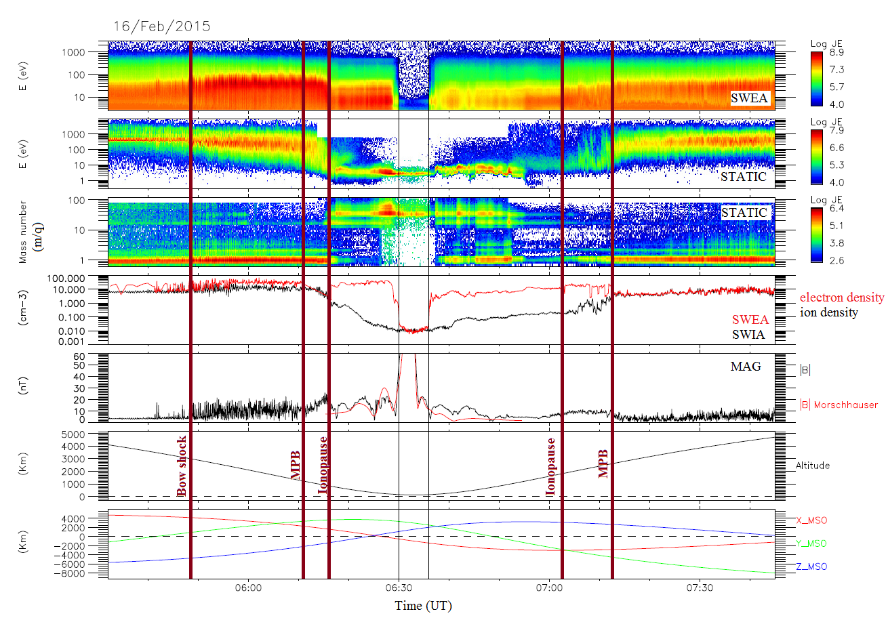

Figure 23. Example of a MAVEN passage in the plasma environment of Mars with a periapsis on the nightside.

Panel 1: SWEA energy-time spectrogram of omnidirectional electron energy flux. Panel 2: STATIC energy-time spectrogram of omnidirectional ion energy flux (C0 mode). Panel 3: STATIC mass-time spectrogram of omnidirectional ion energy flux (C6 mode). Panel 4: Electron density measured by SWEA (**red**) and ion density measured by SWIA (**black**). Panel 5: Magnetic field intensity (measured by MAG in **black** and calculated from the model of *Morschhauser et al.* [2014] in **red**) versus time. Panel 6: Altitude versus time. Panel 7: Coordinates of the spacecraft in the MSO frame (see section 2.5.1). The vertical lines highlight the main boundaries of the Martian environment described in section 1.3.1.

The nightside ionosphere is an important feature of the plasma environment of Mars as it participates in the global-scale plasma circulation around Mars and is a conduit through which particles from the neutral atmosphere can escape. Suprathermal electron depletions are recurrent and specific features of the nightside ionosphere which have already been observed and studied by MGS and MEX. These structures were observed to be strongly linked to the crustal magnetic field of Mars. They hence provide an indirect method of detecting crustal fields, allowing the determination of the topology of the magnetic field using electron spectrometers [*Mitchell et al.*, 2007; *Brain et al.*, 2007], and possible conduit for atmospheric escape in cusp-like regions.

However, for suprathermal electron depletions as for the whole environment of Mars, the new measurements obtained with MAVEN enable a new vision of the phenomenon. Thus, contrary to MGS and MEX vision where suprathermal electron depletions were confined to strong crustal magnetic field regions, MAVEN can observe these structures above the whole Martian surface.

From this observation, the main objective of this PhD has been to better understand the different processes which lead to the presence of suprathermal electron depletions in the nightside of Mars. The MAVEN multi-instrument capacity as well as its unprecedented spatial coverage has been used extensively, conjointly to the dataset provided by MGS and MEX, so that a survey on eighteen years could have been carried out.

The following manuscript is organized as follow:

* As the present study is a multi-spacecraft-multi-instruments analysis, we first present in **section 2** the different spacecraft (section 2.1), instruments (section 2.2), datasets (section 2.3), analysis tools (section 2.4), frames (section 2.5) and models (section 2.6) which are used in the subsequent sections in section 0.
* In **section 3** are presented in more details the suprathermal electron depletions. First, we present how they were observed by MGS and MEX (section 3.1), and then how they are now observed by MAVEN (section 3.2). The three criterion we implemented to automatically detect suprathermal electron depletions in MGS, MEX and MAVEN data are developed in section 3.3, and their application to the three datasets is detailed in section 3.4.
* The three catalogs of electron depletions thus obtained are used in **section 4** to understand the mechanisms at the origin of suprathermal electron depletions. A geographical distribution of these structures is presented in section 4.1, followed by [to complete]
* [to complete]

# Instrumentation, data and analysis tools used

The study of suprathermal electron depletions presented here has been possible only thanks to three spacecraft, and their onboard instruments. Before entering the heart of the subject, we then need to present the different spacecraft (section 2.1), their instruments (section 2.2), the datasets (section 2.3), the analysis tools (section 2.4), the frames (section 2.5) and the models (section 2.6) that we have been used to unveil the origin of suprathermal electron depletions.

## Exploration of Mars

The launch of space vehicles to explore Mars started in 1960 with the launch of **Marsnik 1** by the Soviet Union. Unfortunately, the exploration of Mars only began four years later, on July 14-15, 1965, with the first Martian flyby made by the NASA spacecraft **Mariner 4**. Indeed, the Martian exploration has experienced a high failure rate, especially at its beginnings, from 1960 to 1971. Only five missions on the nineteen sent succeeded. This eagerness to explore Mars was motivated by its spatial proximity and by its past, when Mars may have looked like the Earth. Hence, the main objectives of the missions to Mars, past or future, are to determine if it has ever sheltered life, to understand the evolution of the Martian weather, to understand the origins and the evolution of the Martian geology and finally to prepare the human exploration of Mars.

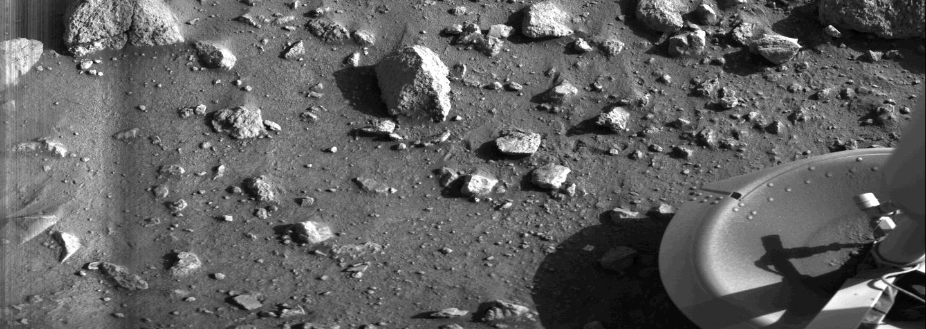

Figure 24. First photograph made by the lander Viking 1 of the Martian surface

On November 14, 1971, the NASA spacecraft **Mariner 9** became the first spacecraft to orbit another planet when it achieved its orbit insertion around Mars. The Soviets finally reached the Martian surface in 1971. **Mars 2** crashed on the surface on November 27, and **Mars 3** landed successfully on the surface on December 2 but ceased transmission within 15 seconds. In July 1976, The NASA lander **Viking 1** offered us the first photograph ever taken from the surface of Mars (Figure 24). The two landers Viking 1 and Viking 2 took also the first in-situ measurement of the atmosphere during their descent toward the surface.

Since then about twenty orbiters, landers and rovers have reached the red planet (Figure 25), even if error of units sometimes made them crash (R.I.P. to Mars Climate Orbiter). In 2017, the operational Martian fleet is composed of two scientific rovers rolling on its surface: **Curiosity** of the Mars Science Laboratory mission (NASA) and **Opportunity** of the Mars Exploration Rover mission (NASA) along with six orbiters surveying the planet: **Mars Odyssey** (NASA), **Mars Express** (ESA), **Mars Reconnaissance Orbiter** (NASA), **Mars Orbiter Mission** (Indian Space Research Organization), **MAVEN** (NASA) and the **ExoMars Trace Gas Orbiter** (ESA).

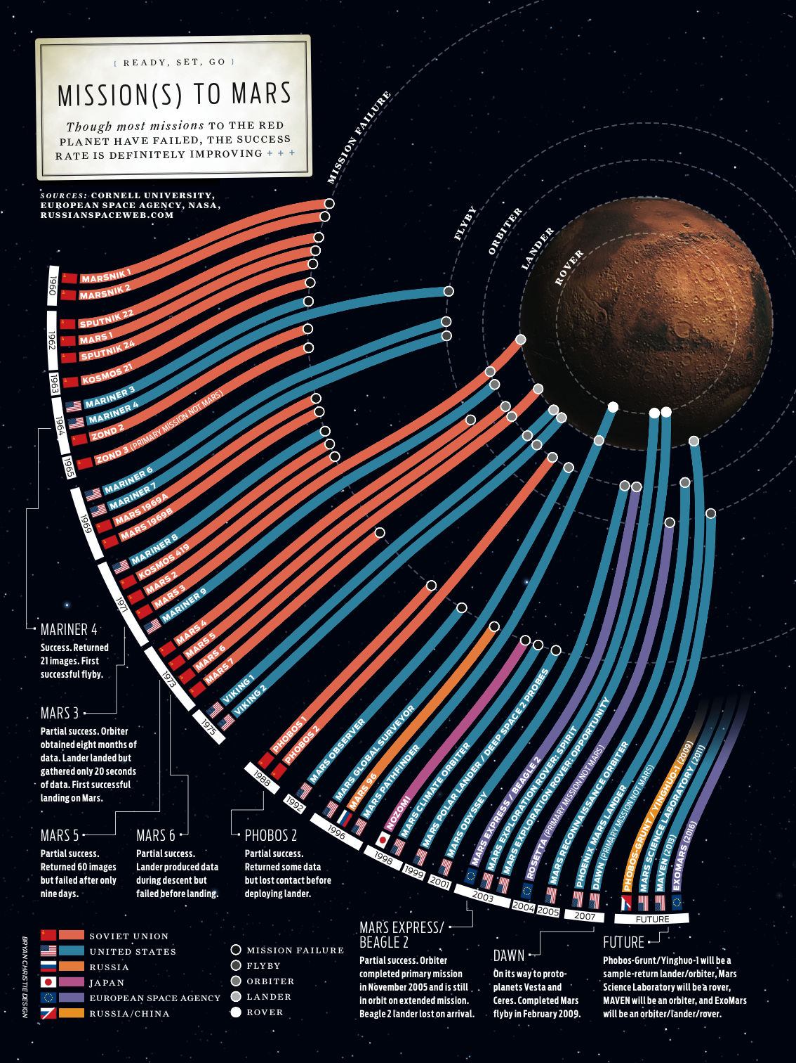

Figure 25. Summary of all the missions ever sent toward Mars.

*The Russian mission* ***Phobos-Grunt*** *failed its launch and stayed in a low Earth orbit. The NASA* ***Mars Science Laboratory*** *successfully landed on Mars and is still rolling on its surface. The NASA* ***MAVEN*** *spacecraft successfully orbits around Mars since 2014. The European* ***ExoMars*** *mission partially succeeded. The orbiter achieved its insertion around Mars but the* ***Schiaparelli*** *lander failed its landing. Next missions are: NASA lander* ***InSight****, ESA rover* ***ExoMars*** *and NASA rover* ***Mars2020****.*

### Mars Global Surveyor

After the success of the Viking program, about twenty years passed with no successful American mission to Mars but many questions about the origin and history of Mars remained unanswered. The **Mars Global Surveyor** (MGS) spacecraft was launched on November 7, 1996 from Cape Canaveral Air Force Station (Florida, USA), four years after the loss of contact with the previous mission spacecraft: **Mars Observer** (several days before its insertion around Mars).

#### Scientific objectives

MGS was the first mission of the NASA Mars Surveyor Program. The objectives of this program were to understand the current and past climates of Mars, the geological and geophysical evolution of the planet and whether life could have started and evolved on Mars [*Albee et al.,* 2001]. The primary objectives specific to the MGS mission were the following:

* Characterize the surface morphology at high spatial resolution to quantify surface features and geological processes;
* Determine the composition, distribution and thermophysical properties of surface minerals, rocks and ices;
* Determine the global topography, geodetic figure, and gravitational field;
* Establish the nature of the magnetic field and map the crustal remnant field;
* Monitor global weather and thermal structure of the atmosphere;
* Study surface-atmosphere interaction by monitoring surface features, polar caps, polar thermal balance, atmospheric dust, and condensate clouds over a seasonal cycle.

Several secondary objectives had been set during the extensions of the mission:

* Provides multiple years of on-orbit relay communications capability for Mars lander and atmospheric vehicles;
* Long-term weather and surface monitoring;
* Support landing site selection through acquisition of high-resolution imaging for the 2007 Phoenix lander and the 2011 Curiosity rover

#### Orbitography

The MGS mission had been designed to be a global mapping mission which investigated the entire planet, from its interior to its surface, through its atmosphere, up to its ionosphere. These constraints lead to the definition of a low-altitude, near-circular, near polar, Sun-synchronous mapping orbit with a short repeat cycle. The selected characteristics were then: a “frozen orbit” with a period of 117.65 min, an inclination of 92.96°, an average altitude of 378 km varying from 368 to 438 km above the surface and a local time set at 1400/0200 LT.

The amount of propellants needed to reach this mapping orbit was too large to be launched. Hence, after Mars orbital insertion, an aerobreaking phase - during which the spacecraft would reach low altitudes at its periapsis - had been planned to use the atmospheric drag on the spacecraft to slow it so as to reach its low-altitude mapping orbit. Such a technique was challenging as it had never been done before and few was known about the structure and dynamics of the Martian atmosphere.

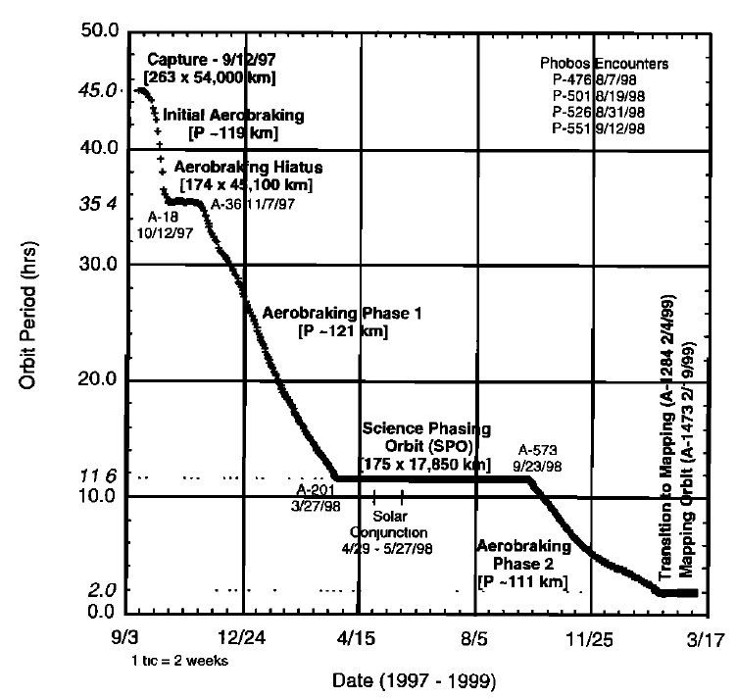

Figure 26. MGS orbit period during its aerobreaking phase. [Albee et al., 2001]

After its launch on November 1996, the MGS spacecraft travelled 11 months before reaching Mars on September 11, 1997 and being inserted in a highly elliptical orbit of 45 hours period. On its third orbit, MGS initiated the aerobreaking phase, operating repeated dips into the upper atmosphere (down to 105 km altitude). According to the initial planning, the spacecraft would have reached its mapping orbit in the spring of 1998. However, due to a problem on one of its solar panel, MGS finally reached its mapping orbit on February 19, 1999 (Figure 26).

The MGS mapping mission was initiated on March 9, 1999. In the nominal mapping mode the spacecraft was continuously nadir-pointed, enabling the instruments to acquire and record data on a continuous basis. The nominal mapping mission end on February 1, 2001. It was extended several times until the end of 2006. MGS then became silent, due to a battery failure. The MGS mission officially ended in January 2007.

#### Instruments

After the failure of the Mars Observer mission, four of its science instruments were retooled for the MGS spacecraft. The aim of the instrument suite was to study Mars in its entirety, meaning at the same time its surface, interior and atmosphere. To meet the scientific objectives of the mission they had to both acquire high-quality data and maximize the data returned within the constraints of the mission. Four instruments and a radio science investigation have been operated onboard MGS, the configuration of which is shown in Figure 27:

- MOC (Mars Orbiter Camera): MOC is a high resolution camera which aim was to map the whole Martian surface [*Malin et al.*, 1992];

- MOLA (Mars Orbiter Laser Altimeter): MOLA is a laser altimeter which aim was to characterize the topology and the gravitational field of Mars [*Zuber et al.,* 1992];

- TES (Thermal Emission Spectrometer): TES is a thermal emission spectrometer which aim was to study the atmosphere and map the mineral composition of the surface thanks to infrared spectroscopy [*Christensen et al.,* 1992];

- MAG/ER (Magnetometer/ Electron Reflectometer): the MAG/ER experiment was composed of two magnetometers (MAG), and an electron spectrometer (ER) [*Acuña et al.*, 1992]. It will be described in more details in section 2.2.1;

- Radio Science (Gravity Field Experiment): the radio science investigation used data provided by the spacecraft telecommunications system, high-gain antenna and onboard ultra-stable oscillator to map variations in the gravity field and to determine the atmospheric pressure at specific locations.

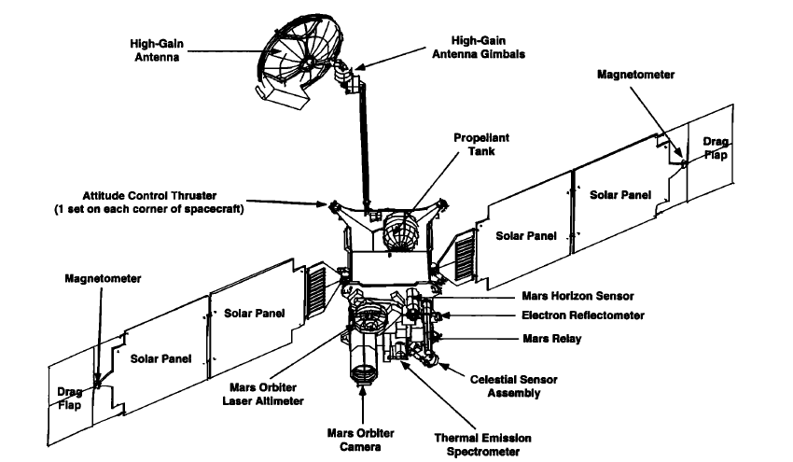

Figure 27. Global view of the MGS spacecraft showing the main components and instruments [Albee et al., 2001]

#### Main discoveries

The use of MOLA data allow the production of a high resolution map of the shape and topography of Mars [*Smith et al.*, 2001]. It showed that a difference of 30 km exists between the lowest point in Hellas and the top of Olympus Mons. It also revealed that Mars is flattened by ~20 km at the poles due to the rotation of the planet and that the North Pole is ~6 km lower than the South Pole. Pictures taken by MOLA also allow the identification of pathways for the flow of past water, the height of clouds, and the first direct global measurement of the amount and distribution of condensed carbon dioxide.

Visible imaging (MOC) and infrared spectral mapping (TES) provided information about the nature of the surface and processes operating on the surface. Thus, the TES data allowed the discovery of new mineralogical and topographic evidence suggesting Mars had abundant water and thermal activity in its early history. They also indicated evidence of an ancient hydrothermal system, implying stable liquid water at or near the surface, and hence implying that a thicker atmosphere existed in Mars’ early history. MOC meanwhile had been used to characterize the properties of the currently active fluids involved in the gullies identified on Mars. It suggested the presence of a current source of liquid water, similar to an aquifer near the planet surface.

During the circularization phase, MAG/ER observations showed that the Martian magnetic field is not globally generated in the planet’s core [*Acuña et al.,* 1998], but is localized in specific areas of the ancient crust [*Acuña et al*., 1999]. These anomalies demonstrate that Mars had once an internal dynamo which ceased operation early in geologic time. This discovery formed the basis of a new model of interaction between the solar wind and Mars, discussed in section 1.3.

### Mars Express

**Mars Express** (MEX) is the first mission launched by the European Space Agency (ESA) to explore another planet of the solar system. It has been so called due to the short duration of its design and construction compared to similar missions. The MEX probe is composed of an orbiter and a lander called Beagle 2, named after Charles Darwin’s ship. It was launched on June 2, 2003 from the Baikonur Cosmodrome (Kazakhstan).

#### Scientific objectives

As MGS, MEX is dedicated to the study of the planet’s interior, subsurface, surface and atmosphere. However, the combination of the MEX orbiter and of the Beagle 2 lander would have allowed unprecedented orbital and in-situ measurements. The scientific objectives of MEX try to fulfill in part the scientific goals of the lost Russian **Mars 96** mission, and added two related new issues [*Chicarro et al.,* 2004]: the current inventory of ice or liquid water in the Martian crust, and possible traces of past or present biological activity on the planet.

The main scientific objectives of the orbiter are:

* Imaging the entire surface with a high-resolution of ~10m/pixel and selecting areas at super resolution (2m/pixel);
* Global infrared mineralogical mapping of the surface at 100m resolution;
* Radar sounding of the sub-surface structure down to the permafrost (depth of a few kilometers);
* Determining the global atmospheric circulation and mapping the atmospheric composition;
* Determining the interaction of the atmosphere with the surface and the solar wind;
* Collecting information about the atmosphere, ionosphere, surface and interior through radio science.

The Beagle 2 lander was designed to perform exobiology and geochemistry research on its landing site [*Pullan et al.,* 2004]. Its ultimate goal was to detect extinct or extant life on Mars. However, a more reachable objective was to establish the conditions that were suitable for the emergence and evolution of life. It was designed to perform in situ geological, mineralogical and geochemical analysis of rocks and soils, study the Martian environment (weather and climate) through chemical analysis of the atmosphere, perform in situ isotopic dating, etc.

#### Orbitography

The year 2003 has not been chosen by chance to launch MEX. This specific year enabled the maximum launch mass, a situation that only happen once every sixteen years. This enabled the launcher to bring Beagle 2, which would not have been possible otherwise. The design of the orbit of the MEX orbiter was set by the objectives of the mission (among others covering the poles) and at the beginning of the mission, by the landing site of Beagle 2. Indeed, for the first 6 months the orbiter needed to fly over the lander site in the Isidis Planitia area. The working orbit chosen initially was a highly-elliptical quasi-polar orbit, with a periapsis at 250 km and an apoapsis at 10 142 km, an inclination of 86.35° and a 6.75h period.

After its launch in June 2003, the interplanetary journey only lasted 6 months (which also explain the denomination of Mars Express) and the spacecraft was captured into Mars orbit on December 25, 2003. Five days before insertion, the Beagle 2 descent capsule was ejected while the orbiter was still on a Mars collision course. From its hyperbolic trajectory, Beagle 2 was supposed to enter and descend through the atmosphere in about five minutes. However, nobody ever knew what happened to Beagle 2, no signal was ever received from the Martian surface. It has been finally found on the surface of Mars thanks to pictures taken by Mars Reconnaissance Orbiter in 2015. The orbiter has continued its mission alone, moving to its operational near polar orbit in January 2004. Since then, it performs successfully measurements and is still operational at the present time. Its periapsis has varied from 245 to 365 km over the years and it is slowly precessing.

In Figure 28 is plotted the orbit of MGS and MEX on March 10, 2005 in the ($X_{MSO}$; $Y_{MSO}$) plane. The Sun is on the right side of the scene. The orbit of Phobos (circular at ~9300 km) has been superimposed to give a scale.

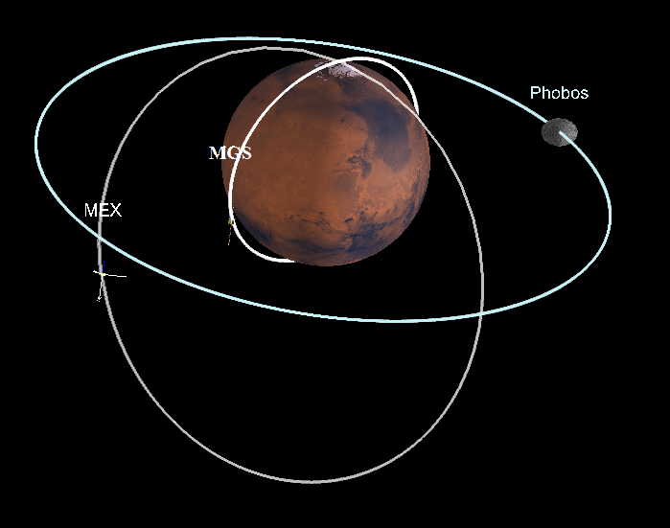

Figure 28. Orbit of MGS, MEX and Phobos on March 10, 2005 in the ($X_{MSO}$; $Y_{MSO}$) plane. Created with 3D view.

#### Instruments

The Mars Express orbiter payload is composed of 6 instruments, some of them reusing directly the designs used for the failed Russian mission **Mars 96**, and a radio-science experiment that requires no additional hardware. These instruments can be sorted in two categories: HRSC, OMEGA and MARSIS are observing the solid planet (surface and subsurface) whereas PFS, SPICAM and ASPERA are studying the atmosphere and the Martian environment. Their location on the spacecraft are showed in Figure 29.

- HRSC (High Resolution Stereo Camera): tThe main goal of the HRSC camera is to image the entire planet in full color with a high spatial resolution [*Neukum et al.,* 2004];

- OMEGA (Observatoire pour la Minéralogie, l’Eau, les Glaces et l’Activité): OMEGA is a visible and near-IR mapping spectrometer [*Bibring et al.*, 2004] which can cover the planet at medium resolution (1-5 km) at altitudes between 1000 km and 4000 km;

- MARSIS (Mars Advanced Radar for Subsurface and Ionosphere Sounding): MARSIS is a subsurface radar sounder and altimeter [*Picardi et al.,* 2004] which maps the sub-surface structures to depth of a few kilometers;

- PFS (Planetary Fourier Spectrometer): The PFS instrument is a double-pendulum infrared spectrometer [*Formisano et al.,* 2005] which covers the wavelength range of 1.2-5µm and 5-45µm with a spatial resolution of 10-20 km;

- SPICAM (Studying the Global Structure and Composition of the Martian Atmosphere): SPICAM is a UV and IR spectrometer complementary to the PFS instrument [*Bertaux et al.,* 2004];

- ASPERA (Analyser of Space Plasmas and Energetic Ions for Mars Express): The ASPERA instrument measures ions, electrons and energetic neutral atoms at different locations along the spacecraft’s orbit [*Barabash et al.,* 2004]. It will be described in more details in section 2.2.2;

- MaRS (Mars Radio Science): the MaRs experiment [*Pätzold et al.,* 2004] is performing radio sounding experiment of the neutral atmosphere and of the ionosphere to provide vertical density, pressure and temperature profiles but also insights into the internal gravity anomalies and the surface roughness.

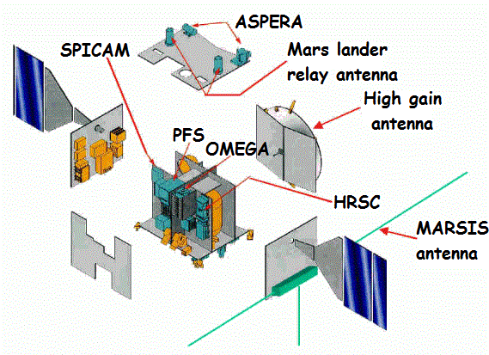

Figure 29. Exploded view of the MEX orbiter, revealing the arrangement of the scientific instruments.

#### Main discoveries

The MEX orbiter has provided for now more than twelve years of spectacular 3D pictures of the canyons, polar caps or impact crater like the one of the Gale crater in which Curiosity is currently working (Figure 30). The orbiter also carried out the mapping of Phobos with a high resolution, enables the determination of its mass and of its low density (1.86 $g.cm^{-3}$).

The OMEGA spectrometer detected for the first time hydrated minerals (phyllosilicate or hydrated sulfate) which proved that water was present on Mars’ surface for a period long enough for these minerals to be formed. OMEGA data also revealed the composition of the Southern polar cap: 85% of $CO_{2}$ ice and 15% of $H_{2}O$ ice. The HRCS camera showed that there is still volcanism on Mars and that the Olympus Mons and the Tharsis’ volcano were still in activity several million years ago.

In 2004, the FPS spectrometer may have detected the presence of methane in the atmosphere. As its lifetime is short (440 years), it would implies the presence of mechanisms creating methane on Mars. The SPICAM data allowed the discovery of localized polar aurorae, which are located over regions with strong crustal magnetic field. MEX also made the first direct observation of the formation of carbon dioxide clouds, and determines they are observed on average at an altitude of 80 km.

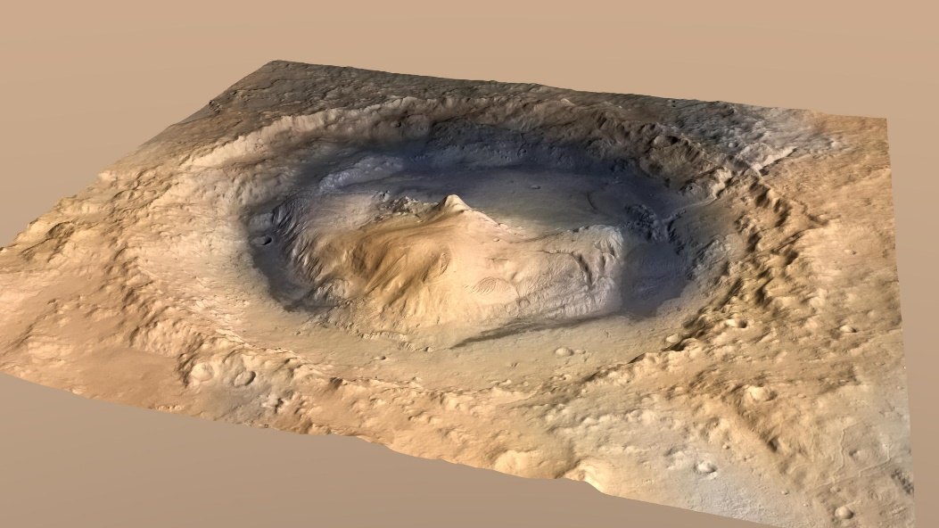

Figure 30. 3D picture of the Gale crater obtained with HRSC

Closer to the problematic of this PhD, the different spacecraft and lander which reached Mars before MAVEN made significate discoveries on the Martian plasma environment which allow the understanding we have today (section 1). Selected key results on the plasma environment made over nearly five decades are gathered in **Erreur ! Source du renvoi introuvable.**.

|  |  |  |
| --- | --- | --- |
| **Mission** | **Dates** | **Selected Key Results** |
| Mariner 4, 6, 7, 9 | 1965-1972 | * Detected bow shock and magnetosheath * First ionospheric density profiles |
| Mars 2, 3, 5 | 1971-1974 | * Measured bow shock, sheath, and inner magnetosphere |
| Viking 1, 2 | 1976 | * *In situ* ionospheric profiles (density, composition, temperature) |
| Phobos 2 | 1989 | * First sampling of central wake * Measured escaping ions |
| Mars Global Surveyor | 1997-2006 | * Discovered crustal fields * Sampled ionosphere down to / below main peak |
| Mars Odyssey & Mars Reconnaissance Orbiter | 2001-present | * Ionospheric density profiles |
| Mars Express | 2004-present | * Discovered localized aurora * Detected ionopause * Confirmed pressure balance near Mars |
| Rosetta | 2007 | * Distant bow shock crossing |

Table 2. Spacecraft missions to Mars that have provided measurements relevant for describing the plasma environment of Mars [Brain et al., 2014].

### MAVEN

The Mars Atmosphere and Volatile Evolution (MAVEN) mission is the latest mission sent by the United States to study the red planet. Contrary to the MGS and MEX missions, MAVEN took the bias to focus its study on the Martian upper atmosphere. It has been sent from Cape Canaveral Air Force Station (Florida, USA) on November 18, 2014.

#### Scientific objectives

Thanks to previous Martian missions such as MGS or MEX, strong observational evidences support the idea that significant escape of gas from the Martian atmosphere to space has occurred, nowadays and since the early history of the planet (section 1.2.2.2). The MAVEN spacecraft is designed to measure the structure, the composition and the variability of the Martian upper atmosphere and its interaction with the Sun and the solar wind, and the resulting loss of gas from the top of the atmosphere to space [*Jakosky et al.,* 2015]. Its main objectives are:

* Measuring the composition and structure of the upper atmosphere and ionosphere today, and determine the processes responsible for controlling them (dependence on geographical location, remnant magnetic field and external conditions). Extrapolating back in time to understand what the upper atmosphere would have looked like under the conditions in the early solar system history;
* Measuring the loss rate of gas from the top of the atmosphere to space, and determine the processes responsible for controlling them;
* Determining properties and characteristics that will allow us to extrapolate backwards in time to determine the integrated loss to space over the four-billion-year history recorded in the geological record.

#### Orbitography

After its launch in November 2013, the MAVEN spacecraft spent ten months in its interplanetary journey and finally reached Mars on September 21, 2014 (Figure 31). It was successfully inserted into a 35 hours elliptical orbit. The MOI was followed by a five weeks transition phase during which propulsive manoeuvers to get into the science mapping orbit have been operated, the science booms have been deployed and the instruments have been tested and calibrated. Once the science mapping orbit has been reached, the Science phase began on November 16, 2014.

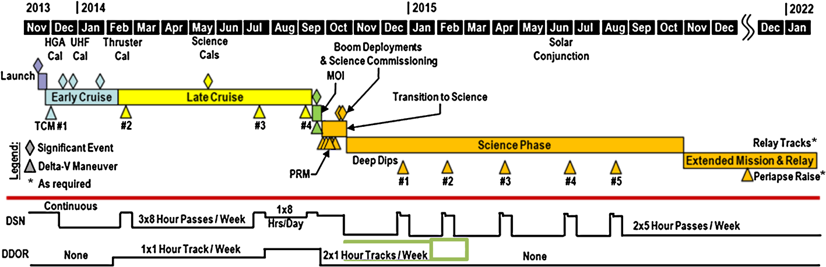

Figure 31. Overall timeline of MAVEN mission, from launch through end of primary mission and into a possible extended mission [Jakosky et al., 2015].

In order to fulfill the objectives of the mission, the spacecraft has been placed on a highly elliptical orbit, with a nominal periapsis at 150 km, and an apoapsis of 6220 km, which means a period of 4.5 hours. The periapsis is chosen on each orbit to be within the atmospheric density range of 0.05-0.15 $kg.km^{-3}$. Its altitude then varies around 150 km depending on the season, the location and the surface elevation. The periapsis is periodically lowered down to 125 km (density corridor 1.5-3.0 kg/km3) for five-day periods known as “deep-dips” [*Bougher et al.,* 2015]. This altitude, though higher than the one reach by MGS during its first aerobreaking phase, is in the vicinity of the homopause, which separates the upper atmosphere from the well-mixed lower atmosphere. “Deep-dips” are only operated on selected times to limit the drag on the spacecraft that could alter the orbit (as in the aerobreaking technique) and to minimize the risk of high-voltage arcing that could alter some of the instruments.

The orbital inclination of 75° has been chosen together with the apoapsis altitude and the orbital period to provide an appropriate precession rate of the orbit in both local time and latitude of the periapsis (Figure 32).

The primary mission lasted one Earth-year and the mission is now extended a second time through September 2018. At the end of its science phase, the MAVEN spacecraft will be able to act as a data relay for rovers or landers like Spirit, Opportunity and Curiosity, a relay to Mars Reconnaissance Orbiter and Mars Odyssey.

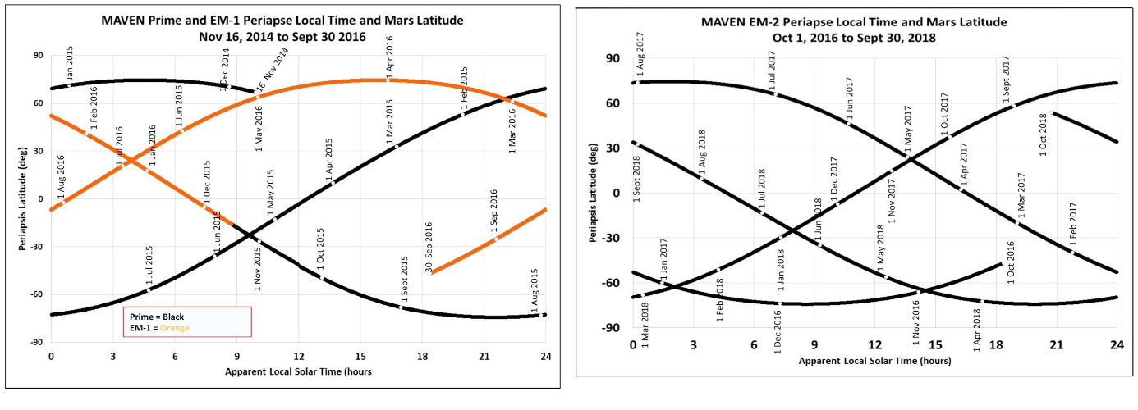

Figure 32. Precession of the MAVEN orbit for the primary mission and the first extension (left) and for the second extension (right). Location of the spacecraft at periapsis is shown as in geographical coordinates [Jakosky et al., 2016].

In Figure 33 is plotted the orbit of MAVEN and MEX on March 10, 2016 in the ($X_{MSO}$; $Y_{MSO}$) plane. The Sun is on the right side of the scene. The orbit of Phobos (circular at ~9300 km) has been superimposed to give a scale.

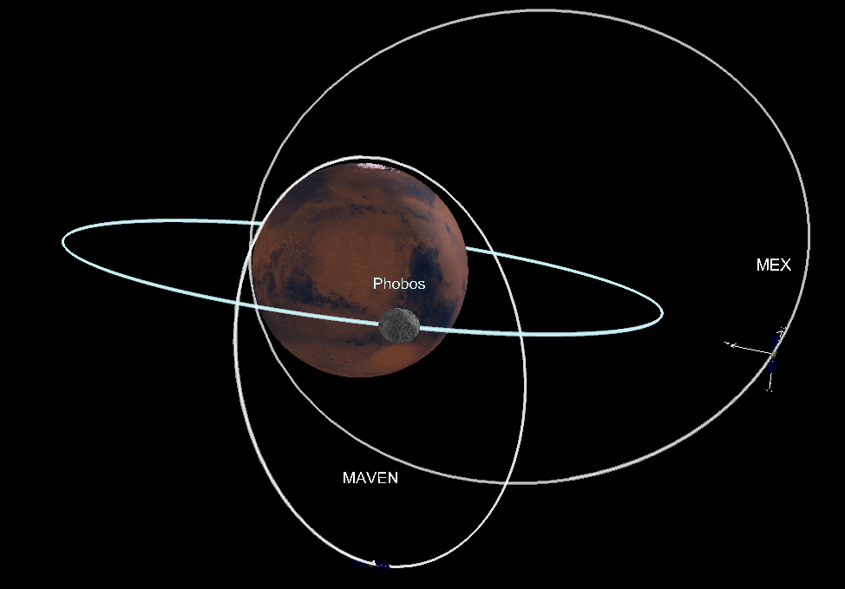

Figure 33. Orbit of MAVEN, MEX and Phobos on March 10, 2016 in the ($X_{MSO}$; $Y_{MSO}$) plane. Created with 3D view.

#### Instruments

The MAVEN spacecraft carries onboard a complete suite of plasma and field instruments, plus an ultraviolet spectrometer and a neutral spectrometer. Three instruments (NGIMS, IUVS and STATIC) are located on an Articulated Payload Platform (APP) which allows them to be oriented in space independently of the spacecraft orientation (Figure 34).

- SEP (Solar Energetic Particle): the SEP instrument [*Larson et al.*, 2015] measures the energy spectrum and angular distribution of solar energetic electrons (30 keV-1 MeV) and ions (30 keV-12 MeV);

- SWIA (Solar Wind Ion Analyzer): the SWIA experiment [*Halekas et al.,* 2013] measures the energy and angular distributions of solar wind and magnetosheath ions;

- STATIC (Supra-Thermal And Thermal Ion Composition analyzer): The STATIC instrument [*McFadden et al.*, 2015] measures the velocity distributions, the temperature and the mass composition of suprathermal and thermal ions. It will be described in more details in section 2.2.3.1;

- MAG (Magnetometer): MAG is a dual vector fluxgate magnetometer [*Connerney et al.*, 2015] which measures the intensity and direction of the magnetic field along the spacecraft orbit. It will be described in more details in section 2.2.3.2;

- SWEA (Solar Wind Electron Analyzer): the SWEA experiment [Mitchell et al., 2016] measured the energy and angular distributions of solar wind and magnetosheath electrons and ionospheric photoelectrons. It will be described in more details in section 2.2.3.3.

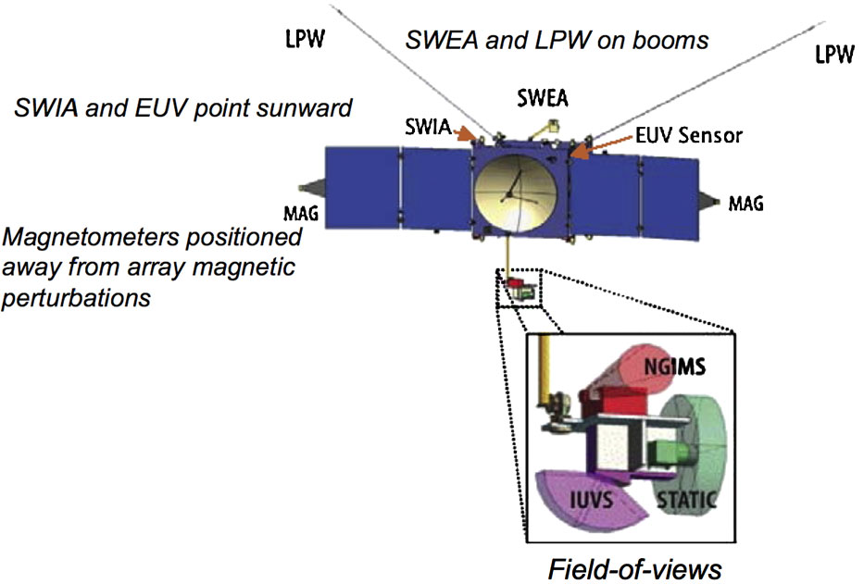

Figure 34. Instrument accommodation on the MAVEN spacecraft. It shows the locations of the science instruments on the body of the spacecraft and on the APP [Jakosky et al., 2015].

-LPW (Langmuir Probe and Waves): the LPW instruments [*Andersson et al.*, 2015] measures the electron density and temperature, and electric field waves in the Martian environment. It will be described in more details in section 2.2.3.4;

- EUV (Extreme Ultraviolet monitor): the EUV monitor [*Eparvier et al.*, 2015] provides additional measurements for determining the solar EUV input to the Mars atmosphere, from photodiode measurements and from the LPW photoelectron saturation current;

- IUVS (Imaging Ultraviolet Spectrometer): the IUVS experiment [*McClintock et al.,* 2014] is a remote-sensing instrument that measures UV spectra with four modes: limb scans near periapsis, planetary mapping, coronal mapping and stellar occultation;

- NGIMS (Neutral Gas and Ion Mass Spectrometer): the NGIMS experiment [*Mahaffy et al.,* 2014] makes in-situ measurements of the neutral composition, isotopic ratios and scale height temperature of the major gas species and thermal ions in the Martian upper atmosphere.

#### Main discoveries

/!\ to complete [ppt Rob]

Ion Plume

Polar ozone in the northern spring

Composition and structure of the ionosphere

Discovery of a metal-ion layer in the ionosphere

Discovery of dust surrounding mars

Diffuse aurora

Hydrogen distribution and escape

Escape rate

Deux papiers Science.

## Instrumentation

Data from three spacecraft have been analyzed during this PhD: MGS, MEX and MAVEN. This made it possible to take advantage of the different plasma instrument suite and of the different spatial and temporal coverage offered by the three missions. Each of the three spacecraft carried onboard its own specific suite of instruments. We here focus on several of their plasma instruments and detail their characteristics.

### Mars Global Surveyor

The MGS magnetic field experiment was composed of a dual system of triaxial fluxgate magnetometers (MAG) which measured the “in situ” ambient field, and of an electron reflectometer (ER) sensor [*Acuña et al.,* 1992] which determine the parameters of the local electron distribution function. MGS did not carry an ion spectrometer.

#### The magnetometer: MAG

MAG was able to detect ambient magnetic fields from $± 4 nT$ to $± 65 536 nT$. The use of two magnetometers allows a real-time estimation of the spacecraft-generated magnetic field and provide redundancy for the measurements of the in-situ magnetic field. The sensors are mounted remote from the spacecraft body at the end of the solar panels (~5m away from the spacecraft body). Magnetometer sensors are best accommodated far away from the body of the spacecraft, to minimize the relative contribution of spacecraft generated magnetic fields, taking much advantage of the $1/r^{3}$ diminution of a magnetic source with distance from the source.

An example of MAG measurement has been shown in Figure 9 and a comparison between MAG and ER measurements is proposed in Figure 36.

#### The Electron Reflectometer: ER

ER is a non-redundant hemispherical imaging electrostatic analyzer followed by a microchannel plate (MCP) and a resistive imaging anode. It has been developed by the Space Science Laboratory (Berkeley, USA) in collaboration with the Centre d’Etude Spatiale des Rayonnements (Toulouse, France). The analyzer is composed of two concentric hemispheres (Figure 35): the outer hemisphere is connected to the spacecraft ground, and the inner hemisphere potential is adjustable to deflect incoming electrons within a specified energy range onto the MCP. Each electron hitting the MCP produces a cloud of electrons, which hit the anode. The relative signal level at each end of the anode is measured to determine where the electronic cloud landed on the anode. As the analyzer focuses on a disk called the plane of the field of view (FOV), this information enables to trace back the position of the initial incoming electron (the operation of an electron spectrometer will be explained in more details in section 2.2.3.3).

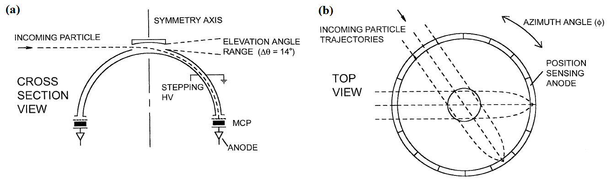

Figure 35. Schematic of the Electron Reflectometer showing the concentric hemispherical deflection plates, the microchannel plate (MCP) and the position-sensing resistive anode. Adapted from Mitchell et al. [2001].

The ER field of view is of 360° $×$ 14° and is divided into sixteen 22.5° $×$ 14° sectors. During a 2 to 48 seconds integration time, the analyzer images a slice of the electron distribution function that falls within the analyzer’s energy acceptance and FOV. The energy acceptance, divided into 30 logarithmically spaced energy channels ranging from 10 eV to 20 keV with an energy resolution of $\frac{δE}{E}=25\%$ (full width at half maximum), is selected by applying a deflection voltage to the inner hemisphere of the analyzer. All these characteristics are recorded in Table 3 so that they can be compared with those of MEX and MAVEN instruments.

Among all the energy channels available, the three channels which collected the majority of the flux were 90-148 eV, 148-245 eV and 245-400 eV.

In Figure 36 are plotted the electron spectrogram measured by ER (panel 1) and the magnitude of the magnetic field recorded by MAG (panel 2) on MGS on a specific orbit [adapted from *Acuña et al.,* 1998]. The different boundaries detailed in section 1.3.1 are highlighted by vertical lines. Contrary to what can be observed in Figure 16 with MAVEN, we can see that the absence of data for electrons with energies below 10 eV make it more difficult to set the different boundaries.

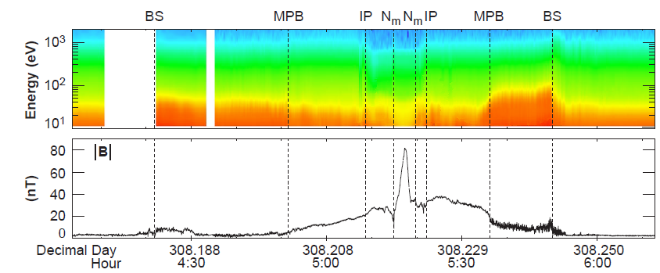

Figure 36. Electron and magnetic field observed by MGS. Panel 1: Electron fluxes (in units of $cm^{-2}s^{-1}sr^{-1}eV^{-1}$) measured by ER are shown as a color spectrogram. Panel 2: Magnetic field amplitude measured by MAG. Vertical lines indicate the position of the bow shock (BS), of the MPB, of the ionopause (IP), and of the ionospheric main peak ($N_{m}$). Adapted from [Acuña et al., 1998].

### Mars Express

The ASPERA-3 experiment is composed of four instruments including the Electron Spectrometer (ELS) and the Ion Mass Analyzer (IMA) [*Barabash et al.,* 2004]. Three instruments, among which ELS, are mounted on a scanning platform, providing a full $4π$ coverage. IMA is technically a separated unit, connected by a cable to the ASPERA-3 main unit (Figure 37). Mars Express does however not carry a magnetometer.

#### Electron Reflectometer: ELS

The ELS instrument is an electron sensor of a very compact design (only 300g compared to 2.2 kg for IMA). It is composed of a standard spherical top-hat electrostatic analyzer and a collimator system. It uses the same mechanisms as ER to image the electron distribution. During a 4 second integration time (maximum time resolution), the instrument can measure the electron fluxes in the energy range 0.001 – 20 keV/q in 128 logarithmically-spaced energy channels with an energy resolution of $\frac{δE}{E}=8\%$ (which is the best energy resolution among the electron spectrometers of the three spacecraft). ELS has a field of view of 360° $×$ 10° divided into sixteen sectors of 22.5° $×$ 10°, corresponding to the sixteen anodes placed behind the MCP. As ELS is mounted on the scanning platform, the full $4π$ angular distribution of electrons is measured during each platform scan with a selectable scan time of 32, 64 or 128s. The characteristics of ELS are gathered in Table 3.

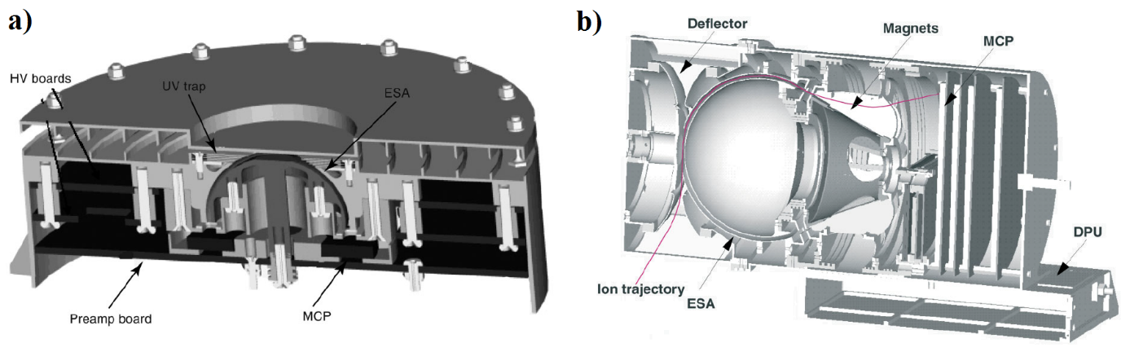

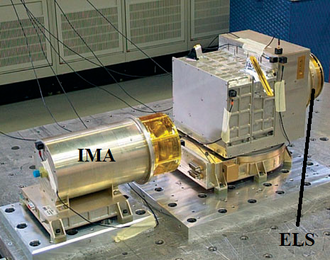

Figure 37. a) The MEX/ELS sensor b) Cross section of the IMA sensor c) The ASPERA-3 mechanical model during vibration testing [adapted from Barabash et al., 2004].

In general, ELS has been operated in four different modes (*Frahm et al.*, [2006] and *Hall et al.*, [2016]):

- Default/Survey mode: Full energy range across 128 log-spaced energy steps with a four second cadence;

- Linear mode: Reduced energy range of 1 - 127 eV across 128 linearly spaced energy steps, also with a four second cadence;

-1s mode: Reduced energy range of 10 - 160 eV across 32 log-spaced energy steps with a one second cadence;

- 32 Hz mode: single energy channel (variable energy), with a cadence of 32 Hz.

The default mode is the most commonly used, operating more than 96% of the time from 2004 to 2014. The linear mode is utilized about once a month and the 32 Hz mode is rarely used. The 1s mode is sporadically used, but when operated, it lasts for several orbits. Over the course of the spacecraft in the induced magnetosphere, there is no change of mode within the same orbit. Regarding the use of the different modes, we will only use in the following analysis data recorded in the Default/Survey mode.

Another specificity of ELS, compared to the other two missions, is that it only records data during one portion of the orbit, this portion varying all along the mission. It is usually centered on the periapsis.

#### The ion spectrometer: IMA

IMA is an ion mass composition sensor. Particles enter the instrument through the outer grid. A deflection system is located behind the grid to divert particles coming from between 45° and 135° with respect to the symmetry axis into the electrostatic analyzer (ESA). Ions which are within a swept energy pass band pass the ESA. They are then deflected in a cylindrical magnetic field set up by permanent magnets. The field deflects lighter ions more than heavy ions away from the center of the analyzer. The ions finally hit an MCP and are detected by an anode system. Ions are simultaneously analyzed for direction and mass per charge. The mass range and mass resolution can be chosen by modifying the magnet assembly. A system of 32 concentric rings behind the MCP measures the radial impact position (representing the ion mass) and 16 sector anodes measure the azimuthal impact position (representing ion entrance angle).

IMA has a field of view of $360° ×90°$. Electrostatic sweeping performs elevation coverage ($±45°$). It can provide 3D ion fluxes in the energy range 0.01-30 keV/q, with an energy resolution o*f $\frac{δE}{E}=7\%$*  , for the main ion components: $H^{+}$, $He^{++}$, $He^{+}$, $O^{+}$, and for the group of molecular ions: 20-80 amu/q. Its time resolution for full 3D is 32s. The characteristics of IMA are gathered on Table 3.

In Figure 38 is plotted data recorded by ELS (panel 1) and IMA (panel 2) at a MEX periapsis on July 7, 2007. Superimposed with the electron spectrogram is the amplitude of the magnetic field determined by the MARSIS instrument. Among MGS, MEX and MAVEN, ELS is the electron spectrometer which have the best energy resolution and hence we clearly see the photoelectron lines at ~20 eV between ~00:15 UT and ~00:22UT. The measurement of IMA allow to distinguish the two different ion populations present in the Martian environment: the planetary one, close to the planet, with low energy (~20 eV); and the solar wind ion population, farther from the planet and with higher energies. At the MPB, around 00:30 UT, the two populations are mixed.

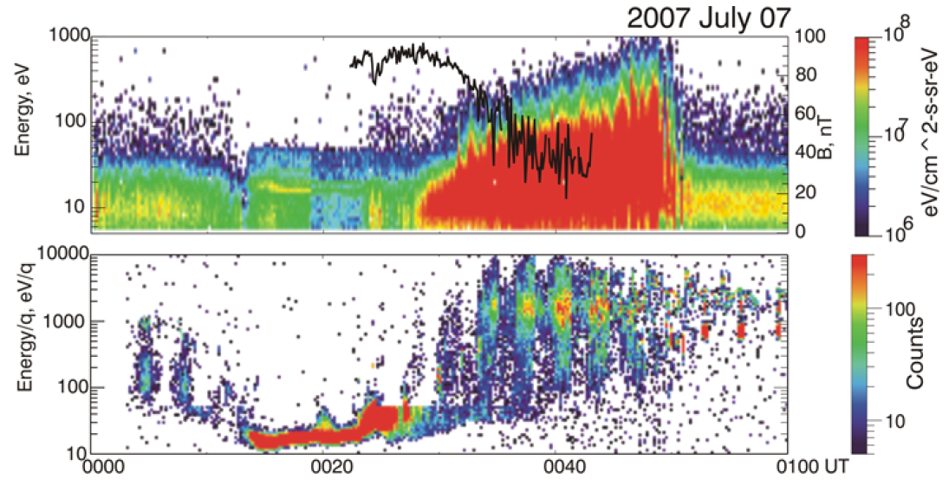

Figure 38. Panel 1: Energy-time spectrogram of the electron fluxes with the superimposed curve of the magnetic field value determined by MARSIS. Panel 2: Energy-time spectrogram of the ion fluxes. Adapted from Dubinin et al. [2008b].

### MAVEN

The MAVEN particles and fields package is composed of seven instruments, including an ion spectrometer (STATIC), an electron spectrometer (SWEA), a Langmuir probe (LPW) and two magnetometers (MAG), presented in Figure 39.

#### The ion spectrometer: STATIC

The STATIC instrument consists of a toroidal “top hat” electrostatic analyzer with a nominal 360° $×$ 6° field of view, followed by a time-of-flight velocity analyzer with 22.5° resolution in the detection plane. The energy analyzer also includes electrostatic deflectors at the entrance which expand the nominal FOV to 360° $×$ 90°. The instrument is designed to resolve ion energy per charge (E/q), direction and velocity per charge. Knowing the charge state of the ions (nearly all ions at Mars are singly charged except solar wind alphas), these measurements lead to the velocity distributions and mass composition of suprathermal and thermal ions over an energy range of 0.1 eV to 30 keV with an energy resolution of $\frac{δE}{E}=16\%$ and a base time resolution of 4 seconds [*McFadden et al.*, 2015]. It is able to resolve major ions: $H^{+},He^{++},He^{+},O^{+},O_{2}^{+}$ and $CO_{2}^{+}$. STATIC is mounted on the APP to orient differently its FOV according to the position of the spacecraft on its orbit. The characteristics of STATIC are gathered in Table 3.

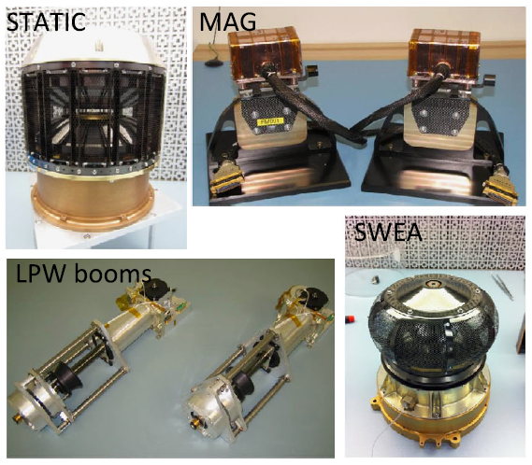

Figure 39. MAVEN science instruments used in this PhD. Adapted from Jakosky et al. [2015].

STATIC is operated in several different modes, depending on the region or phenomenon of interest. These modes mainly differ on the time resolution, the number of energy and mass channels used, the integration on the deflectors and/or anodes sectors. We here only use two of them: C0 (time resolution of 4s, omnidirectional, 64 energy channels, 2 mass channels) for the time-energy spectrograms and C6 (time resolution of 4s, omnidirectional, 32 energy channels, 64 mass channels) for the time-mass spectrograms.

In Figure 40 is plotted an example of energy-mass spectrogram of the omnidirectional ion energy flux, measured with STATIC at a specific time in the nightside. We can observe four ion species: $H^{+}$ (1 amu/q), $He^{++}$ (2 amu/q), $O^{+}$ (16 amu/q), and $0_{2}^{+}$ (32 amu/q), with their main energy peak at ~10 eV. The $H^{+}$ energy spreads toward thousands of eV.

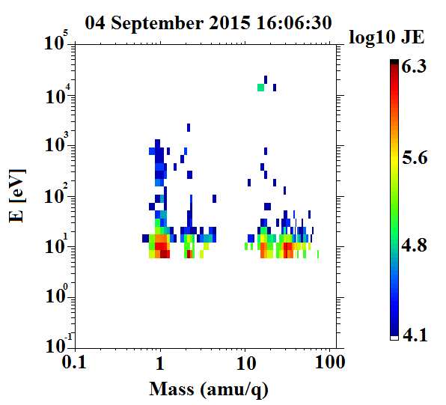

Figure 40. STATIC energy-mass spectrogram of omnidirectional ion energy flux (C6 mode) at a specific time in the nightside ionosphere.

The SWIA instrument is less relevant for our study as its measurements are restricted to high energies, which typically corresponds to the magnetosheath and the solar wind. Moreover, SWIA cannot separated the different ion species.

#### The Magnetometer: MAG

MAG consists of two identical independent triaxial fluxgate magnetometer sensors which can measure the magnitude and direction of the ambient magnetic field from $±$ 0.06 to $±$ 65 536 nT [*Connerney et al.,* 2015] with a resolution of 0.008 nT in the most sensitive dynamic range and an accuracy of better than 0.05%. Both magnetometers sample the ambient magnetic field at an intrinsic sample rate of 32 samples/sec. The two sensors are mounted on the ends of the solar arrays on small extensions (0.66m in length), placing them approximately at 5.6m from the center of the spacecraft body. The characteristics of MAG are gathered in Table 3.

A spacecraft magnetic control program was implemented to provide a magnetically clean environment for the magnetic sensors and occasional spacecraft maneuvers have been planned to characterize spacecraft fields and/or instrument offsets in flight.

In Figure 41 is plotted the projection of the magnetic field as measured by MAG along the MAVEN orbit onto two periapsis pass in the Southern hemisphere. We can clearly observe the enhancement of the magnitude and the rotation of the magnetic field as the spacecraft travels above crustal magnetic field sources.

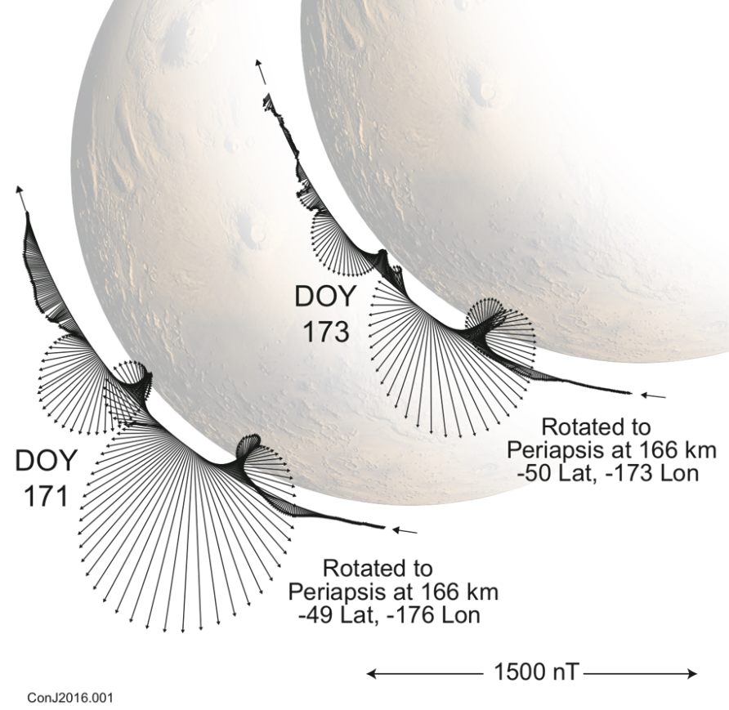

Figure 41. A projection of the MAVEN spacecraft trajectory and observed magnetic field onto a plane perpendicular to the Mars orbit plane and the Mars-Sun line for two specific periapsis (presented by J. E. P. Connerney at a MAVEN meeting).

#### The Electron spectrometer: SWEA

As ER on MGS and ELS on MEX, SWEA is a symmetric, hemispheric electrostatic analyzer with deflectors [*Mitchell et al.*, 2016]. It is designed to measure the energy and angular distributions of both solar wind electrons (core and halo populations) and ionospheric photoelectrons in the Martian environment, but also magnetosheath shock-energized electrons, tail lobe and auroral electrons. The instrument is a collaboration between the Space Sciences Laboratory at the University of California, Berkeley (UCB-SSL) and the Institut de Recherche en Astrophysique et Planétologie (IRAP) in Toulouse, France. The SWEA design is closely based on an instrument sharing the same name currently operating on the STEREO spacecraft [*Sauvaud et al.*, 2008]. For MAVEN, IRAP provided the analyzer and front-end electronics (MCP, anode, preamplifiers and high voltage power supply), while UCB-SSL provided the low voltage power supply and digital electronics.

To fulfil its objectives and measure the energy and angular distributions of solar wind electrons, auroral electrons and ionospheric primary photoelectrons (Figure 17), the energy range chosen is 3 to 4600 eV. The instrument works by measuring the electron flux in consecutive given energy ranges. The pooling of all these measurements gives the distribution function of the electrons.

SWEA is roughly composed of two deflectors, followed by two concentric hemispheres leading to the electron detector (MCPs + anodes), as shown in Figure 42. SWEA selects electrons within a specified energy range by placing a potential difference, $∆V_{A}$, between the two concentric hemispheres. Electrons within this energy range are transmitted through the hemispheres to the exit grid to be counted, while those outside the range impact the walls and are scattered and absorbed. The center energy of transmitted electrons is proportional to $∆V_{A}$ through the following expression:

$$E_{0}=\frac{R_{0}}{2d}q∆V_{A}$$

Where $R_{0}$ is the average radius of the two concentric hemispheres and d the distance between these two hemispheres. An energy spectrum is obtained by sweeping $∆V_{A}$ from 750 to 0.5 eV, which correspond – given the geometry of the instrument – to an energy range of 4600 to 3 eV. The energy resolution of SWEA is $\frac{δE}{E}=17\%$. The different characteristics of SWEA are gathered in Table 3.

As only a small fraction of scattered electrons reach the exit grid, they are accelerated by a 300-V potential onto a pair of MCPs mounted head to tail so as to maximize the amplification. The signal is amplified through this process by a factor of $\sim {10}^{6}$. The resulting electron cloud lands on a charge collecting anode that is segmented into 16 equal sized sectors. An incident parallel electron beam is focused by the hemispheres to a point on the anode providing a 22.5° azimuth resolution.

The field of view of the concentric hemispheres is 360° $×$ 7°. As MAVEN is not a spinning spacecraft but a three-axis stabilized spacecraft, it uses the deflectors to sweep the field of view above and below the aperture center plane. Electrons with a trajectory forming an angle up to $θ$ with $X_{SWEA}$ can then be selected (Figure 42). Deflection is achieved by placing a potential on either the upper or lower deflector, which bends the electron trajectories through an angle before reaching the aperture center plane and entering the hemispheres. The analyzer geometry limits the maximum deflection range to $±60°$. This full deflection is achieved up to an energy of 2 keV, resulting in an overall FOV of 360° $×$ 120°, which represents 87% of the sky. At higher energies, the deflection range decreases with energy, reaching $±26°$ at 4.6 keV.

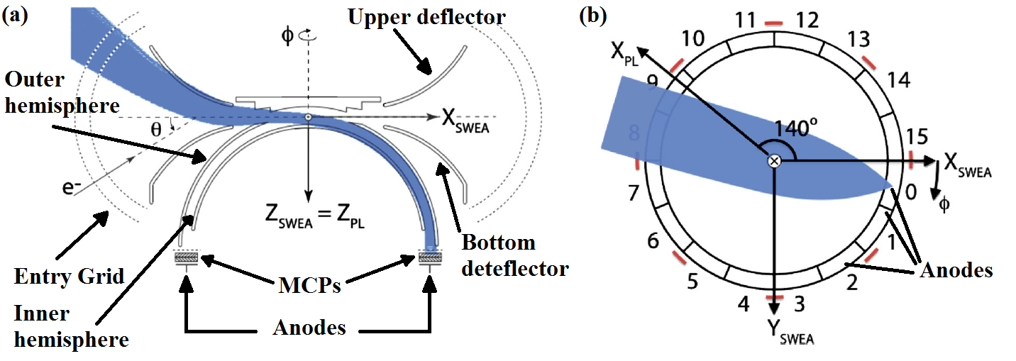

Figure 42. Left: Cross-sectional view of SWEA, defining the instrument frame regarding the payload (PL) frame. Right: Top view of the anodes. Simulated electron trajectories (blue) are shown for a deflection of $θ=-45°$.

Adapted from [Mitchell et al., 2016].

The instrument is mounted at the end of a 1.5-meter boom, at which distance the spacecraft blocks 8% of the instrument’s FOV. Its final field of view is then 360° $×$ 120°. It spans 80% of the sky with $\sim 20°$ resolution. The position of SWEA regarding the spacecraft as well as the two different FOV depending on the energy are presented in Figure 43. SWEA has a 2-second measurements cadence which confers it a spatial resolution of 8 km. The instrument takes data over the first 1.95 seconds, as the analyzer and deflectors voltages are commanded to discrete values. This is followed by a 0.05 seconds “gap”, during which the instrument does not take data as the voltages reset and settle in preparation for the next measurement. In parallel with these measurements, SWEA calculates three different data products (see *Mitchell et al.* [2016] for full description):

* 3D: low cadence of 32, 16 or 8 seconds depending on the altitude, 64 energy channels, 16 azimuths/anode bins and 6 elevations/deflections bins;
* PAD: cadence of 2 or 4 seconds, average of the 3D products on the 6 elevation bins;
* SPEC: cadence of 2 or 4 seconds, average of the 3D products over the 96 azimuth-elevation bins.

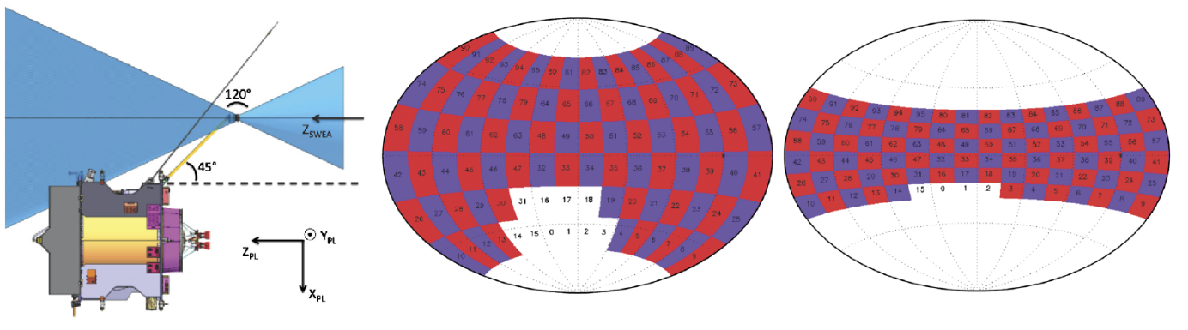

Figure 43. Left: SWEA is on the end of a 1.5-meter boom, with its symmetry axis ($Z_{SWEA}$) aligned with the spacecraft Z axis ($Z_{PL}$). SWEA has a FOV (blue shading indicates the instruments blind spots). Middle: SWEA’s field of view at all energies below 2 keV, mapped in SWEA coordinates over the full sky with an Aitoff projection. The FOV is subdivided into 96 angular bins (16 azimuths 6 deflections). SWEA’s blind spots are two oppositely directed cones. Ten of the angular bin, shown in white, are blocked by the spacecraft. Right: SWEA’s field of view at an energy of 4.6 keV. At this energy, four angular bins are blocked by the spacecraft. Adapted from [Mitchell et al., 2016].



#### The Langmuir probe: LPW

LPW consists of two identical cylindrical sensors, 40 cm long, each located at the end of a 7-meter boom. It is designed to measure the temperature and density of thermal ionospheric electrons, and to measure spectral power density of waves in Mars’ ionosphere [*Andersson et al.,* 2015]. The LPW instrument is optimized to measure $n_{e}$ in a range covering $\sim 100 cm^{-3}$ to ${10}^{6}cm^{-3}$, $T_{e}$ in the broad range of 500-50 000 K. The goal of the instrument is to have an altitude resolution better than 2 km, which is met with a time resolution of 4 seconds.

The technique used for LPW consists in measuring the current from the plasma to a voltage-biased probe over a range of probe voltages, creating a current-voltage (I-V) characteristic. The I-V characteristics are fitted so as to determine the electron density and temperature, the ion density, the spacecraft potential and properties of photoelectrons.

In Figure 44 is plotted the electron spectrogram measured by SWEA on the first panel, and the electron density measured by SWEA (in **black**) and by LPW (in **red**) on the second panel for a MAVEN pass in the ionosphere. The dayside ionosphere can be observed until ~23:43 UT, before the spacecraft enters the nightside ionosphere, where we can observe several electron depletions. Note that during this time interval the quality flag of the LPW density and of the spacecraft potential used for the calculation of the density from SWEA data is always greater than 50, which means that these data are reliable.

Due to instrumental limits the density calculated with SWEA data is restricted to electrons with energies greater than 3 eV (see Table 3), whereas the density calculated with LPW includes lower-energy electrons, which explains the difference observed between the two densities (especially here in the ionosphere where the plasma is essentially cold). The characteristic drop in the suprathermal electron flux is very clear in the SWEA density during the electron depletion, whereas there is no drop in LPW density, i.e., in thermal electron density.

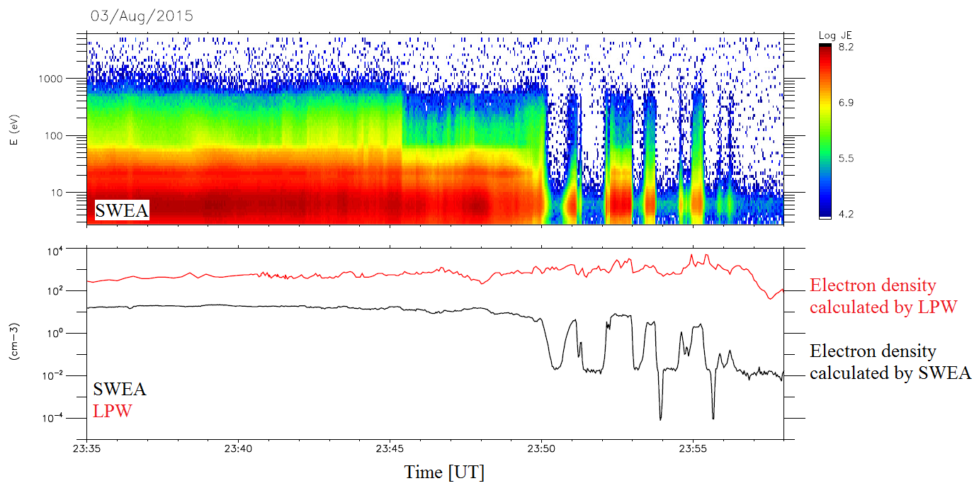

Figure 44. Comparison of LPW and SWEA densities. Panel 1: SWEA time-energy spectrogram of omnidirectional electron energy flux. Panel 2: Electron density calculated with SWEA (**black**) superimposed with the density calculated with LPW (**red**).

In Table 3 are gathered the different characteristics of the MGS, MEX and MAVEN instruments that have been used during this PhD, so that they can be easily compared.

|  |  |  |  |  |
| --- | --- | --- | --- | --- |
| **Instrument Type** | **Quantity** | **MGS** | **MEX** | **MAVEN** |
| **Magnetometer** | Magnitude range | 4 – 65536 nT | none | 0.06 - 65536 nT |
| **Electron spectrometer** | Energy range | 10 – 20000 eV | 1 – 20000 eV | 3 – 4600 eV |
| Energy resolution | 25% | 8% | 17% |
| **Ion spectrometer** | Energy range | none | 10-30000 eV/q | 0.1-30000 eV/q |
| Energy resolution | 7% | 16% |
| Mass range | 1, 2, 4, 8, 16 and >20 m/q | $$H^{+}, He^{++}, He^{+}, O^{+},$$ $$O_{2}^{+} and CO_{2}^{+}$$ |
| **Langmuir probe** | Temperature | none | none | 0.05 to 5 eV |

Table 3. Summary of the characteristics of the magnetometer, electron spectrometer, ion spectrometer and Langmuir probe onboard MGS, MEX and MAVEN.

### Contamination

The measurements made by the different instruments are subject to several sources of contamination, which degrade the data. For the study of electron depletions, the contamination on electron spectrometer is the more significant so that it will be the only kind of contamination discussed in this section.

**Background**

In Figure 45 is plotted the electron energy spectrum corresponding to the background of ER [*Mitchell et al.*, 2001]. This background can come from a variety of sources. First, outgassing of the different materials with which the detectors are made. After the cruising phase of the spacecraft, the outgassing background normally reached a negligible level. The radioactive decay of ${}_{ }^{40}K$ in the MCP glass is expected to produce a constant background of a few counts per second over the entire detector [*Mitchell et al.*, 2015].

Another source of background are penetrating particles [*Delory et al.*, 2012]. They can come from galactic cosmic rays and solar energetic particles (SEP). Protons with energies greater than ~20-40 MeV can penetrate the instrument housing and internal walls and finally generate counts. Galactic cosmic rays are expected to generate several counts per second integrated over the entire detector. This value can be modified in function of the solar cycle or the position of the spacecraft regarding the planet. SEP fluxes are episodic and vary widely in intensity, but large events can increase the background by orders of magnitude for several days.

The instrument background is specific to each instrument. Hence, it is different for ER, ELS and SWEA.

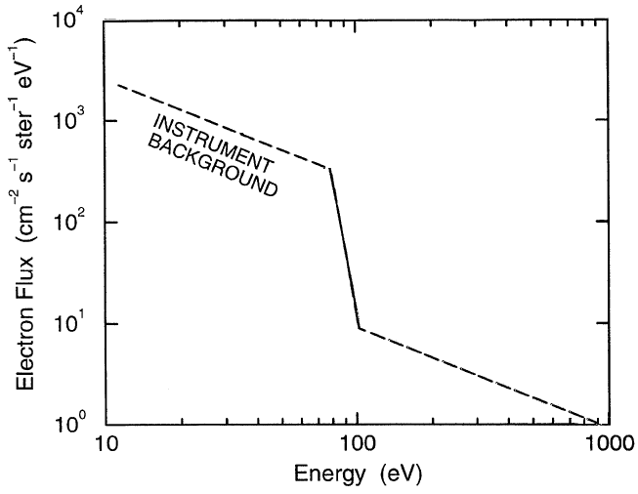

Figure 45. Electron energy spectra corresponding to the instrument background. Adapted from Mitchell et al. [2001].

**Spacecraft potential**

The plasma instrument energy scale is referenced to the spacecraft ground. All objects in a space plasma acquire a net electrical potential such that the total plasma current to the object sums to zero. This spacecraft potential can vary regarding the location of the spacecraft in the plasma environment and the illumination pattern of the spacecraft. The spacecraft potential affects plasma measurements by shifting the energies of incoming ions and electrons, bending the trajectories of low energy and low mass charged particles, and repelling charged particles with energies at or below the potential. The reliability of these instruments are thus relatively poor at low energies [*Mitchell et al.,* 2001].

In sunlight, the spacecraft potential typically floats a few volts positive relative to the plasma in which the spacecraft is immersed, due to the loss of photoelectrons from the spacecraft surface. Spacecraft photoelectrons with energies below the potential are attracted back to the spacecraft, while the other ones escape. Ambient electrons entering the electron spectrometer are accelerated by the spacecraft potential upstream the instrument: all energies are shifted upward by a few eV. Hence, electron spectrometers measure spacecraft photoelectrons at energies below the spacecraft potential and the ambient electrons for energies above the potential. The boundary between the two populations is often marked by a sharp change of slope in the energy spectrum at the spacecraft potential. This signature was observed on the solar wind spectrum in Figure 17. The spacecraft photoelectrons population corresponds to the peak observed near ~7 eV and the spacecraft potential in this case is ~8V. It can also be observed in the magnetosheath spectra at ~5V. In Figure 15, these photoelectrons coming from the spacecraft are clearly detected in the solar wind. They correspond to the dark orange color, below 10 eV.

When the spacecraft charge is negative, as in the nightside ionosphere, part of the electron distribution is repelled by the spacecraft or shifted to low energies not sample by the electron spectrometers.

In the solar wind and the magnetosheath, the spacecraft potential can easily be determined with an electron spectrometer, thanks to spacecraft photoelectrons. At high plasma densities, and hence low altitudes, the spacecraft potential is well derived from a Langmuir probe like LPW. In the ionosphere, the potential can be derived from ion spectrometer, using the difference between the measured energy and the expected ram energy from the spacecraft motion (see section 3.2.2 for more details on the ram energy).

**Secondary electrons**

In some configurations of the spacecraft, sunlight can enter the aperture of the instrument and scatter inside the instrument, creating secondary electrons. Some fraction of these electrons scatter down to the anode and generate a pulse of spurious count. This sunlight pulse appears at all energies but is most noticeable from 10 to 80 eV and above 1 keV [*Mitchell et al.,* 2001]. UV photons can also enter the aperture, scatter and produce photoelectrons from interior surfaces. The counts produce by such photoelectrons are usually few but can increase the total background by a factor of two under specific conditions.

Contamination by secondary electrons is usually suppressed by scalloping the inner and outer hemispheres.

## Data coverage

So as to obtain a global view of the suprathermal electron depletions, we choose to take advantage of the different characteristics of the three missions described above. This will enable an observation from different points of view.

MGS data are used from 1999 to 2006 in order to take advantage of the mapping circular orbit at a roughly constant altitude (~400 km) of the spacecraft, allowing observations of the phenomenon every 2 h over the whole range of possible latitudes [-90°, 90°]. This seven years of data enable a coverage of the whole Martian surface on a restricted range of altitude [368 km;438 km] and at a local of 02:00pm.

MEX data are used from 2004 to 2014, which gives us an unparalleled long-term view of the phenomenon at both relatively low (down to ~250 km) and high altitudes. This time interval enable a coverage of the whole surface except the poles ([-86°;86°]) at all this altitudes and at all the local time in the nightside.

Finally, MAVEN data are used from October 2014 to March 2017. During this time period the spacecraft covered both hemispheres except the poles, but due to this short duration and MAVEN orbital parameters, all latitudes are not yet covered at all possible altitudes. Even though the coverage and duration of this data set are much lower than those of MGS and MEX, MAVEN reached during this time period altitudes down to ~125 km, which are unsampled by MGS nor MEX.

This huge data set gathering observations made over 18 years by different instruments reaching different altitude regimes enables us to compare events observed in similar conditions (several spacecraft in the same region) and enrich this joint vision with new observations closer to the surface (with MAVEN). Due to the large time interval under study for MGS and MEX, these two datasets are only used to show the global properties of suprathermal electron depletions in the following studies. MAVEN data, on the other hand, which are only available for two years and a half until now, will be used to study the structure in more details.

The different characteristics of the three datasets used are gathered in Table 4.

|  |  |  |  |
| --- | --- | --- | --- |
|  | **MGS** | **MEX** | **MAVEN** |
| **Periapsis [km]** | 368 | 245-365 | 125-150 |
| **Apoapsis [km]** | 438 | ~10 000 | 6 200 |
| **Period [h]** | 2 | 6.75 | 4.5 |
| **Inclination [°]** | 93 | 86 | 74 |
| **Precession** | Locked at 02am/02pm | yes | yes |
| **Duration studied** | 1999-2006 | 2004-2014 | 2014-2017 |

Table 4. Characteristics of the three dataset used.

[plot of the cylindrical coverage of the three missions?]

In Figure 46 is plotted the solar cycle in function of the number of the sunspot counted at the surface of the Sun between 1995 and 2017. Superimposed are the duration of the MGS mission (blue dashed lines), the MEX mission (green dashed lines) and the MAVEN mission (purple dashed lines).

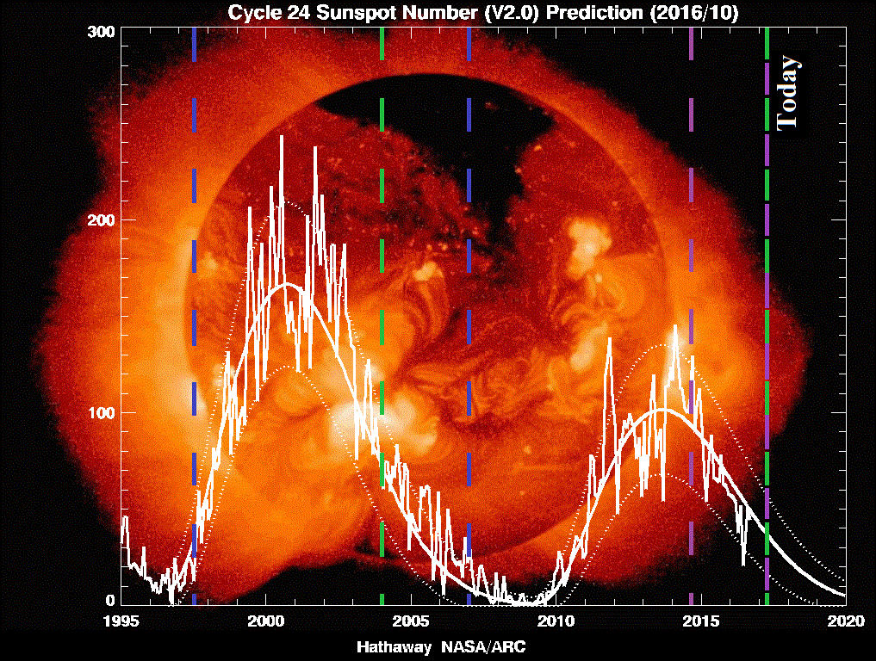

Figure 46. Solar cycle between 1995 and 2017 as observed by the number of sunspots observed on the Sun. The duration of the MGS, MEX and MAVEN missions are delineated by the blue, green and purple dashed lines, respectively.

## Analysis tools

Throughout my PhD I was led to work with different tools provided by the Virtual Observatories in planetary sciences in Europe. I have used intensively three of them: AMDA, 3DView and CL, in close interaction with the developing team so as to participate to its evolution.

### AMDA and 3D view

**AMDA** (Automated Multi-Dataset Analysis) and **3DView** are currently developed by the CDPP (Centre de Données de la Physique des Plasmas,  [www.cdpp.eu](http://www.cdpp.eu/)) within IRAP. The CDPP is the French national center for space physics data. It was jointly created by CNES (Centre National D’Etudes Spatiales) and CNRS (Centre National de la Recherche Scientifique) in 1998.

AMDA (<http://amda.cdpp.eu/>) is a web-based facility for on-line analysis of space physics data coming from its own database or from the user one [*Jacquey et al.,* 2010; *Génot et al.*, 2010], developed since 2006. On line classical manipulations can be performed by the user, such as visualization, parameter computation or data extraction. The user only manipulates parameters (density, magnetic field…) on AMDA, no more data files. The different parameters are associated with properties (scalar, vector, tensor, units …) and with corresponding options (frame of references…). AMDA also offers innovative functionalities, such as event search on data, in either visual or automated way, and the generation, use and management of time-tables (which are basically a collection of time intervals). User-edited automatic research will be developed in more details in section 3.3.

MGS, MEX and MAVEN data are all available on AMDA. MGS data are taken from the PDS (Planetary Data System, <https://ppi.pds.nasa.gov/> ) and are available from 1997/09/14 to 2006/10/11. MAVEN data are also taken from the PDS, which means that they have been treated upstream by the instrument team and that they are available ~3 months after their acquisition. MEX data are treated internally at IRAP and are available shortly after their acquisition.

The 3DView tool (<http://3dview.cdpp.eu/>) provides immersive visualizations and is further developed to include simulation and observational data [*Génot et al.*, 2017]. The user is able to manipulate scenes of 3D orbit visualization. All celestial objects from the Solar System are included together most of scientific spacecraft. In Figure 28 and Figure 33 are two examples of the use of 3D view. See [*Génot et al.*, 2014] for more information about the different tools developed by the CDPP.

### CL

The CL software is currently developed by E. Penou at IRAP: <http://clweb.irap.omp.eu/>. It has been originally created for the Cluster project in 2000. The CL software can plot orbit data, as well as spectrograms as in Figure 16, Figure 17 or Figure 40. Some functionalities have been added to CL following this PhD, such as the possibility to plot superimposed energy-flux spectrograms on a specific time period, as it will be shown in section 3.2.2.

MAVEN raw data are directly treated by CL, so that they are available a few days after their acquisition by the spacecraft. The SWEA moments (density, velocity, heat flux, pressure...) are also calculated through CL, independently from the American team.

## Frames

Two dynamic reference frames are used in this manuscript: the **Mars-centric Solar Orbital** (MSO) and the $IAU_{Mars}$. After setting their definitions in section 2.5.1 and 2.5.2, we will discuss the definition of the altitude (section 2.5.3) and of the nightside (section 2.5.4) used throughout this PhD.

### The Mars-centric Solar Orbital (MSO) frame

The MSO coordinates are defined as follows: the origin is the center of Mars, the X axis points from the center of Mars to the Sun, Y points opposite to Mars’ orbital angular velocity and Z completes the right-handed set so that the frame rotates slowly as Mars orbits the Sun. All the ephemerides used in this manuscript are expressed in the MSO coordinates.

### The $IAU_{Mars}$ frame

The $IAU_{Mars}$ frame is defined with respect to the Martian latitude and longitude. The zero longitude is defined by a small crater of 0.5m diameter called “Airy-0”. The setting of the (longitude; latitude) coordinate system regarding the relief can be observed in Figure 10. Only the positive East longitude convention is used in this manuscript.

The $IAU_{Mars}$ coordinates are defined as follows: the origin is the center of Mars, the X axis points from the center of Mars to 0° East longitude, 0° Latitude, Y points from the center of Mars to +90° East Longitude, 0° Latitude and Z completes the right-handed set (+90° Latitude = rotation axis = north pole). The frame therefore rotates with the solid body.

From the $IAU_{Mars}$ coordinates can be defined a planetocentric spherical coordinate system: the radial component $r$ which points outward the planet, the azimuthal component $θ$ and the zenithal component $φ$ which are parallel to the surface of the planet. This system is mainly used for the magnetic field.

### Definition of the altitude

The altitude is the distance from a point to a reference surface. There are different reference surfaces, so there are different definitions of altitude.

The simplest reference surface is a sphere with Mars’ volumetric mean radius of $3389.51 km$. This leads to **areocentric** coordinates. This definition is the default altitude used in this manuscript, when precision are given.

However, another definition, more precise, will be used in section 5. In this approach, the reference frame is the IAU 2000 Mars ellipsoid (oblate spheroid), which leads to **areodetic** coordinates. In this case the radius at the equator is $R_{equator}=3396.19 km$ and the radius at the poles is $R_{pole}=3376.20 km$.

### Definition of the nightside

**Local Time**

The local time (LT) corresponds to the angle (in hours) between the line linking the orthogonal projection of the spacecraft on the Martian equatorial plane to the center of Mars, and the line linking the center of Mars to the center of the Sun. The local time is defined between 00h00 and 24h00. Dawn corresponds to 06h00, noon to 12h00, dusk to 18h00 and midnight to 00h00. The local time is computed as follows:

$$LT\left(h\right)=\arctan\left(\frac{Y_{MSO}}{X_{MSO}}\right)*\frac{12}{π}+12$$

**Solar Zenith Angle**

The solar zenith angle (SZA) corresponds to the angle between the line linking the spacecraft to the center of Mars, and the line between the center of Mars and the center of the Sun. The SZA is between 0° and 180° and defined as fellow (where r is the radial distance of the spacecraft from the center of Mars):

$$SZA\left(°\right)=\operatorname{acos}\left(\frac{X_{MSO}}{r}\right)*\frac{180}{π}$$

These two parameters are complementary as the local time does not take into account the altitude of the spacecraft and the SZA does not make any difference between the dusk and the dawn side.

The nightside can be defined different ways. The more coarsely, it can be defined as:

$$X_{MSO}<0$$

This definition also corresponds to $LT ∈\left[00:00;06:00\right]∪[18:00;24:00]$.

However, the real border between sunlit and dark sides (called terminator) occurs at different SZA for different altitudes. A more precise definition will be discussed in section 5.

## Model of crustal magnetic field: the model of *Morschhauser et al.* [2014]

Several models of crustal magnetic fields have been implemented following the measurements made by the MGS magnetometer around Mars, such as the model of Cain et al., [2003], which is still widely used by the Martian community. However, in this study we will use the model developed by *Morschhauser et al.,* [2014] (hereinafter referred to as model of Morschhauser), which is more recent and more relevant when used at several different altitudes.

The Morschhauser model is based on the entire measurements of the MGS magnetometer (the three components of the magnetic field) during its aerobreaking phase, science phase and mapping phase (Figure 26). It uses the technique of the spherical harmonic functions to describe the potential associated with the magnetic field. The resulting model produces all known characteristics of the Martian crustal field and shows a richest level of details than previous models. It is characterized by a high resolution, a low level of noise and it is robust when downward continued to the surface. The Morschhauser model is hence relevant for altitudes from 400 km down to the surface.



Figure 47. Amplitude of the crustal magnetic field calculated thanks to the Morschhauser model at 400 km altitude.

Two example maps of the magnitude of the crustal magnetic field calculated thanks to the Morschhauser model are plotted in Figure 47 and Figure 48. The first one is plotted at an altitude of 400 km, and the second one at 170 km, where a lot more of details can be observed. These maps have been realized with the help of Arnaud Beth.



Figure 48. Amplitude of the crustal magnetic field calculated thanks to the Morschhauser model at 170 km altitude.

The use of models of the crustal magnetic field has proven necessary for the studies carries out during this PhD for several reasons:

* The raw data generally contain field contributions of non-crustal origin [Acuña et al., 1999; Ferguson et al., 2005]. This phenomenon can be observed on the fifth panel of Figure 16 and Figure 23, in which the in situ measurements present features (such as the current sheet) which are not observed in the crustal magnetic field model;
* Each measurement is associated with a relatively large area of magnetized rock, as the footprint of the data points approximately corresponds to the satellite altitude;
* Data obtained over a same region are usually obtained at varying altitudes.

The Morschhauser model is a valuable tool to face these problems, as it enables a consistent projection and downward continuation to any altitudes below 400 km. It also allows to separate the internal and external parts of the field relative to the altitude of the spacecraft.

# Identification of suprathermal electron depletions in the nightside ionosphere

Martian suprathermal electron depletions have been observed to date by three spacecraft: MGS, MEX, and MAVEN. First called ‘plasma voids’, the improved performances of the plasma instrument suite over the different missions allow now for a more accurate understanding of these structures and to rename them more adequately as ‘suprathermal electron depletions’. After a review of what have been discovered on electron depletions by MGS and MEX (section 3.1), we present how they are observed by MAVEN through several case studies (section 3.2). We then detail how we create automatic criteria to detect electron depletions in MGS, MEX and MAVEN data (section 3.3) and how they have been applied to the different datasets (section 3.4).



## A story of depletions

### Discovery of electron depletions

Using MGS/ER measurements, *Mitchell et al.* [2001] first observed that the nightside ionosphere was punctuated by abrupt drops of the instrumental count rate by up to three orders of magnitude to near background levels across all energies, hence calling these structures “**plasma voids**”.

An example of such structures observed by MGS is presented in Figure 49 [adapted from *Mitchell et al.*, 2001]. On the first panel is plotted the electron spectrogram measured by ER, on the second panel are plotted the amplitude of the in situ magnetic field measured by MAG (**black**) and of the calculated magnetic field thanks to the model of Morschhauser (**blue**), and on the third panel is the location of the spacecraft in the MSO coordinates. Different energy environments are separated by black vertical lines. Typical spectrum for each regions are plotted in Figure 50 [*Mitchell et al.*, 2001].

We can observe that plasma voids are located in the Martian optical shadow, and are punctuated by electron “**flux spikes**” at ~09:55, ~09:58, ~10:03 and ~10:05 UT (red arrows). Plasma voids are observed to generally occur in association with strong crustal magnetic fields, as in the case presented in Figure 49. However, the flux spikes are usually coincident with a maximum of the radial crustal magnetic field component (inward or outward). Finally, as the electron spectrum inside a plasma voids is more or less the same as the instrument background, in the flux spikes, the electron spectrum looks like a magnetosheath distribution, but with a reduction in flux level at all energy channels (Figure 50).

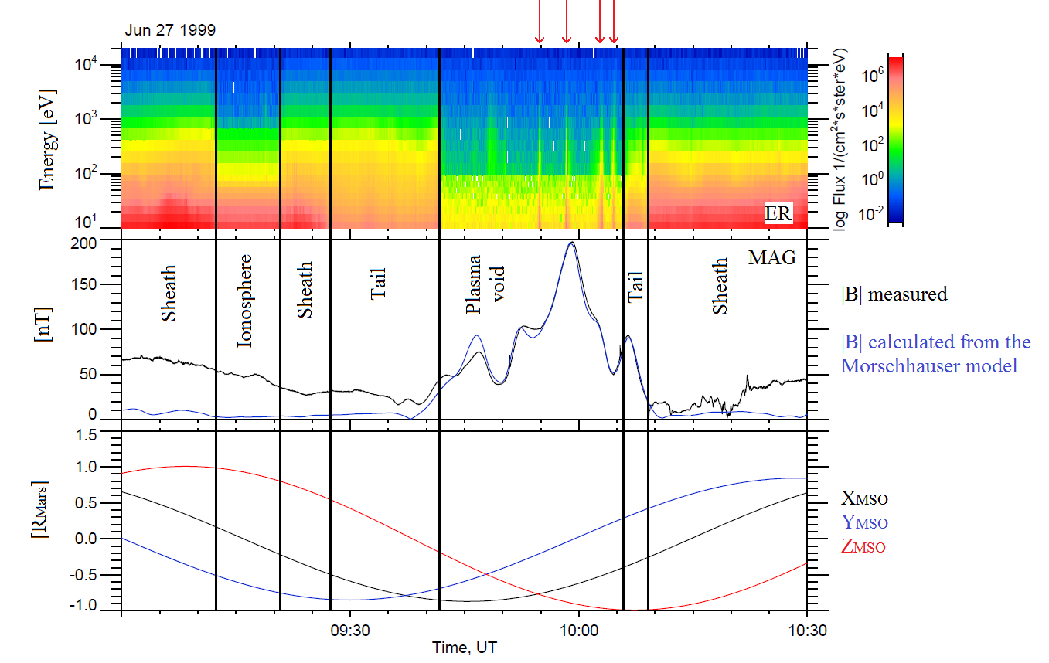

Figure 49. Example of a plasma void observed by MGS on June 27, 1999.

*Panel 1: ER energy-time spectrogram of omnidirectional electron flux. Panel 2: Amplitude of the magnetic field measured by MAG (****black****) and calculated thanks to the Morschhauser model (****blue****). Panel 3: MGS coordinates in the MSO frame. The black vertical lines delineate the main region of the Martian environment encountered by the spacecraft and the red arrows highlights the flux spikes.*

From all these observations, *Mitchell et al.,* [2001] concluded that in the Southern hemisphere, intense crustal magnetic fields are strong enough to form localized “magnetocylinders’, or **closed crustal magnetic field loops**, that can stand off the solar wind at altitude well above 400 km. On the nightside, these closed loops are marked by series of plasma voids, separated by flux spikes that can be seen as Earth-like cusps. Inside these plasma voids, the spacecraft is on closed crustal magnetic field lines, which are effectively cut off from the solar wind plasma traveling up the magnetotail and from ionospheric plasma from the sunlit hemisphere. The electron spectra of the flux spikes indicate that crustal magnetic field lines are connected to the IMF between two closed loops. When theses loops rotate in sunlight, they should become populated with newly created photoelectrons produced from the neutral atmosphere, so that no plasma void are observed on the dayside.

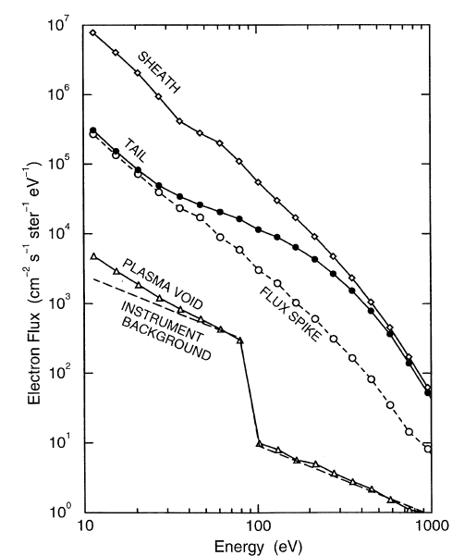

Figure 50. Electron energy spectra observed in different regions crossed by MGS in Figure 49.

Plasma voids should not be associated with “density depressions”, which are reductions in the electron number density [*Brace et al.*, 1982], usually observed on Venus. Although both classifications should, a priori, be similar, it is important to mention the difference existing between instruments used to derive electron fluxes and instruments used to derive electron densities. Electron spectrometer that typically make electron flux measurements sample suprathermal electron populations (> 10 eV), while instruments that measure electron number densities sample across thermal (<10 eV) and suprathermal electron populations. As these two parameters are not calculated for the same electron population, a density depression does not necessarily correspond to a reduction in the electron flux, and vice-versa. We here only focus in decrease in the electron fluxes.

A few years after the observations of *Mitchell et al.,* [2001], *Soobiah et al.,* [2006] observed thanks to 144 passages of MEX at low altitudes that the electrons flux underwent significant changes close to crustal magnetic fields. Intensified flux signatures were observed mainly on the dayside whereas flux depletions were features of the nightside hemisphere. They suggested that the phenomena were related to regions in which strong crustal magnetic fields reconnect with the IMF leading to possible atmospheric loss channels. Hence, the topology of the crustal can significantly influence the structure of the magnetosphere, as well on the dayside as on the nightside.

An example of plasma void as observed by ELS is plotted in Figure 51 (adapted from *Soobiah et al.,* 2006]. On the first panel is plotted the electron energy-time spectrogram measured by ELS, on the second panel is plotted the magnitude of the crustal magnetic field calculated thanks to the model of Morschhauser at the altitude of the spacecraft. On the third and fourth panel are the location of the spacecraft in the Martian environment. Different energy environments are separated by black vertical lines. As with the MGS example, we can observe that plasma voids are punctuated by flux spikes, at ~21:54 UT and ~21:59 UT. Looking at the Morschhauser model, we can observe that electron depletions are also located above a strong crustal magnetic field sources, in the nightside.

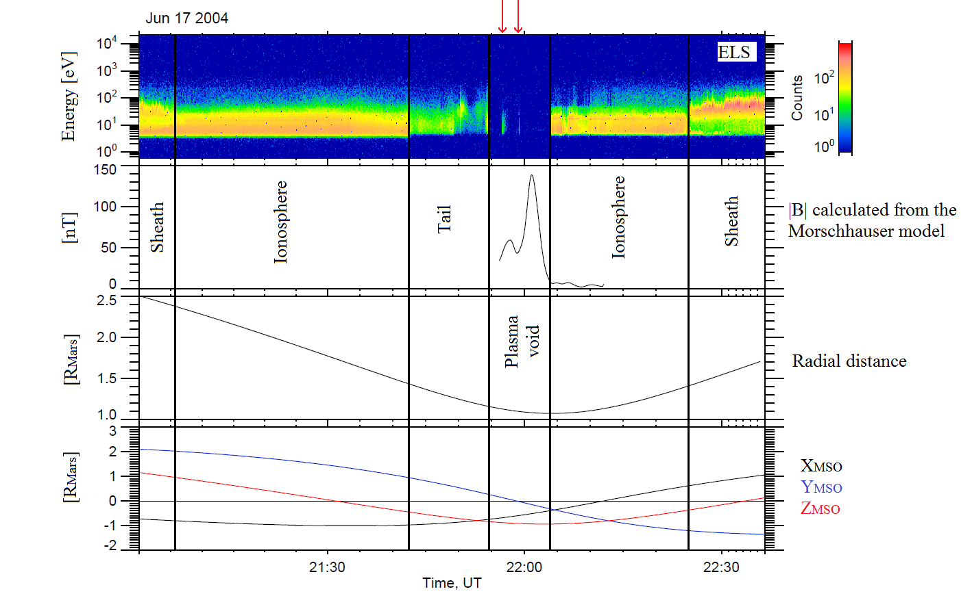

Figure 51. Example of a plasma void observed by MEX on June 17, 2004.

*Panel 1: ELS energy-time spectrogram of omnidirectional electron counts. Panel 2: Amplitude of the magnetic field and calculated thanks to the Morschhauser model. Panel 3: Radial distance of MEX from Mars. Panel 4: MEX coordinates in the MSO frame. The black vertical lines delineate the main region of the Martian environment encountered by the spacecraft and the red arrows highlights the flux spikes.*

### On the origin of plasma voids

An indirect study of plasma voids by *Brain et al.,* [2007] looked statistically at seven and an half years of magnetic field and electron flux (at energies of 115 eV) measurements by the MAG and ER instruments onboard MGS. They use these data to determine the Pitch Angle Distribution (PAD) of the electrons across the surface of Mars. Different PAD were associated to the different magnetic topology observed in Figure 21. For example, a two-sided loss cone distribution corresponds to closed magnetic field lines (or trapped particles) while plasma voids are characterized by PADs in which the electron flux is at background levels across all pitch angles.

In this study, the dayside is defined as SZA<90° while the nightside is define as SZA >120° at 400 km. With these definitions, the plasma voids have been found to be observed approximately 31.5% of the time when the spacecraft is in the nightside, while they were virtually never observed in the dayside (<7000 cases out of 31 million PADs).

This statistical study also showed that plasma voids are concentrated near strong crustal magnetic fields and that very few voids are seen at large distances from crustal magnetic sources, as observed in Figure 52, in which plasma voids are plotted in red. A plasma void occurrence of 100% (across the full seven and an half years data set) had even be observed over the strongest crustal field regions in the southern hemisphere. They hence suggested than these regions were closed crustal magnetic field regions that would remain closed irrespective of external conditions.

This study also revealed that plasma voids are surrounded by areas with trapped electron PADs in orange in Figure 52), consistent with the idea of closed magnetic field lines and indicating that the outer layers of closed magnetic field regions are populated thanks to source processes such as reconnection with the draped IMF.

From the observation that nightside closed field lines regions are filled with isotropic electron PADs when they rotate in the dayside, *Brain et al.* [2007] suggested that plasma voids are the result of a balance between electron source and loss processes. On the dayside, closed crustal magnetic field loops can trap ionospheric plasma, including suprathermal photoelectrons. When they travel to the nightside, the electrons are removed through a combination of outward diffusion, scattering, and interactions with the collisional thick atmosphere at lower altitudes. Meanwhile, the external sources of plasma (solar wind plasma traveling up the magnetotail and ionospheric plasma) are excluded from the inner layers of the closed field regions, so that sinks overpass sources thus creating plasma voids. When the crustal magnetic loops rotate back to the dayside, they trap newly created ionospheric plasma and the source processes would dominate loss processes. As the ionospheric plasma is homogeneously created in the dayside, voids are essentially never seen on this side of Mars.

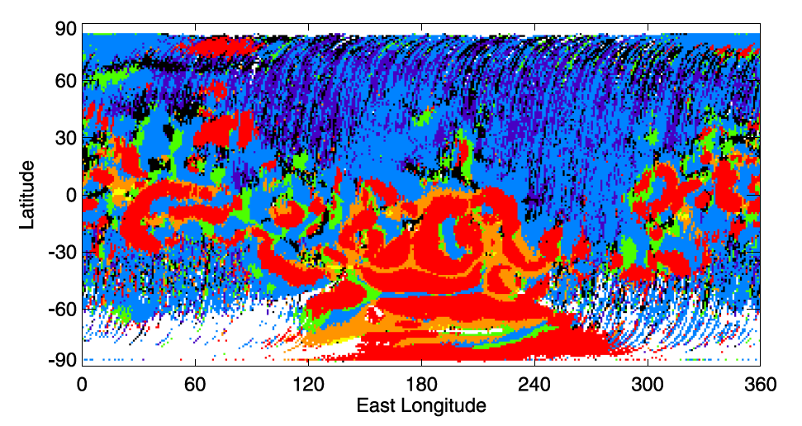

Figure 52. Geographic map of dominant PAD types recorded by MGS ER at 400 km on the nightside: plasma voids (red); trapped (orange); fully isotropic (green); incident isotropic, return loss cone (blue); incident field-aligned beam, return loss cone (purple); conic (yellow); and other (black). [Brain et al., 2007]

**Venusian Interlude**

The description of the Martian plasma voids can make one think of the Venusian “ionospheric density holes” identified by *Brace et al.* [1982]. These structures are characterized by a strong sunward or antisunward enhancement in magnetic field compared to the adjacent regions, a concurrent diminution in electron and ion density, and they occur in pairs with oppositely polarized field enhancement, one sunward and the other tailward. *Collison et al.*, [2014] proposed that the plasma depletion associated with ionospheric holes are only a manifestation of tubes of enhanced draped IMF, emerging in pairs from low altitudes and stretching far down the tail.

However, one major difference with the Martian plasma voids is that the Venusian density holes occurs in two main regions near the poles, whereas *Duru et al.*, [2011] found no convincing evidence of the same distribution at Mars.

### Global properties of the plasma voids observed by MGS and MEX

Based on 21 MEX-observations of electron density depressions, *Duru et al*., [2011] showed that electron flux reductions were coincident with density depression on 19 cases, while nothing happened on the left four cases. They suggested that density depressions joined by a flux reduction might correspond to plasma voids. Cases in which the electron flux has no change across a density depression may occur in closed regions that have sudden access to external plasma, or where atmospheric degradation occurs.

While *Brain et al.,* [2007] statistically showed that plasma voids are restricted to the nightside, studies made with MEX data by *Soobiah et al.* [2006] and *Duru et al.* [2011] showed no dissymmetry between the dawn and the dusk side. Plasma voids are globally distributed regardless of nightside local time (18h00-24h00; 00h00-06h00), within the limits of their studies.

Crustal magnetic loops do not necessarily stay closed as the planet rotates [*Ma et al.,* 2014] and crustal fields can connect and reconnect with the piled-up, draped and dynamic IMF. Hence, when they travel to the nightside, regions with strong enough horizontal crustal fields are able to stand off the IMF effects. The crustal magnetic loops in these regions thus stay closed all the way across the nightside and are populated by permanent plasma voids, which means we can observe this phenomena during each passage above such regions on the nightside. On the other hand, regions with weaker horizontal fields are essentially intermittently populated with plasma voids, depending on the external drivers. For low and moderate solar wind pressure crustal magnetic loops are closed and devoid of plasma. However, for high solar wind pressure the crustal field lines open up and get connected to the IMF. These weak crustal magnetic field regions are then filled with solar wind plasma travelling through the tail [*Lillis and Brain,* 2013].

[the Spot?]

More recently, *Hall et al.,* [2016] used the rapid reductions of a proxy measurement of the electron flux derived from the MEX/ELS electron flux measurements integrated across the 20-200 eV energy range to automatically identify plasma voids. The study covers approximately ten years of the MEX mission from 2004 to 2014 and is restricted to the illuminated induced magnetosphere (region of space inside the magnetic pileup boundary and outside the cylindrical shadow of the planet). Using this method, plasma voids were detected amongst 56% of the orbits under study, from 266 km (MEX lowest periapsis) to 10 117 km. Statistical study of the distribution of these events showed that approximately 80% of them occurred below 1 300 km, predominantly at SZA between 90° and 120°. Study of the spatial and altitudinal distributions of the detected plasma voids confirmed the strong link existing between the plasma voids occurrence and the magnitude of the crustal magnetic field. The bigger the source was, the higher plasma voids could be observed. However, some regions appears to be in contradiction with this global behavior which suggests that other processes are involved in plasma void creation such as the interaction between the solar wind and the Martian plasma.

## Global properties of suprathermal electron depletions as observed by MAVEN: case studies

All the results presented in section 3.1 have been obtained using MGS or MEX data which have several constraints either in instrumentation or in orbitography. Neither of them reached altitude below 250 km, MGS was locked in local time and did not carry an ion spectrometer while MEX does not carry a magnetometer. The MAVEN instrument payload dedicated to plasma study and its periapsis reaching ~125 km allows unprecedented measurements of these plasma phenomenon at previously unsampled altitudes.

Through several case studies we will present some properties of electron depletions, beginning with explaining why we choose to rename plasma voids as suprathermal electron depletions (section 3.2.1). We then describe the characteristics of the ions and of the remaining electrons observed in the electron depletions (section 3.2.2). In section 3.2.3 we discuss the nature of the border of electron depletions. A specific highlight on the nature of the flux spikes is made in section 3.2.4. We finally take a quick look on the location of different electron depletions regarding the distribution of crustal magnetic sources (section 3.2.5).

### Plasma voids or suprathermal electron depletions?

The structure called plasma voids have been renamed after observations made with MGS, which did not carry any ion spectrometer but an electron spectrometer whose measurements were limited to electrons with energy greater than 10 eV. Plasma voids are then structures void of electrons having energies greater than 10 eV.

Thanks to a new multi-instruments vision of the plasma voids, enabled by MAVEN, we choose to rename them as ‘suprathermal electron depletions’. This has been made possible thanks to SWEA, which detects electrons with energies down to 3 eV, STATIC, which separates ions species until low energies (i.e. in the ionosphere), and LPW which measures the thermal electron population (below 5 eV).

Figure 53 shows an example of plasma voids observed with MAVEN on July 11, 2015. The first panel is the SWEA energy-time spectrogram of omnidirectional electron energy flux (also referred to as JE hereinafter). The plasma voids observed during this interval are roughly delimited by the two black vertical lines. However, we can see that they are not void of electrons: there is a remaining electron population at approximately 6-7 eV, which could not be observed by MGS due to its energy range, and by MEX, probably due to higher negative spacecraft potential.

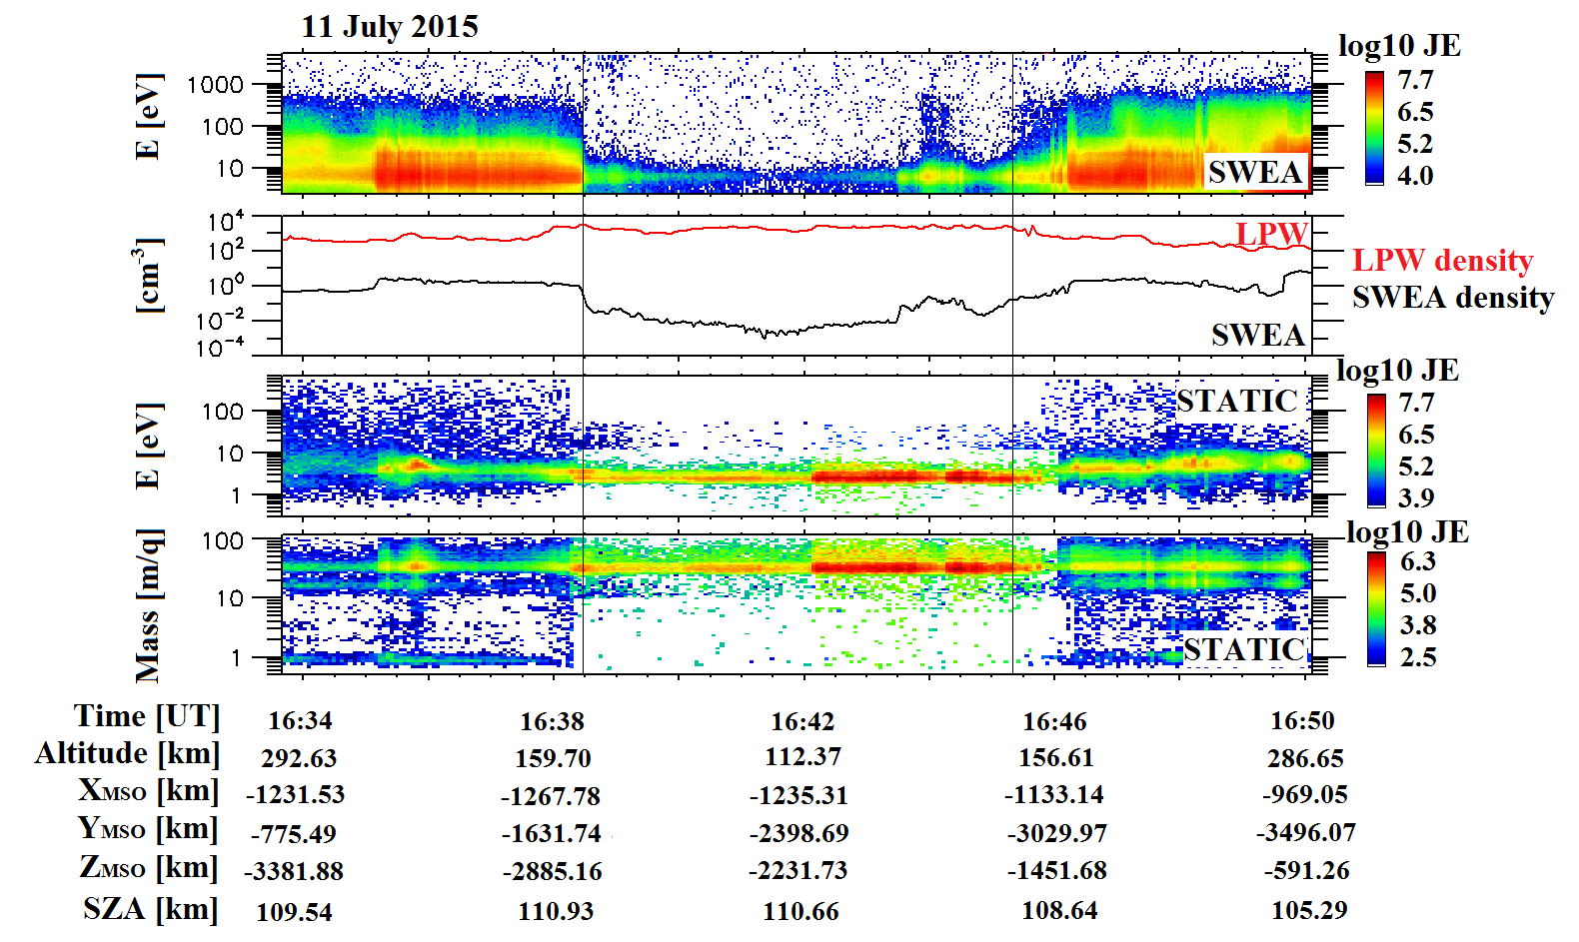

Figure 53. Example of electron depletion observed with MAVEN on July 11, 2015.

*First panel: SWEA energy-time spectrogram of omnidirectional electron energy flux (ENGY mode) corrected for the potential measured with LPW. Second panel: Electron density calculated with SWEA (****black****) superimposed with the density calculated with LPW (****red****). Third panel: STATIC energy-time spectrogram of omnidirectional ion energy flux (C0 mode). Fourth panel: STATIC mass-time spectrogram of omnidirectional ion energy flux (C6 mode).*

Moreover, the second panel shows the density calculated from SWEA data in **black** and the density from LPW in **red**. Note that during this time interval the quality flag of the LPW density and of the spacecraft potential used for the calculation of the density from SWEA data is always greater than 50 except for 16:37:55 (in the ionosphere) and 16:45:20 (at the end of the depletion) which means that these data are reliable [*L. Andersson*, private communication]. Due to instrumental limits the density calculated with SWEA data is restricted to electrons with energies greater than 3 eV (see Table 3), whereas the density calculated with LPW includes lower-energy electrons, which explains the difference observed between the two densities (in particular in the ionosphere where the plasma is essentially cold, typically $kT_{e}<0.4 eV$). The non-thermal population measured by SWEA represents a small fraction of the total electron density. The characteristic drop in the suprathermal electron flux is very clear in the SWEA density during the electron depletion, whereas there is no drop in LPW density, i.e. in thermal electron density, which even increases slightly.

On panels 3 and 4 are plotted the STATIC energy-time spectrogram of omnidirectional ion energy flux and the STATIC mass-time spectrogram of omnidirectional ion energy flux. Thus the electron depletions are mainly filled with $O_{2}^{+}$ at 3 eV. The plasma composition of suprathermal electron depletions will be discussed in more details in section 3.2.2.

The presence of ions inside plasma voids was already suggested by MEX/IMA measurements as plotted on Figure 54. We here shows an example of electron depletions observed by MEX on June 23, 2012. The first panel is the ELS energy-time spectrogram of omnidirectional electron counts per second. Note that ELS’s geometric factor is approximately fixed, so that counts are proportional to electron flux. Two plasma voids can be observed between the two vertical black lines. The second panel is the energy-time spectrogram of the omnidirectional heavy ions counts per second (m/q >20) measured by IMA. There are few light ions detected (not shown) but we can see that electron depletions are filled with heavy ions (mainly $O_{2}^{+}$ and ${CO}_{2}^{+}$ at this altitude in the nightside [*Haider et al.,* [2013]]), having an energy E/q of a dozen of eV. This difference of energy measured by IMA and STATIC could be explained by a difference of spacecraft potential between the two missions, which would be in agreement with the non-observation of the 6-7 eV remaining electron population in suprathermal electron depletions by ELS.

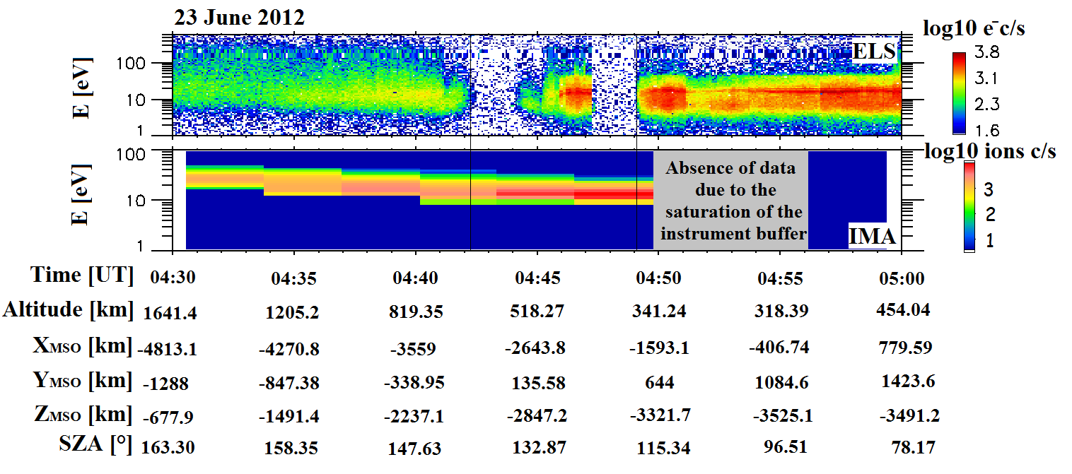

Figure 54. Example of electron depletion observed by MEX on June 23, 2012.

*First panel: ELS energy-time spectrogram of omnidirectional electron counts per second. Second panel: IMA energy-time spectrogram of omnidirectional heavy ions counts per second (m/q>20).*

Hence, the depletions are not entirely void of plasma. Only suprathermal electrons with energies greater than ~10 eV are depleted, which justifies the name “suprathermal electron depletions” given by *Steckiewicz et al.* [2015].

Note that suprathermal electron depletions can be observed on each anode of SWEA and each deflection sector.

### Plasma composition

In Figure 55 are plotted the concatenated spectrum of STATIC and SWEA inside the electron depletions plotted in Figure 53, between 16:38:28 and 16:45:20. On the left is the energy-JE spectrogram obtained with the C0 mode of STATIC, on the middle is the mass-JE spectrogram obtained with the C6 mode of STATIC and on the right is the energy-JE spectrogram obtained with SWEA. All these data are corrected from the spacecraft potential measured by LPW when needed.

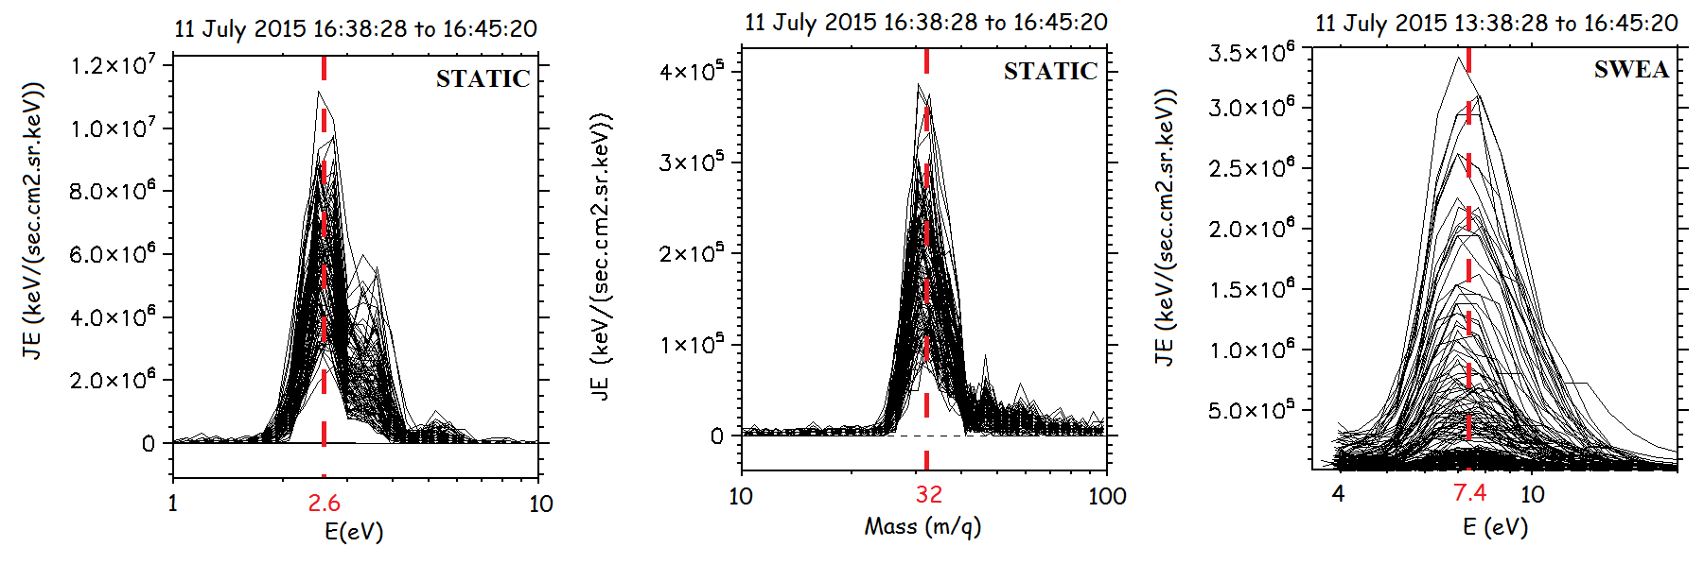

Figure 55. Concatenated spectrum of STATIC and SWEA during the electron depletion on July 11, 2015, between 16:38:28 and 16:45:20. All data are corrected from the spacecraft potential measured by LPW.

*Left: Ion energy-JE concatenated spectrogram (STATIC/C0 mode); Middle: Ion mass-JE concatenated spectrogram (STATIC/C6 mode); Right: Electron energy-JE concatenated spectrum (SWEA/ENGY mode)*



#### Ions characteristics

We can clearly observe on the left panel that the ion population is strongly peaked around a mean value of ~2.6 eV with a full width at half maximum of 1 eV. Looking in detail at the mass-time spectrogram (middle panel) enable us to derive the ion composition within electron depletions dominated by $O_{2}^{+}/NO^{+}$ at 32 m/q (note that STATIC cannot resolve between these species). A smaller peak can be observe at ~44 m/q, which may correspond to $CO_{2}^{+}$. This observation is consistent with the nightside ionosphere composition calculated by *Haider et al.* [2013] with $O_{2}^{+}$ as the main ion species below 200 km followed by $NO^{+}$ and $CO_{2}^{+}$.

Combining this two information, the energy of the ions measured by STATIC suggests that we observe cold ions with the ram velocity. If we consider ionospheric ions with no significant initial speed, the ion energy measured will be the energy given by the movement of the spacecraft, called the ram energy:

$$E=\frac{1}{2}*m*v^{2}$$

For $O_{2}^{+}$, this energy varies between 2.2 eV at 1000 km altitude and 3 eV at the periapsis of MAVEN. For $CO_{2}^{+}$, it varies between 3.0 eV and 4.0 eV at the periapsis. The values calculated for $O_{2}^{+}$ well correspond to the main peak and its dispersion. The secondary peak between 3 and 4 eV meanwhile well corresponds to the ram velocity calculated for $CO_{2}^{+}$.

#### Electrons characteristics

Looking at the right panel, we can observe that all the electron spectrum inside the observed electron depletion are peaked at ~7 eV, with correction from the spacecraft potential. This electron population corresponds to the remaining electron population after absorption by the atmospheric neutrals. In Figure 56 is plotted the different cross sections for electron collision with atomic oxygen (a), carbon dioxide (b), nitrogen molecules (c), and oxygen molecules (d) [*Itikawa et al.*, 1986, 1989; *Itikawa and Ichimura*, 1990; *Itikawa*, 2002], which are the dominant neutrals in the Martian atmosphere at the altitudes of interest (Figure 7). On each panel are plotted the corresponding cross sections for several specific mechanisms, such as ionization, elastic-scattering, momentum transfer, vibrational excitation, etc.

At first, the total cross section (and the elastic cross section for O) can be observed to roughly compare the electron interaction with the different species. The $CO_{2}$ cross section is clearly bigger than the three other one, of approximately one order of magnitude at all energies greater than 1 eV. The $CO_{2}$ total cross section present a specific shape, with a strong dip at ~6 eV and two strong peaks at 4 and 30 eV. When superimposed on the electron time-energy spectrogram in Figure 57, we can observe that the remaining electron population roughly corresponds to the cross section peak and that hardly any electrons are observed at the location of the cross sections peaks. Since a peak in the cross section is related to an electron loss process, electron absorption by the atmospheric $CO_{2}$ seems a good candidate to explain the large electron disappearance above 10 eV observed in the depletions as well as the remaining thermal electron population observed between 4 and 12 eV.

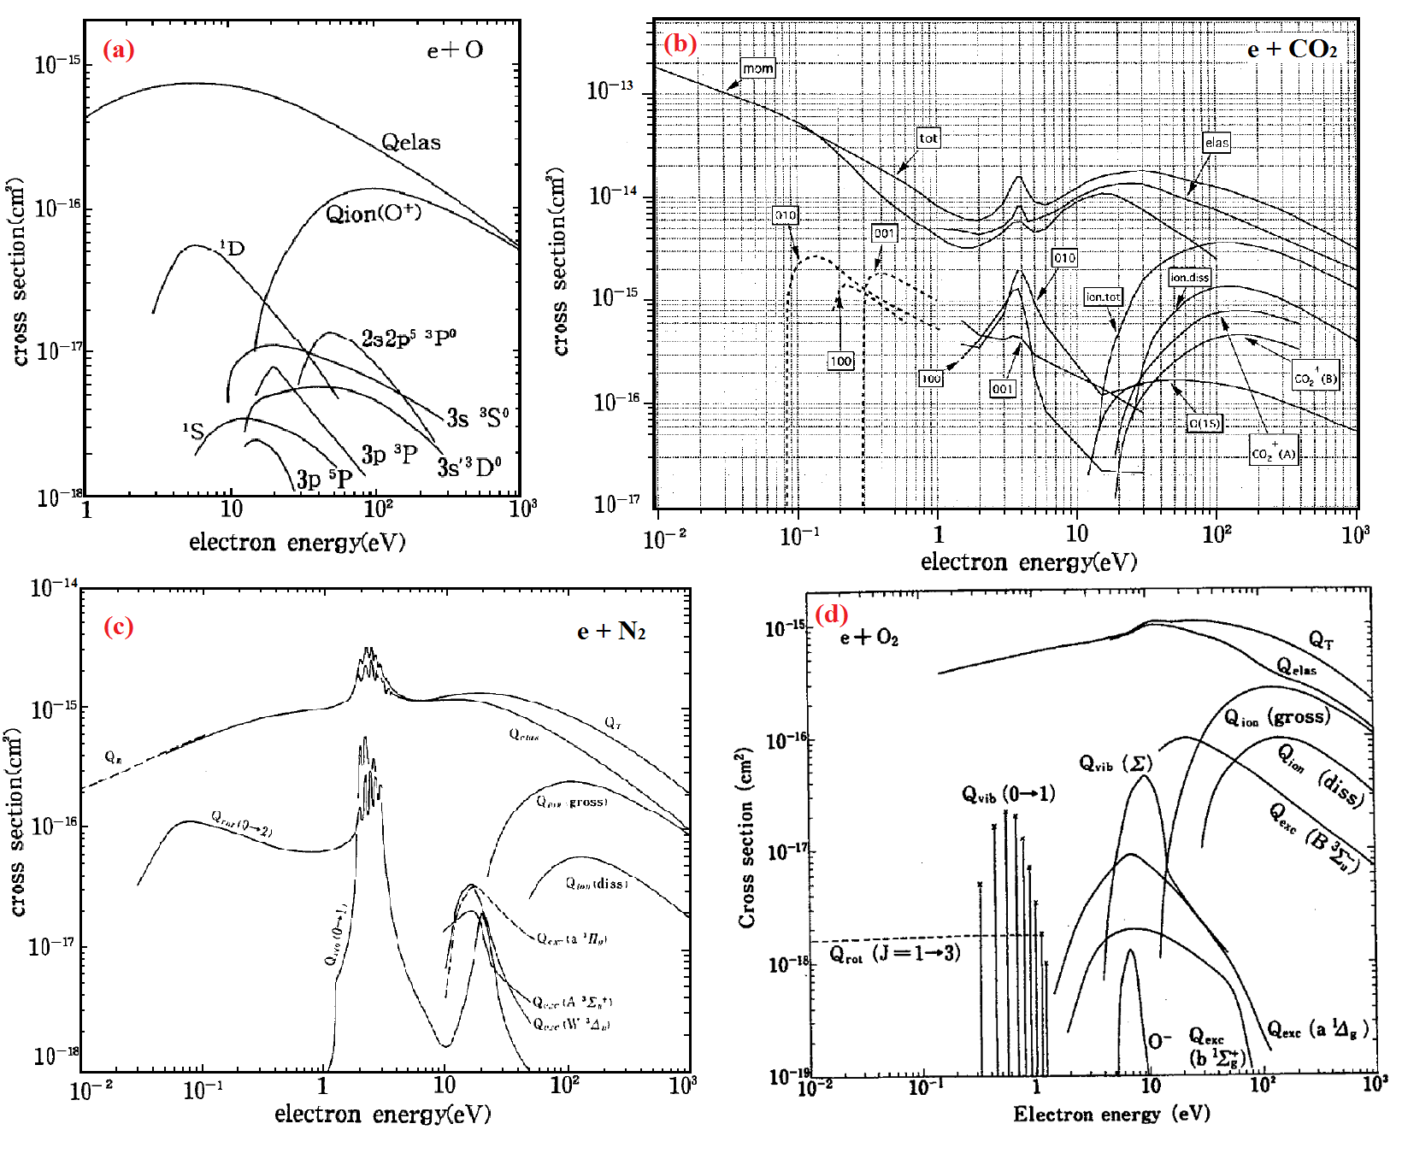

Figure 56. Summary of the cross sections for the electron collision with the main neutrals of the atmosphere: (a) Electron collision with atomic oxygen [Itikawa and Ichimura, 1989]; (b) Electron collision with carbon dioxide [Itikawa, 2002]; (c) Electron collision with Nitrogen molecules [Itikawa et al., 1986]; (d) Electron collision with oxygen molecules [Itikawa, 1988].

The interaction between electrons and $CO_{2}$ is actually diverse and is discussed in details by *Itikawa* [2002]. There are essentially momentum transfer collisions or several excitation modes of 𝐶𝑂2 that thermalize electrons, but also to a lower extent attachment or ionization reactions that induce a direct loss of electrons.

The other neutrals presented in Figure 56 does not present such structures which explain the presence of the peaked remaining electron population inside the electron depletion. However, they can participate to the global depletion of electrons.

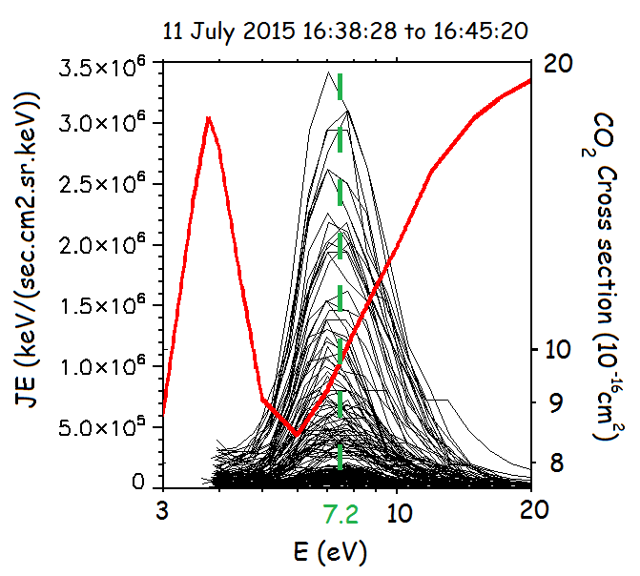

Figure 57. Concatenated electron energy-JE spectrum of SWEA during the electron depletion on July 11, 2015, between 16:38:28 and 16:45:20. All data are corrected from the spacecraft potential measured by LPW. Superimposed in **red** is the total electron collision cross section for $CO_{2}$ taken from Itikawa et al. [2002].

### The border of suprathermal electron depletions

[to complete with Laila paper]

[evolution of the electron spectrum when going into the depletion]

[16/02/2015 20:05]

### Flux Spikes

On a single periapsis, electron depletions are often observed by groups of three of four (see section 3.4), separated by structures called ‘flux spikes’ by *Mitchell et al.* [2001]. This structures have several origins, among which three will be discussed in the next sub-sections: incursion of ionospheric plasma (section 3.2.4.1), injection of hot electrons (section 3.2.4.2) and the present of a current sheet (section 3.2.4.3).

#### Injection of ionospheric plasma

[to complete]

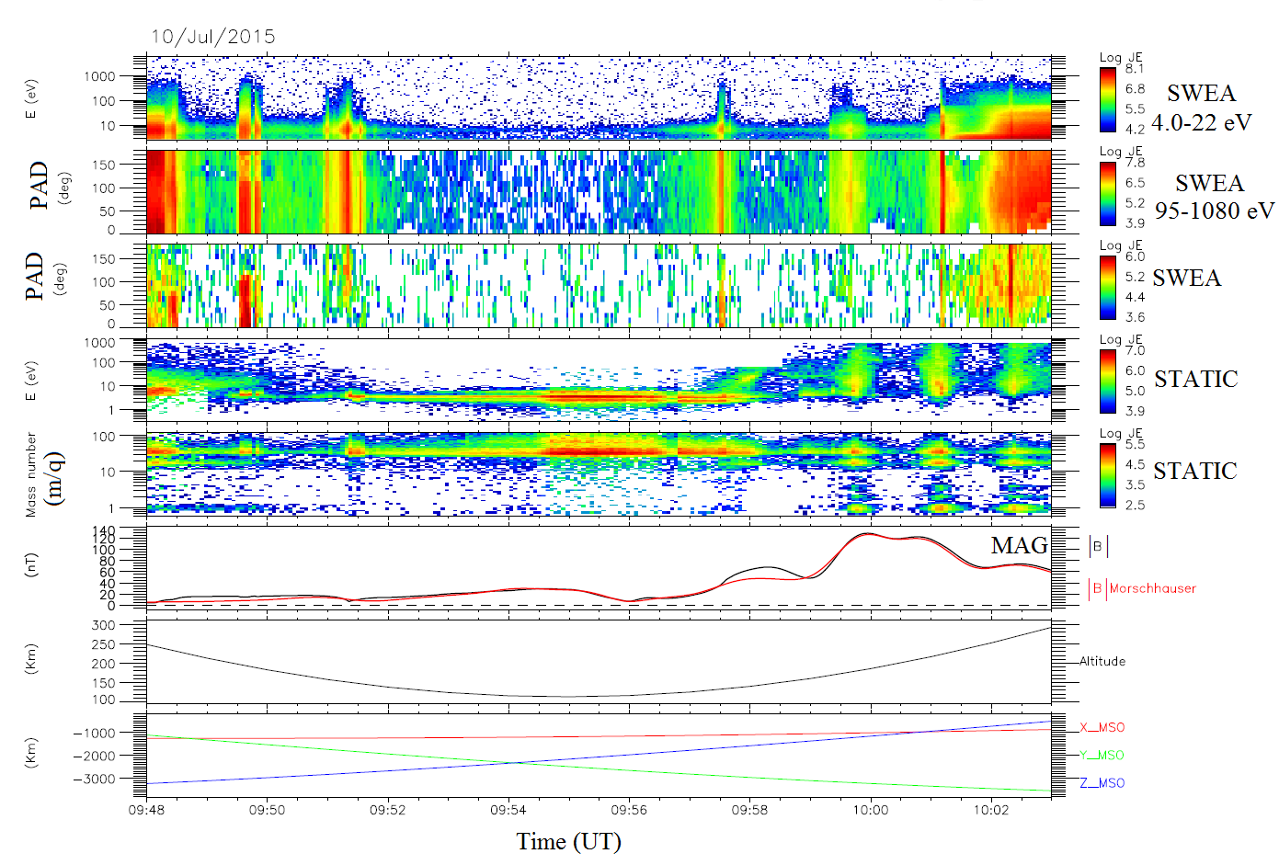

Figure 58



Figure 59

[Electron density observed by SWEA and LPW ?]

[Electron spectrum inside the spikes ?]

[delimitation of the spikes]

#### Energy-time dispersed electron signature

[to complete]

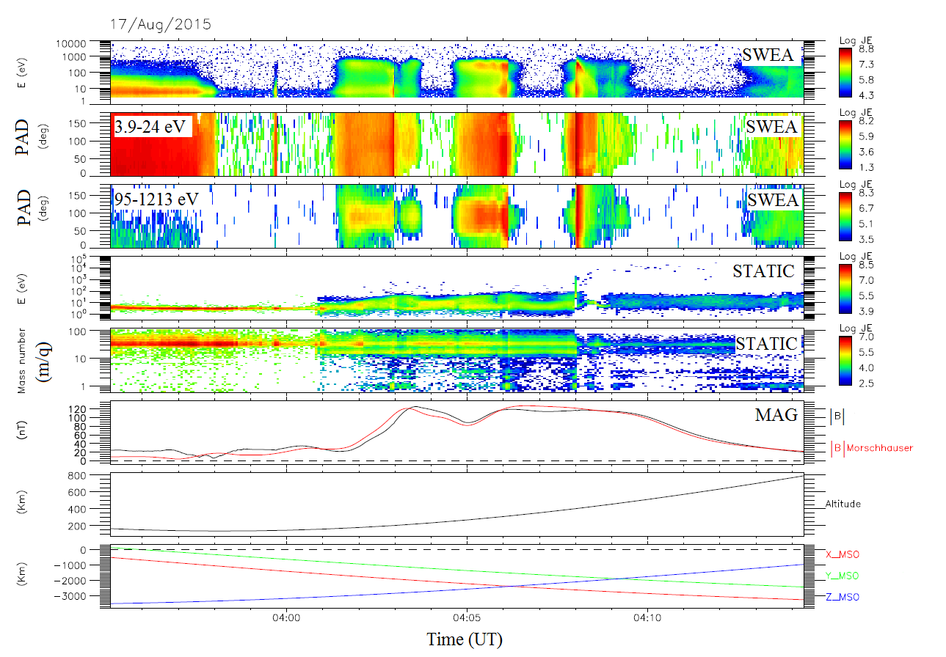

Figure 60

[electron spectrum inside the spikes ?]

[Harada]



Figure 61.

#### Current sheet

In Figure 60 is plotted a series of electron depletions, separated by nature-different flux spikes. The panels are the same as Figure 56 and Figure 58. Coincidently with three flux spikes (highlighted by the black vertical lines), we can observe a diminution of the amplitude of magnetic field, as well as an inversion of some of its component and an enhancement of the particles flux (ions and/or electrons). These are typical features of current sheets. However, as during this passage the spacecraft is very close from the planet (lower than 600 km), a closer look to the crustal magnetic field is necessary before setting the current sheet nature of these flux spikes.

[to complete]

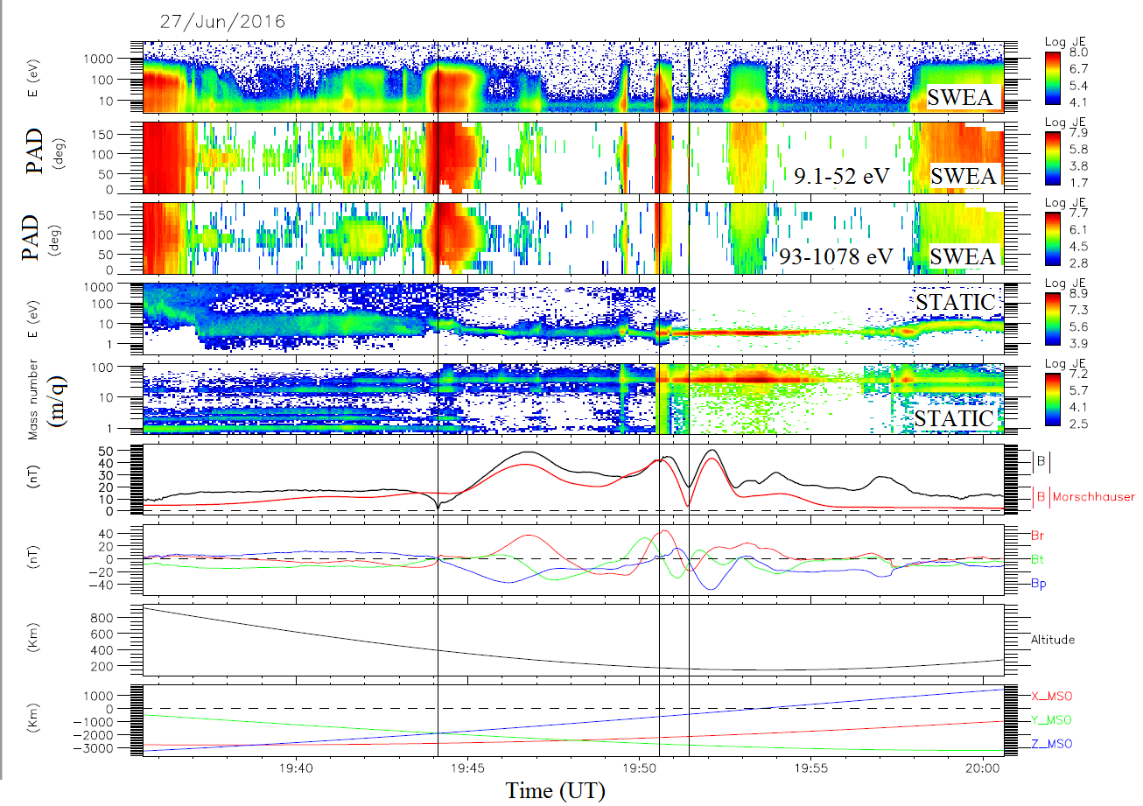

Figure 62. Example of current sheet crossing observed by MAVEN during an electron depletion.

*Panel 1:* *SWEA energy-time spectrogram of omnidirectional electron energy flux (ENGY mode). Panel 2: Electron PAD calculated by SWEA for electrons with energies between 9.1 and 52 eV. Panel 3: Electron PAD calculated by SWEA for electrons with energies between 93 and 1078 eV. Panel 4: STATIC energy-time spectrogram of omnidirectional ion energy flux (C0 mode). Panel 5: STATIC mass-time spectrogram of omnidirectional ion energy flux (C6 mode). Panel 6: Magnitude of the magnetic field measured by MAG (****black****) superimposed with the amplitude of the crustal magnetic field calculated thanks to the model of Morschhauser (****red****). Panel 7: The three components of the magnetic field in the IAU frame measured by MAG. Panel 8: Altitude of the spacecraft. Panel 9: Position of the spacecraft in the MSO coordinates.*

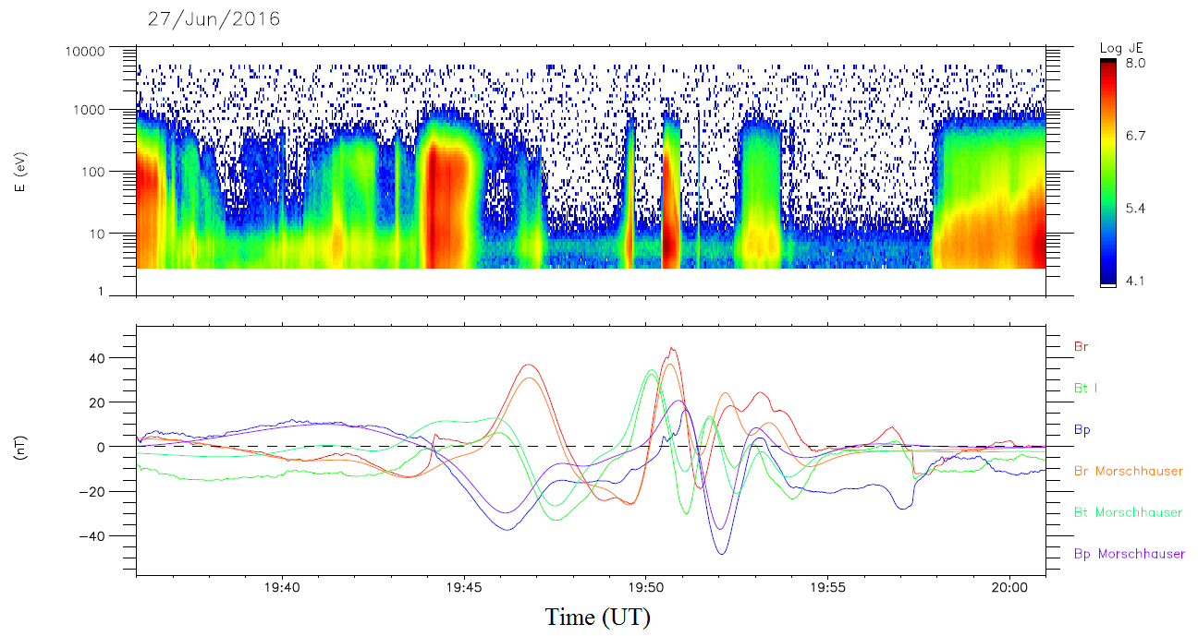

Figure 63. Example of current sheet crossing observed by MAVEN during an electron depletion.

*Panel 1: SWEA energy-time spectrogram of omnidirectional electron energy flux (ENGY mode). Panel 2: The three components of the magnetic field in the IAU frame measured by MAG superimposed with the three components of the magnetic field in the IAU frame calculated thanks to the Morschhauser model.*

[MVA?]

As the spikes are usually observed when the magnetic field is radial, another interesting point would have been to study the possible link existing between the observation of spikes and aurora.

### Really related to crustal fields?

With MGS and MEX the electron depletions were observed mainly above strong crustal magnetic sources, with few events out of these regions. With MAVEN, we still observe electron depletions above strong crustal magnetic sources, but not only. In Figure 62 and Figure 63 we present two orbits of MAVEN when it reaches its periapsis on the nightside. In both cases, the first panel is the SWEA energy-time spectrogram of omnidirectional JE, the second panel is the STATIC energy-time spectrogram of omnidirectional JE, the third panel is the STATIC mass-time spectrogram of omnidirectional JE and the fourth panel is the magnitude of the in-situ magnetic field measured by MAG (**black**), superimposed with the magnitude of the crustal magnetic field calculated with the Morschhauser model.

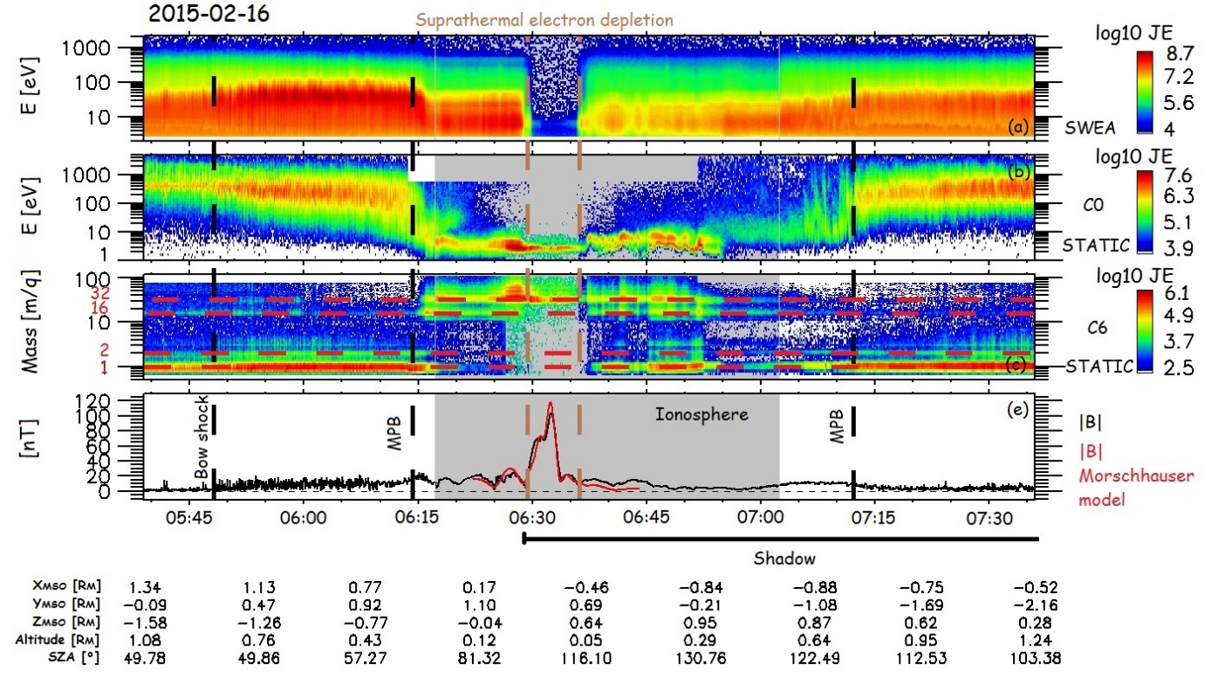

Figure 64. Example of electron depletion observed with MAVEN on February 16, 2015.

First panel: SWEA energy-time spectrogram of omnidirectional electron energy flux (ENGY mode). Second panel: STATIC energy-time spectrogram of omnidirectional ion energy flux (C0 mode). Third panel: STATIC mass-time spectrogram of omnidirectional ion energy flux (C6 mode). Fourth panel: Magnitude of the magnetic field measured by MAG (**black**) superimposed with the amplitude of the crustal magnetic field calculated thanks to the model of Morschhauser (**red**). The bow shock and the MPB are roughly represented by the black dashed vertical lines.

In Figure 62 is a pass over a strong magnetic anomaly in the northern hemisphere (the periapsis is above the geographic location (40°N, 74°E). The periapsis is in this case at 125 km altitude (it was made during the first “deep dip” campaign). During this orbit, SWEA recorded between 06:29 and 06:36 UTC a large electron depletion (delineated by brown vertical dashed lines). During this electron depletion the spacecraft was in the nightside ionosphere below 160 km altitude and passed over a strong magnetic anomaly between 06:29 and 06:33 UTC as indicated by the observed pronounced increase in magnetic field intensity (up to ~120 nT) and in agreement with the model of Morschhauser. We can note that between 06:33 and 06:36 UTC the electron depletion is still present, whereas no significant magnetic field can be observed.

In Figure 63 is plotted a similar pass over a quiet magnetic area (the amplitude calculated by the Morschhauser model do not exceed 9 nT). In this case the spacecraft passed its periapsis at 150 km altitude, above the geographic location (50°N, 150°E). Several electron depletions can be observed between 18:12 and 18:21 UT (between the brow dashed vertical lines), below an altitude of 250 km.

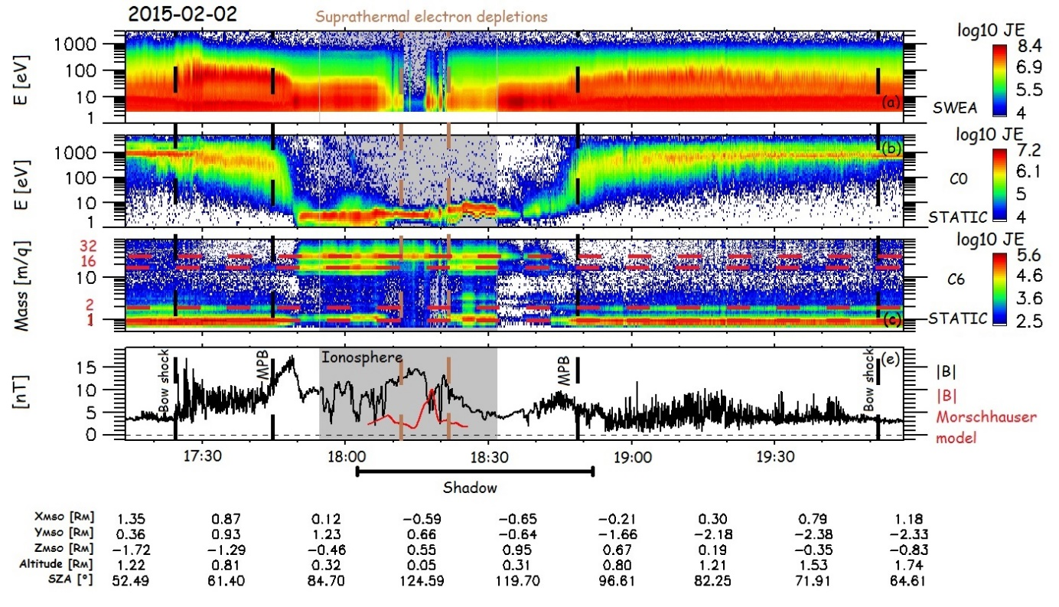

Figure 65. Example of electron depletion observed with MAVEN on February 02, 2015.

First panel: SWEA energy-time spectrogram of omnidirectional electron energy flux (ENGY mode). Second panel: STATIC energy-time spectrogram of omnidirectional ion energy flux (C0 mode). Third panel: STATIC mass-time spectrogram of omnidirectional ion energy flux (C6 mode). Fourth panel: Magnitude of the magnetic field measured by MAG (**black**) superimposed with the amplitude of the crustal magnetic field calculated thanks to the model of Morschhauser (**red**). The bow shock and the MPB are roughly represented by the black dashed vertical lines.

Electron depletions detected in both case have the same properties, i.e. no electron above 10 eV, a remaining electron population peaked at ~6 eV and $O_{2}^{+}$ at ~3eV. The main difference between this two examples is the presence of crustal magnetic fields. In Figure 63, no significant crustal magnetic field is recorded. The model however predicts a small enhancement of the crustal field at 18:18 UT but this value seems too small to be significant as it is embedded in the ambient magnetic field. This observation demonstrates that crustal magnetic anomalies cannot be the unique source process leading to the observation of suprathermal electron depletions.

These two case studies have been chosen as representative of a large number of electron depletions observed by MAVEN. The first one above a crustal magnetic anomaly corresponds to the typical case reported previously from MGS and MEX observations. The second one above a quiet magnetic area was occasionally reported from those past observations (see *Hall et al.*, [2016] for example) but is now commonly observed by MAVEN as it will be illustrated by the statistical analysis presented in section 4.1. [observed at each periapsis]

## Automatic detection of suprathermal electron depletions: definition of the criteria

Electron depletions can be observed by MGS, MEX and MAVEN respectively on ER, ELS and SWEA spectrograms. We present here three criteria, adapted to each set of data, used to automatically detect electron depletions. The starting point of the definition of these criteria is the criterion developed for the MAVEN/SWEA data and published in *Steckiewicz et al.* [2015]. We thus first explain how this criterion is used for MAVEN before adapting it to MEX and MGS and their own specificities [*Steckiewicz et al.*, 2016]. The application of these three criteria - detailed in section 3.4 - leads to three catalogs of electron depletions used in the next sections to study the different process leading to the observation of electron depletions (section 4) and the interaction plasma/neutrals (section 5).

### MAVEN

Using the electron depletions properties observed by MAVEN (section 3.2), both for the electron population inside the depletions and inside the spikes, we have created for SWEA data the criterion given in equation (1):

$$\frac{1}{3}\sum_{i=1}^{3}{\begin{aligned}\frac{CR\left(E_{i}\right)}{<CR\left(E_{i}\right), 1h>} \\ \end{aligned}} < 0.01 (1)$$

It is based on electron count rates (CR) from SWEA observations and relies on three energy channels $(E_{1}=4.26 eV, E_{2}=98.93 eV and E_{3}=111.16 eV)$. The numerator gives the count rate at an energy of $E_{i}$ (per time step), whereas the denominator gives the mean count rate at the same energy over a one hour period centered on the current time step. This simple criterion thus gives an idea of how the electron flux is at the current time step compared to average conditions. An electron depletion is detected if a ratio of two orders of magnitude is identified.

These three channels have been chosen after looking at the electron spectrum inside the electron depletions. As seen in section 3.2.2, inside the electron depletions there is a remaining electron population peaked at 6-7 eV and hardly any electrons above 10 eV. Hence we chose an energy channel below 6 eV, and two above to give more weight to depletions of high energies electrons and to avoid a significant influence by the 6 eV electrons due to spacecraft charging. Usually, the spacecraft potential in the nightside ionosphere is approximately -2 V. This implies a little modification in the energies detected which are reduced by the same amount (see section 2.2.4). These small potentials have no significant impact on the criterion results.

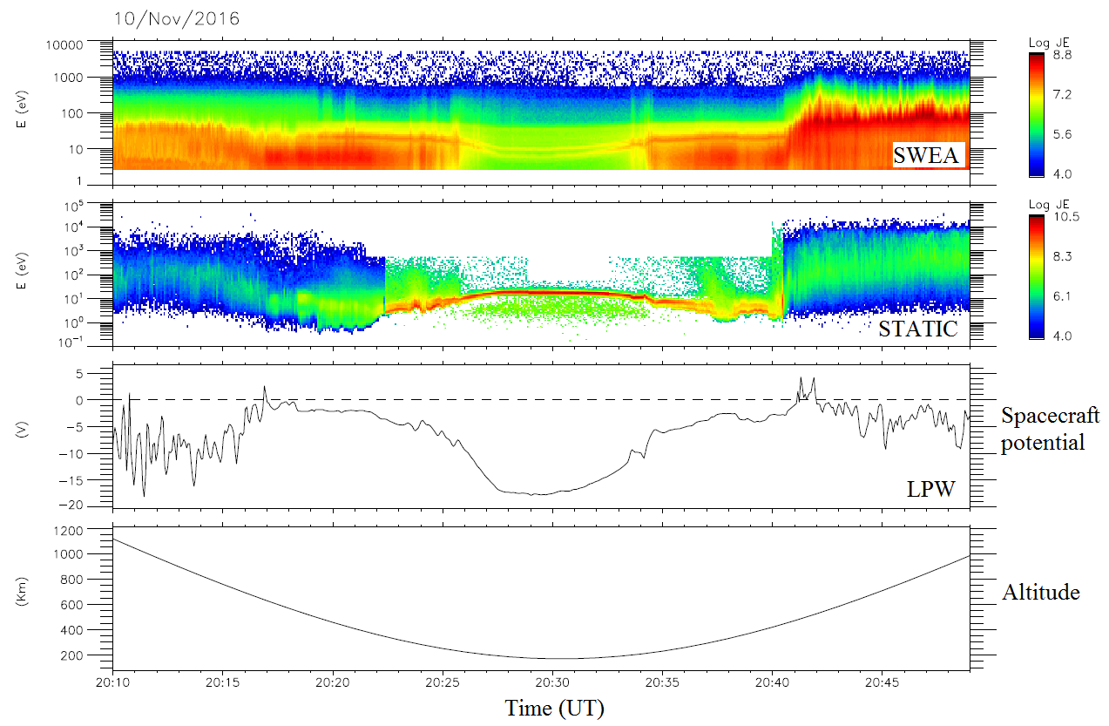

Figure 66. Example of a strong spacecraft charging observed on November 10, 2016.

First panel: SWEA energy-time spectrogram of omnidirectional electron energy flux (ENGY mode). Second panel: STATIC energy-time spectrogram of omnidirectional ion energy flux (C0 mode). Third panel: Spacecraft potential measured by LPW Fourth panel: Altitude of the spacecraft.

However, some strong spacecraft charging events can bring the spacecraft potential to a dozen of volts. An example of such event is presented in Figure 64. On the first panel is the electron time-energy spectrogram measured by SWEA, on the second panel is the time-energy spectrogram measured by STATIC (C0 mode), in the third panel is the spacecraft potential measured by LPW and finally is plotted the altitude of the spacecraft on the fourth panel. The charging event can be observed between ~20:26 and ~20:34 UT, when the spacecraft potential decreases down to -18 V. A typical enhancement in the ion energy is observed at the same time, together with a modification of the electron spectrum and the occurrence of two distinct lines, here at ~10 eV, corresponding to the two photoelectron lines (section 1.3.1.4) which are normally unresolved by MAVEN and merge into a single line. The electron flux detected at 6 eV during these events is then much lower than the mean electron flux calculated over one hour and an electron depletion can be detected, whereas no electron depletions is effectively observed. A few cases have been found during the time period under study and have been removed by hand, as far as possible. Indeed, some of these cases are located on the dayside so that they do not have any incidence on the detection of electron depletions. However, in December 2016/January 2017 a lot of spacecraft charging events have been observed near the terminator, impacting the detection of electron depletions. This issue will be discussed in more details in section 5.

The sampling time step used for the criterion is the same as the measurement cadence of the SWEA instrument: 4s. Consequently the electron depletions detected last at least 4s which corresponds to a maximum of 16 km traveled by the spacecraft when at its periapsis.

### MEX

Based on our experience with MAVEN data, we adapted criterion (1) to MEX/ELS data to obtain criterion (2):

$$\frac{1}{3}\sum_{i=1}^{3}{\begin{aligned}\frac{CR\left(E_{i}\right)}{<CR\left(E_{i}\right), 1h>} \\ \end{aligned}} < 0.02 (2)$$

In this case we use the three following energy channels: $E_{1}=21.20 eV$ (for low energies), $E_{2}=95.04 eV and E_{3}=103.25 eV$ (for high energies). Thus by taking a minimum energy above 20 eV we prevent most of the spacecraft charging effects to impact results of criterion (2). Indeed, the charged particles of lower energies are in general most sensitive to spacecraft charging and the 20 eV energy has been found to be a good compromise (*Fränz et al.* [2006]; *Hall et al*. [2016]).

We also modify the threshold ratio from 1% to 2% based on the observations of ELS data. The sampling time step used for the criterion is the same as the measurements cadence of the ELS instrument when operated in its default survey mode: 4s. Consequently, the electron depletions detected last at least 4s which corresponds to a maximum of 17 km in the spacecraft orbital direction when at periapsis.

### MGS

In the case of MGS, a criterion based on three energy channels (one low, two high) does not work well, probably due to the energy resolution of 25%. Hence, we decided to compare the measured omnidirectional flux summed over all the available energies [11 eV; 16 127 eV] every two seconds with the same product averaged over two orbits (4 hours). An electron depletion is detected if this ratio is less than 1% which corresponds to a drop of two orders of magnitude in the electron flux. The MGS criterion is described in equation (3) with a similar form to equations (1) and (2).

$$\frac{Flux\left( \left[11 eV;16 127 eV\right] \right)}{<\left(Flux\left( \left[11 eV;16 127 eV\right] \right),4h\right)>}<0.01 (3)$$

Among the energy range [11 eV; 16 127 eV], the three channels which collected the majority of the flux were 90-148 eV, 148-245 eV and 245-400 eV. Electron depletions thus show up in those three most reliable energy channels which are far too high energy to be affected by any spacecraft charging which would almost always be less than $\sim 20 eV$. Hence, the way criterion (3) have been defined make it little sensitive to spacecraft charging.

The sampling time step used for the criterion is the same as the measurements cadence of the ER instrument: 2s. Consequently, the electron depletions detected size is at least 7 km in the orbital direction.

## Application of the criteria

Once the criterion were set, we applied them to the three datasets described in section 2.3. Application to MGS and MAVEN data has been relatively easy, while the specificities of the MEX mission makes it more complicated and implied the use of results from the other two. We thus first present the application of the MGS criterion in section 3.4.1, then the application of the MAVEN criterion in section 3.4.2 and we finish by the application of the MEX criterion in section 3.4.3.

### Application to MGS

For the study of the electron depletions observed with MGS we only focus on the data obtained during the circular mapping orbit phase at an altitude of $\sim$ 400 km. The dataset covers the time period from March 10, 1999 to October 11, 2006 which represents more than 42 000 orbits. As the MGS orbit was circular at 400 km, electron depletions can potentially be observed during each orbit. Such statistics average all the effects of external drivers on electron depletions so that only stands out the general behavior of the electron depletions. Due to this huge dataset, all the electron depletions detected has not been checked, as it has been done for MAVEN, hence some artifacts can be contained in the resulting catalog.

The example proposed in Figure 65 illustrates how the criterion detects the electron depletions in agreement with the ER spectrogram. The first panel is the ER energy-time spectrogram of omnidirectional electron flux and the second panel is the ER electron flux summed over all the observed energies. The blacked out regions in the third panel delineate the electron depletions automatically detected by criterion (3), when the electron flux drops by more than two orders of magnitude at all observed energies. The fourth panel is the magnitude of the magnetic field measured by MAG (**black** profile) superimposed with the magnitude of the crustal magnetic field calculated from the model of Morschhauser (**blue** profile). On the last bottom right panel is plotted the orbital trajectory of MGS in a cylindrically symmetric MSO coordinates frame. Five depletions are detected during this time interval, in good agreement with the electron spectrogram. However we can notice that all the decreases that can be observed on panel 1 and 2 are not detected as electron depletions. This is due to the threshold of 1% chosen.

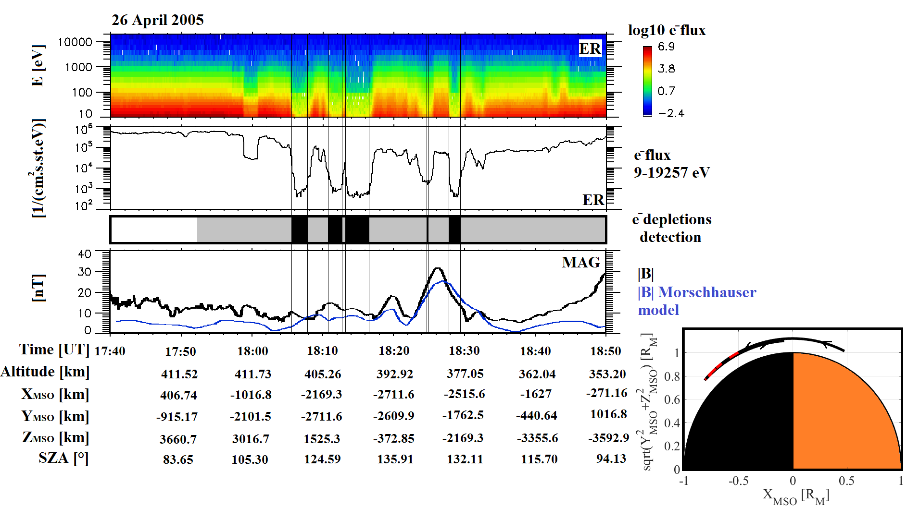

Figure 67. Example of electron depletion observed by MGS on April 26, 2005.

*First panel: ER energy-time spectrogram of omnidirectional electron flux. Second panel: ER omnidirectional electron flux summed over all energies available [11-16127 eV]. Third panel: Detection of electron depletions by criterion (3) (black boxes). The shadow corresponds to the nightside. Fourth panel: Magnetic field intensity (measured by MAG in* ***black*** *and calculated from the model of Morschhauser in* ***blue****). Fifth panel (bottom right): MGS orbital trajectory in a cylindrically symmetric MSO coordinates frame. The location of the electron depletions detected are highlighted in red.*

The application of this criterion with no additional restriction resulted in a time table of 116 278 electron depletions which means that, several electron depletions can be detected during a single orbit as in the example shown in Figure 65. Almost all these electron depletions have been detected in the nightside, except few (less than 100) isolated cases. A median value of four depletions observed per orbit has been obtained (Table 5).

### Application to MAVEN



#### Application of criterion (1)

The criterion specified in equation (1) has been applied on SWEA data from October 7, 2014 to March 13, 2017 with no restriction on the nightside nor on the altitude, which corresponds to more than 4 600 orbits.

The example proposed in Figure 66 illustrates how the criterion detects electron depletions in agreement with the SWEA spectrogram. Panel 1, 2, 4 and 5 are the same as panel 1, 2, 3 and 4 of Figure 53. In addition, on panel 3 are plotted blacked out regions which delineate the electron depletions automatically detected by criterion (1), and on panel 6 are plotted the amplitude of the magnetic field measured by MAG (**black**) and the magnitude of the crustal magnetic field calculated from the model of Morschhauser (**red**). Three electron depletions can be observed on this example, in good agreement with SWEA spectrogram. The delimitation of the depletions is clear at ~16:39 UT, while on the three other case, they are set by the threshold chosen. All the three electron depletions are located in the nightside.

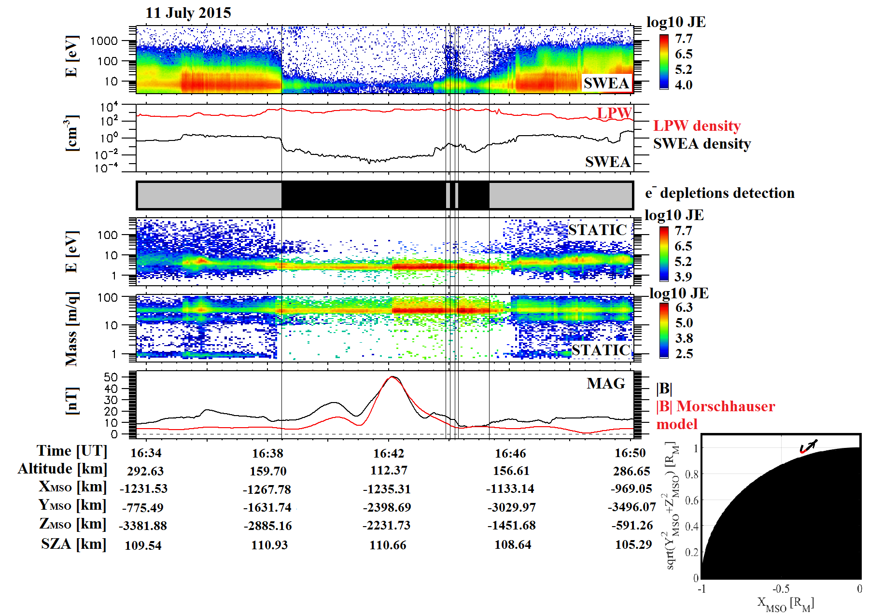

Figure 68. Example of electron depletion observed with MAVEN.

*First panel: SWEA energy-time spectrogram of omnidirectional electron energy flux (ENGY mode) corrected for the potential measured with LPW. Second panel: Electron density calculated with SWEA (black) superimposed with the density calculated with LPW (red). Third panel: Detection of electron depletions by criterion (1) (black boxes). See section 3 for more details. The shadow corresponds to the nightside. Fourth panel: STATIC energy-time spectrogram of omnidirectional ion energy flux (C0 mode). Fifth panel: STATIC mass-time spectrogram of omnidirectional ion energy flux (C6 mode). Sixth panel: Magnetic field intensity (measured by MAG in black and calculated from the model of Morschhauser in red). Seventh panel (bottom right): MAVEN orbital trajectory in a cylindrically symmetric MSO coordinates frame. The location of the electron depletions detected have been highlighted in red.*

The application of criterion (1) to the time interval under study resulted in a dataset of 9802 electron depletions identified. We thus detected several electron depletions per orbit. A median value of four depletions observed per orbit have been found, as it was found for MGS events.

#### MAVEN coverage

During the time interval under study, electron depletions have only been detected during five specific periods as it can be observed in Figure 67. In this figure is plotted in red the location of the electron depletions detected by criterion (1) in terms of altitude, latitude, local time and SZA. Superimposed in blue is the global coverage of MAVEN of the nightside low altitudes ( $X_{MSO}<0$ and altitude < 900 km). The white stripes that can be observed at some times (like in March 2016) are data gaps.

MAVEN observes electron depletions from ~110 km (during a deep dip) up to ~900 km (during the second period). Although MAVEN reached higher altitudes in the induced magnetosphere, criterion (1) detected no depletion above 900 km. With these five periods, approximately all the possible latitudes reachable by MAVEN have been sampled, but all the altitudes are not yet equally covered. Looking at panel 3 and 4 of Figure 67 we can see that all but seven electron depletions are located on the nightside defined as $X_{MSO}<0$. These seven cases will be investigated in section 5.1. At first glance, electron depletions seem to be more detected on the dawn side than on the dusk side, but it is only a coverage issue. Depending on the period, the dawn side and the dusk side are not equally covered, and the deep nightside (SZA close to 180°) is rarely reached.

In summary, electron depletions are detected during specific periods when the spacecraft reaches low altitudes (<900 km) in the nightside. They can last from 4s up to 15 minutes.



Figure 69. MAVEN coverage of the nightside low altitudes (<900km) (**blue**) superimposed with the location of the detected electron depletions (**red**).

*Panel 1: Altitude vs time; Panel 2: Latitude vs time; Panel 3: Local time vs time; Panel 4: SZA vs time.*

### Application to MEX

The time period under study for MEX data is from March 1, 2004 to December 31, 2014, which is similar to the one studied by *Hall et al.* [2016]. This corresponds to approximately 14072 orbits. However we only applied criterion (2) on time intervals longer than one hour when ELS was working in the Survey mode, which corresponds to 9 983 time intervals. The time period under study is long enough to allow the periapsis to cover the whole surface of Mars between latitudes of -86° and +86° and all the local times in the nightside thanks to the precessing orbit of MEX.

#### Unrestricted application

The application of criterion (2) with no restriction on the altitude nor on the nightside resulted in a time table of 17 592 electron depletions. The example proposed in Figure 68 illustrates how the criterion detects the electron depletions in agreement with the ELS spectrogram. The first panel is the ELS energy-time spectrogram of omnidirectional electron counts per second and the second panel is the ELS omnidirectional electron counts per second summed over all the available energies. The blacked out regions in the third panel delineate the electron depletions automatically detected by criterion (2), when the electron count drops abruptly by more than two orders of magnitude at all the considered energies and thus reaches the background noise level ($\sim$ 40 c/s $)$. On the last bottom right panel is plotted the orbital trajectory of MEX in a cylindrically symmetric MSO coordinates frame. Three depletions are detected in this example, in good agreement with the electron spectrogram.

The depletions detected by criterion (2) are detected from 245 km to $\sim$ 10 000 km both on the nightside and on the dayside (for a small amount of cases). Globally, the depletions have been detected as in the MAVEN case during specific time periods when the periapsis went across the nightside at low enough altitudes. However, most of the depletions observed on the dayside and at altitudes above 1 000 km have to be considered with caution (since they include very short data gaps and the lobes - the region located on either side of the plasma sheet with reduced particle fluxes - that cannot be easily excluded). An example of observation of the lobes is provided in Figure 69. On the first panel is plotted the ELS energy-time spectrogram of omnidirectional electron counts per second, on the second panel is the radial distance of the spacecraft and on the third panel its location in MSO coordinates. The two decreases observe between ~11:31 UT and ~11:38 UT, and between ~11:40 UT and ~11:48 UT are quite similar to two electron depletions separated by a spike. However, looking at the entire orbit, these structure are more likely to be two lobes, separated by a current sheet. Usually, criterion (2) cannot make this difference and detects electron depletions as well as tail lobes. However, the tail lobes are usually located at large distances from the planet.

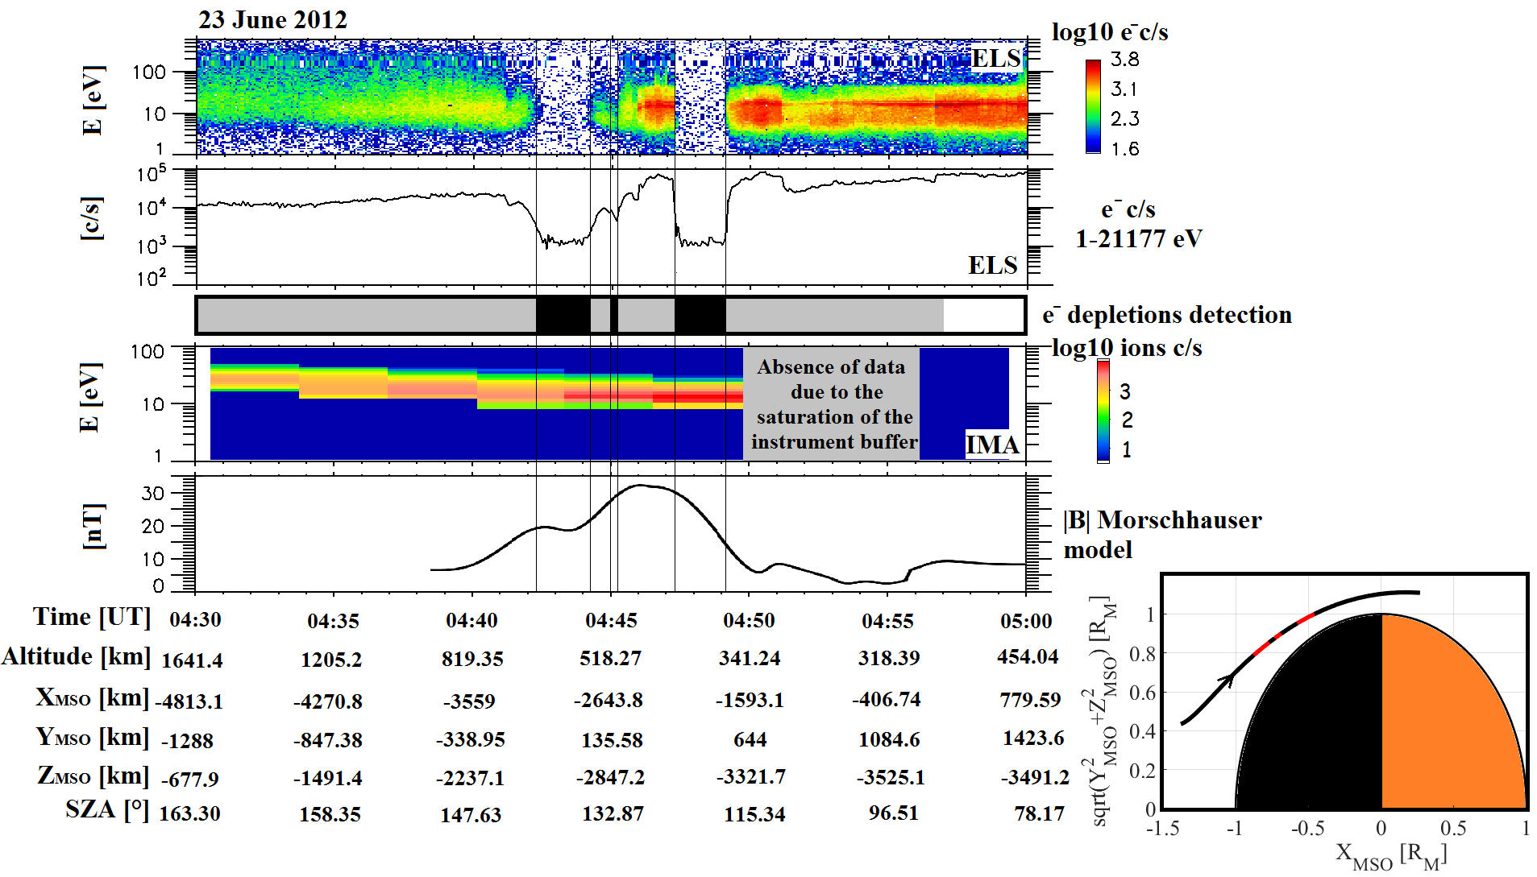

Figure 70. Example of electron depletion observed by MEX on June 23, 2012.

*First panel: ELS energy-time spectrogram of omnidirectional electron counts per second. Second panel: ELS electron counts per second summed over all the energies available (1-21177 eV). Third panel: Detection of electron depletions by criterion (2) (black boxes). The shadow corresponds to the nightside. Fourth panel: IMA energy-time spectrogram of omnidirectional heavy ions counts per second (m/q>20). Fifth panel: Magnetic field intensity calculated from the Morschhauser model. Sixth panel (bottom right): MEX orbital trajectory in a cylindrically symmetric MSO coordinates frame. The location of the electron depletions detected are highlighted in red.*

Surprisingly, the MAVEN criterion achieves to make the difference between electron depletions and lobes. This issue is not yet fully understand but may be due to the energy range of the instrument. Regarding MGS, its restriction to altitude close to 400 km prevented it from detecting lobes.

#### Restricted application

We therefore chose to only consider for the next studies depletions observed in the nightside below 900 km, which is consistent with our MAVEN results and enables the two studies to be compared. With these restrictions, 14 517 depletions have been found on 2 197 orbits, which implies a strong presence of spikes in MEX data as in the example in Figure 51 and Figure 68. A median value of five depletions observed per orbit have been found.

The median number of depletions per orbit for MEX data is a slightly higher but remains similar to both MAVEN and MGS which confirms that the occurrence of the electron depletions is stable during the three periods and consistent among the three spacecraft.

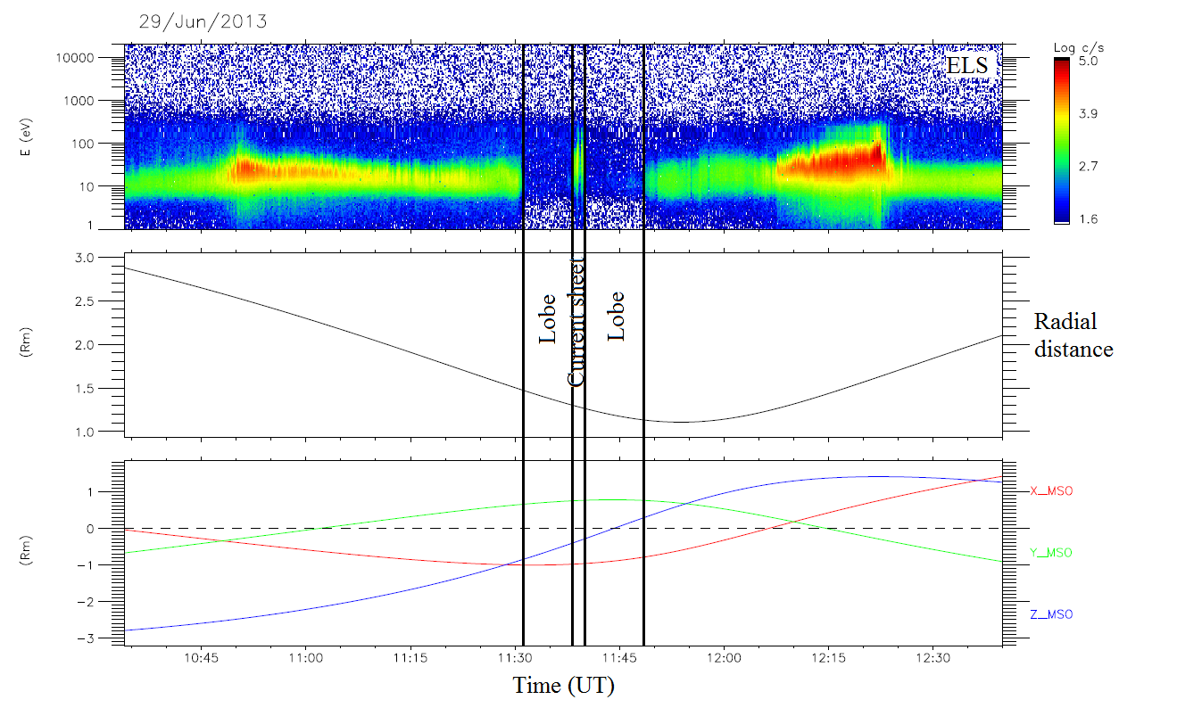

Figure 71. Example of a tail crossing by MEX on June 29, 2013.

*Panel 1: ELS energy-time spectrogram of omnidirectional electron counts per second. Panel 2: radial distance of the MEX spacecraft. Panel 3: Position of the MEX spacecraft in MSO coordinates.*

|  |  |  |  |
| --- | --- | --- | --- |
|  | **MGS** | **MEX** | **MAVEN** |
| **Number of orbits under study** | 42 048 | 9 983 | 4661 |
| **Number of depletions detected** | 116 278 | 14 517 | 9802 |
| **Number of orbits containing depletions** | 29 460 | 2 197 | 2 157 |
| **Median number of depletions per orbit** | 4 | 5 | 4 |

Table 5. For each mission are reported here the number of orbits under study (for MEX it corresponds to the number of time intervals longer than one hour when ELS was in the survey mode. It corresponds approximately to the number of orbits studied), the number of depletions detected by criterion (3) for MGS, criterion (2) for MEX and criterion (1) for MAVEN, the number of orbits containing depletions and the median number of depletions per orbit.

# Determination of the processes at the origin of suprathermal electron depletions

Application of criterion (1), (2) and (3) results in three catalogs of electron depletions, with different coverages, allowing a global vision of the phenomenon which enable us to better understand the processes at the origin of their observation.

As it was observed with MGS and MEX that electron depletions mainly coincide with strong horizontal crustal magnetic fields, we first study the geographical distribution of electron depletions (section 4.1). The use of these three catalogues enable us to observe this phenomenon according to different point of view: MGS and its rather constant altitude of $\sim$ 400 km and MEX has its lower periapsis at 245 km, MAVEN can reach altitudes down to 125 km during its ‘deep-dip’ campaigns.

## Altitude distribution of suprathermal electron depletions

In order to investigate the altitude distribution of all electron depletions we binned our data with constant bins of 2 km altitude. For each bin we first determined the number of electron depletions and then the number of MAVEN’s passages contained therein during the time period under study (excluding data gaps during safe mode) in order to remove any orbital bias. The percentage of electron depletions per MAVEN passage is then the ratio of these two numbers, and the result of our statistical binning is provided in Figure 72. The results for the five different periods are plotted in different colors and the total altitude distribution is superimposed in dashed line.

First, the number of electron depletions increases with decreasing altitude. Second, there is a particularly noticeable slope change in our data distribution around 170 km: above 170 km there are 14% of depletions per passage, whereas below 170 km there are 46% of depletions per passage. The percentage even reaches 100% at 125 km during the deep-dip campaign. In order to understand the differences between electron depletion occurrence above and below 170 km we will at first examine the geographic distribution of the electron depletions below this altitude and then above.



Figure 72.

[Add total percentage + recalculate the percentage above and below 170 km]



## Geographical distribution maps of electron depletions

Thanks to the three catalogs obtained after application of the three criteria described above, we created geographical distribution maps of electron depletions detected by MGS, MEX and now MAVEN above all the Martian surface. In the next three sub-sections we present the geographical distributions obtained with the three spacecraft whose periapsis decreased from MGS to MAVEN. We start with a mean altitude of 400 km with MGS, then go down to ~250 km with MEX and finally reach altitudes of ~125 km with MAVEN.

### The vision from above 250 km altitude

#### MGS

In Figure 70 is plotted the number of electron depletions detected by criterion (3) on a geographical map. The latitude-longitude map of Mars is detailed in spatial bins of 1° by 1°. We can observe the presence of zebra all over the map. This effect is only due to the spacecraft coverage which is not uniform. Another effect of the spacecraft coverage is a distortion in latitudes, the high latitudes being more often observed than the equatorial latitudes.

So as to prevent these effects, we calculate the percentage of electron depletions detected per spacecraft passage. For each bin we scored the number of time steps when electron depletions are detected and divided it by the total number of time steps when MGS was in this bin on the nightside. There is on average more than 1 000 time steps when MGS is in the nightside per bin. The corresponding ‘density map’ of electron depletions is plotted in Figure 71. The color code corresponds to the percentage of electron depletions detected per MGS passage on the nightside. We have also superimposed logarithmically spaced (between 10 to 100 nT) contour lines of the horizontal crustal magnetic field calculated at 400 km altitude from the Morschhauser model.



Figure 73. In color, the number of electron depletions detected by criterion (3) from MGS data on a geographic map of the Martian surface with a constant bin size of 1° per 1°.

We can see that, globally, the electron depletions are localized over some spots where the horizontal crustal field is at a local maximum. The contours of the majority of these regions with enhanced depletions occurrence are in good agreement with the extension of the strong crustal magnetic field sources. Hence this map confirms the strong link existing between electron depletions and horizontal crustal magnetic field at 400 km. However we can see that some depletions are located over weak horizontal crustal magnetic field areas such as [340°E, 20°N] or are slightly shifted from the nearest crustal magnetic field source location such as [200°E, 20°N]. Such depletions away from crustal magnetic sources may indicate the presence of loops of closed magnetic field connecting together crustal magnetic field sources in widely separated locations [*Brain et al.,* 2007]. We can also notice that the large area with high horizontal crustal magnetic field at high negative latitudes does not fit well with high electron depletions density area. This effect may be due to the inclination of Mars on its orbit which is about 25°. This implies seasons during which part of the polar regions are always in sunlight whereas they are considered as being in the nightside due to the use of the MSO coordinates. Thus no depletions are detected but these periods are taken into account as MGS passage in the nightside. We will be able to compare this effect with MEX results in the next section (MAVEN does not cover this region).



Figure 74. In color, the percentages of electron depletions detected with criterion (3) from MGS data per MGS passage on the nightside on a geographic map of the Martian surface with constant bin size of 1° by 1°. In black, the horizontal magnetic field contour lines calculated from the model of Morschhauser at an altitude of 400 km. The contour lines have been plotted for horizontal crustal fields of 10, 13, 16, 20, 25, 32, 40, 50, 63, 79, and 100 nT.

The presence of permanent (100% of electron depletions detected per MGS passage in the nightside) and intermittent electron depletions can also be observed, as first reported by *Lillis and Brain,* [2013]. The permanent depletions seem to be coincident with the strongest horizontal crustal magnetic fields whereas the intermittent ones are located over weaker crustal magnetic sources or on the border of the strongest ones. MGS data are particularly useful to study the permanent or intermittent nature of electron depletions as data have been sampled into a narrow range of altitudes.

#### MEX

Figure 72 shows the density map of the electron depletions evaluated with criterion (2). We chose to divide the surface of Mars into spatial bins of 2° by 2°, as there is less data points than for MGS (Table 5). The color code corresponds to the percentage of electron depletions per MEX passage. For each bin we calculated the ratio between the number of time steps when an electron depletion is detected and the total number of time steps when MEX is in the nightside with an altitude below 900 km. There are on average 500 MEX observation time steps per bin. We have also superimposed logarithmically spaced (between 10 and 100 nT) contour lines of the horizontal crustal magnetic field calculated at 400 km altitude from the Morschhauser model so that the map of MEX and MGS can be compared.



Figure 75. In color, the percentages of electron depletions detected with criterion (2) from MEX data per MEX passage on the nightside on a geographic map of the Martian surface with constant bin size of 2° by 2°. In black, the horizontal magnetic field contour lines calculated from the model of Morschhauser at an altitude of 400 km. The contour lines have been plotted for horizontal crustal fields of 10, 13, 16, 20, 25, 32, 40, 50, 63, 79, and 100 nT.

As for MGS, we can see that the electron depletions are globally localized over regions of strong horizontal crustal magnetic field. This supports the idea that, above $\sim$ 250 km, the main mechanism responsible for electron depletions is still the exclusion by closed crustal magnetic loops. Some electron depletions can still be found over areas without strong crustal magnetic field such as: [40°E, 60°N]. However, we can see on this map that the areas with strong crustal fields located at high southern latitudes are now in a better agreement with the distribution of electron depletions. This difference with MGS may be due to the different ways MGS and MEX covered the Martian surface. MGS covered each latitude on the nightside on each orbit whereas MEX periapsis only covers the southern pole during specific periods. Thus, depending on the seasons when these periods occurred, the percentages obtained in the southern pole region are shifted. As observed previously on Figure 71, both maps show that the regions with strong concentration of electron depletions are surrounded by regions having moderate occurrence rate.

The percentages found on Figure 72 are much lower than those found on Figure 71 with MGS and do not enable us to analyze the presence of permanent and intermittent depletions. However, these percentages seem quite similar to those found by *Hall et al.* [2016]. Using the depletions automatically detected thanks to their criterion, *Hall et al.* [2016] produced an occurrence map (Figure 73) of the electron depletions observed with MEX during the same time period with a resolution of 15° by 15°, in order to emphasize large scale occurrences. This map highlights several areas where electron depletions are concentrated which are consistent with the ones observed on Figure 72, like the regions centered on [300°E, -40°N] or [200°E, -60°N]. The two maps are comparable except for the regions centered on [200°E; -10°N] where *Hall et al.* [2016] found their maximum occurrence of depletions. We here found for this region a percentage of $\sim 15 \%$ with no real extension toward the Northern hemisphere but rather toward the Southern hemisphere where the maximum percentages are located, coincident with the strongest horizontal crustal magnetic fields. Figure 71 and Figure 72 also revealed the presence of electron depletions in the region centered on [70°E, 80°N] where a small crustal magnetic source exist but which is not observed by *Hall et al.* [2016], maybe due to the resolution chosen. Finally, the noise observed on Figure 72 has also been detected by *Hall et al.* [2016] who found a background level around 10% present all over their map. We here tend to limit this noise by selecting events on the nightside and at altitudes below 900 km.

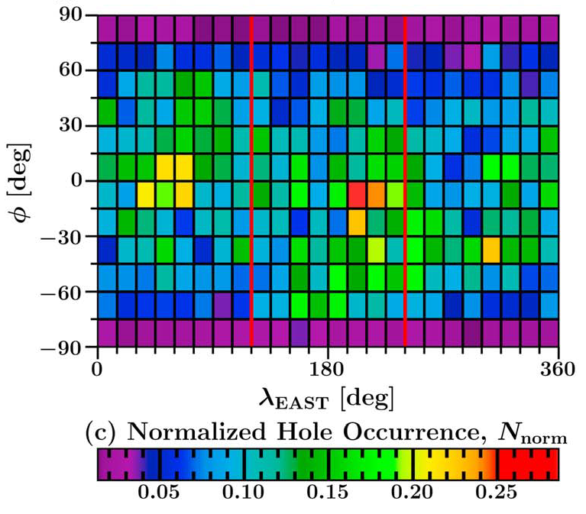

Figure 76. Electron hole occurrence normalized by orbital coverage ($N_{norm}$) at altitudes less than 1300 km above the surface of Mars. The map has a spatial resolution of 15° $×$ 15° latitude ($φ$) and east longitude ($λ_{E}$). Adapted from Hall et al., [2016].

#### MAVEN (above 250 km)

In Figure 74 is plotted the density map of the electron depletions evaluated with criterion (1) at altitudes greater than 250 km. We chose to divide the surface of Mars into spatial bins of 2° by 2°, as for the MEX map. As for Figure 71 and Figure 72 the color code corresponds to the percentage of electron depletions per MAVEN passage. For each bin we calculated the ratio between the number of time steps when an electron depletion is detected and the total number of time steps when MAVEN is in the nightside with an altitude below 900 km. There are on average 227 MAVEN observation time steps per bin. We have also superimposed logarithmically spaced (between 10 and 100 nT) contour lines of the horizontal crustal magnetic field calculated at 400 km altitude from the Morschhauser model so that this map of MAVEN at high altitudes can be compared with the ones of MGS and MEX.

The map obtained with MAVEN data at high altitudes is quite similar to the MEX map, though the percentage are higher, certainly due to the recurrent passage of MAVEN at 250 km while MEX only reach these altitudes a few times. Electron depletions are in this case too localized over regions of strong horizontal crustal magnetic field.

The electron depletions which appear away from crustal magnetic sources in Figure 71 and Figure 72 ([40°E, 60°N]; [340°E, 20°N]; [200°E, 20°N]) are still observed with MAVEN, though they are less stand out. One region we clearly find on the three maps is the one at [70°E; 30°N], in the middle of two weak crustal magnetic field sources.



Figure 77. In color, the percentages of electron depletions detected above 250 km with criterion (1) from MAVEN data per MAVEN passage on the nightside on a geographic map of the Martian surface with constant bin size of 2° by 2°. In black, the horizontal magnetic field contour lines calculated from the model of Morschhauser at an altitude of 400 km. The contour lines have been plotted for horizontal crustal fields of 10, 13, 16, 20, 25, 32, 40, 50, 63, 79, and 100 nT.

The comparison of the geographical distribution of the electron depletions obtained with three datasets confirmed the strong linked existing between the suprathermal electron depletions and the closed crustal magnetic field lines, down to 250 km. Now, thanks to MAVEN, we can dive down to ~125 km to observe if this link still exist at low altitudes.

### Going down to 125 km altitudes with MAVEN

#### From 250 to 170 km

In Figure 75 is plotted the density map of electron depletions detected by MAVEN at altitudes between 170 and 250 km. As for Figure 74 we calculated the number of time steps when electron depletions are detected in spatial bins of 3° longitude by 3° latitude and divided it by the number of time steps when MAVEN is in the nightside in each bin. We chose a lower spatial resolution as the MAVEN coverage of the Martian surface decrease with the altitude. There are for this map an average of 147 MAVEN passages per bin. The density map is superimposed with a map of the horizontal crustal field calculated at 170 km with the Morschhauser model. The contour lines are logarithmically spaced between 10 and 1000 nT.



Figure 78. In color, the percentages of electron depletions detected above 170 km and below 250 km with criterion (1) from MAVEN data per MAVEN passage on the nightside on a geographic map of the Martian surface with constant bin size of 3° by 3°. In black, the horizontal magnetic field contour lines calculated from the model of Morschhauser at an altitude of 170 km. The contour lines have been plotted for horizontal crustal fields of 10, 18, 32, 56, 100, 178, 316, 562 and 1000 nT.

We can observe that the electron depletions are far more spread on the Martian surface than on the maps obtained for altitudes above 250 km. However, as the altitude decreases, the crustal magnetic field sources get also more spread and finally, the correspondence between the location of suprathermal electron depletions and strong horizontal crustal magnetic field is still good. The boundaries of the high percentage of electron depletions area are not as well defined as in the MGS map, due to size of the magnetic field sources regarding the size of the bins chosen.

The variability of the percentage of electron depletions per MAVEN passage seems to support the idea of permanent and intermittent electron depletions. Hence percentages close to 100% are preferentially seen near the local maxima of horizontal crustal fields whereas lower percentages are observed far from crustal magnetic field sources, which means that electron depletions are not always present when MAVEN observes these regions. However, as the MAVEN coverage is still not as fine as the one of MGS, we cannot affirm that permanent depletions are surrounded by intermittent ones as it was observed on MGS distribution but we can see a trend emerge.

A clear and well delimited aggregate of electron depletions can be observed at [40°E; 70°S]. It is however not coincident with strong crustal magnetic sources. This structure slightly appears on the MEX map but not on the other structure. Observing the neighboring magnetic topology, a small crustal magnetic source can be observed northward, slightly sifted westward. This shift has already been observed on MGS and could be attributed to …

#### From 170 to 110 km

In Figure 76 is plotted the density maps of electron depletions detected with MAVEN for altitudes below 170 km. In the same way as for Figure 75, we calculated the number of time steps when electron depletions are detected in spatial bins of 3° longitude by 3° latitude and divided it by the number of time steps when MAVEN is in the nightside in each bin. The density map is superimposed with a map of the horizontal crustal field calculated at 170 km with the Morschhauser model. The contour lines are logarithmically spaced between 10 and 1000 nT. On average, there are 138 time steps per bin.

We can see that the higher percentage of electron depletions are still localized above strong crustal magnetic field sources but we can notice that the global distribution is far more homogeneous than for the distribution above 170 km, regardless of the horizontal magnetic field.

Thus closed crustal magnetic loops are still an important process responsible for electron depletions. However, there is also another important process which is involved and which does not depend a priori on crustal magnetic field, like electron absorption by atmospheric $CO_{2}$. The study of the Southern hemisphere of Mars confirms the fact that the distribution of electron depletions is highly dependent on altitude.



Figure 79. In color, the percentages of electron depletions detected below 170 km with criterion (1) from MAVEN data per MAVEN passage on the nightside on a geographic map of the Martian surface with constant bin size of 3° by 3°. In black, the horizontal magnetic field contour lines calculated from the model of Morschhauser at an altitude of 170 km. The contour lines have been plotted for horizontal crustal fields of 10, 18, 32, 56, 100, 178, 316, 562 and 1000 nT.

## Composition

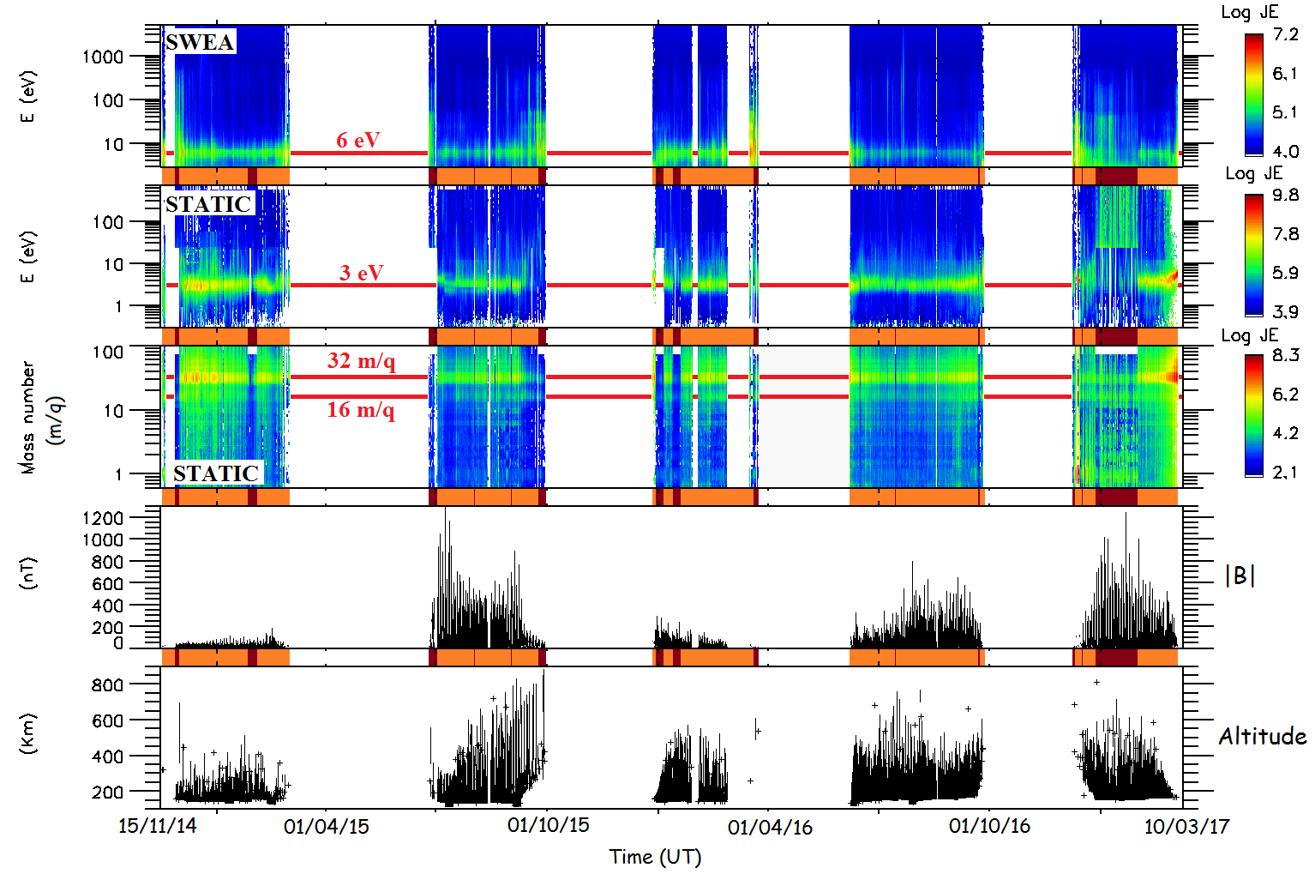

Figure 80

## Pressure balance



### Comparison between the Northern and Southern hemisphere

Since the MAVEN data currently only covers latitudes northward of $\sim$ 20° and southward of $\sim$-20°, we only include MEX observations of the electron depletions detected in the same range of latitudes. We have also studied the Northern and the Southern hemispheres separately. For both spacecraft we took an altitude resolution of 2 km, which represent $\sim$ 10 000 MEX passages per bin and $\sim$ 2 600MAVEN passages per bin on average. For each bin we calculated the number of time steps when electron depletions are detected and the number of time steps when the spacecraft is in the nightside. The ratio gives the percentage of electron depletions among the spacecraft passages in each altitude bin. The MGS observations previously discussed are not applicable to this analysis, since the spacecraft had a circular orbit with an almost constant altitude.

Figure 81 shows the percentage of electron depletions detected along the MAVEN and MEX passages as a function of altitude. The red and green profiles correspond to observations made by MAVEN and MEX respectively above the Southern hemisphere, whilst the blue and black profiles correspond to observations made by MAVEN and MEX respectively above the Northern hemisphere. We can notice that MEX data are only available down to 307 km in the Northern hemisphere whereas they are available down to 245 km in the Southern hemisphere. This difference is only due to MEX orbital geometry.



Figure 81.

We can see that the MEX and MAVEN data match well between 900 and 300 km. In this range of altitude, both datasets show that there is far more chance to detect an electron depletion in the Southern hemisphere than in the Northern hemisphere. This phenomenon seems to be due to the presence in the Southern hemisphere of stronger crustal magnetic sources than in the Northern hemisphere. Hence the closed crustal magnetic loops can extend higher in the Southern hemisphere than in the Northern. Between 300 and 245 km, as data are no more recorded by MEX in the Northern hemisphere, there are still some in the Southern hemisphere. Although strong variations can be observed on MEX data, we can see that the profile fellows the trend set by MAVEN data. These variations may be due to the range of altitudes which is beneath the nominal periapsis and hence sparsely covered by the spacecraft.

For altitudes greater than 500 km, *Hall et al.* [2016] found that the normalized occurrence of electron depletions was less than 5% across the majority of latitudes and altitudes, except for the strongest crustal magnetic field regions around which the majority of the events are distributed and where enhanced occurrence are then detected up to 1 000 km. This is consistent with the results obtained on figure 8 even if the percentages are lower than those found by *Hall et al.* [2016]: 1% in the Northern hemisphere and 3% in the Southern hemisphere at 500 km. Below 500 km, the occurrence of electron depletions increases rapidly in both studies. The main difference is that *Hall et al.* [2016] found that below 500 km the distribution of electron depletions become more homogeneous, even if the higher occurrence are still located above the strongest crustal magnetic fields area. On figure 8 we clearly see that there is more electron depletions detected by MEX in the Southern hemisphere than in the Northern hemisphere, at least until 300 km. The difference between the two hemispheres even increase between 500 km and 300 km.

Where MEX ceases to record data, MAVEN continues to observe electron depletions at lower altitudes. We can see that the difference in percentage between the Southern and the Northern hemispheres persists until a transition region near 160-170 km altitude, where the two curves join and stay close until 125 km. Hence, at low altitudes the electron depletion distribution does not depend on the hemisphere nor on the presence of crustal magnetic sources. This result reinforces the conclusions of *Steckiewicz et al.* [2015] in which two main processes are responsible for electron depletions, each of which become more predominant at different altitude regimes. Events above 160-170 km altitude are predominantly produced by the exclusion of suprathermal electrons by closed crustal magnetic fields, whereas events below 160-170 km are predominantly produced by absorption by atmospheric $CO_{2}$. The study of the Southern hemisphere with MAVEN data also shows that the transition between the altitude regimes seems to be the same in both hemispheres, regardless the intensity of the crustal magnetic sources.

### Evolution of the altitude distribution with crustal field



Figure 82

### Pressure balance

## Discussion

**[Papier shaosui shape parameter at low altitudes]**

# Physical processes: Interaction plasma/neutrals

[to complete]



## Observation of electron depletions on the dayside

Among the five periods during which MAVEN detected electron depletions (section 3.4.2.2), we found seven cases during which part of the electron depletions was located on the dayside ($X_{MSO}>0)$. Four are located during the second period, in September 2015, and the three other are located during the fifth period, in December 2016/January 2017. The detection of such structures in dayside is not due to the same process in both cases.

### An altitude issue

The four portions of electron depletions detected by MAVEN in the dayside in September 2015 corresponds to the boundaries of real electron depletions, which are observed shortly before entering the nightside. These four cases occurred during a MAVEN deep dip, during which the spacecraft reached ~110 km altitude. Such low altitudes has never been reached again since then in the nightside.

The boundaries of suprathermal electron depletions can be discussed, as they are fixed by the threshold chosen for criterion (1). However, as the same criterion has been applied to the whole MAVEN data, we can consider these boundaries as legitimate as the others and that at very low altitudes, electron depletions can extend to the dayside. This issue will be discussed in more details in section ??.

### A spacecraft charging issue

The three portions of electron depletions detected by MAVEN on the dayside in December 2016/January 2017 are artefacts due to spacecraft charging. As mentioned in section 3.4.2.2, a lot of spacecraft charging events occurred in late 2016, early 2017. Before December 2016, the periapsis occurred on the dayside so that spacecraft charging events were easily observable and removable. However, from December 09, 2016, the periapsis get close enough to the nightside for electron depletions to be observed on SWEA data. As criterion (1) detects the same way electron depletions and spacecraft charging events, if an electron depletion is present close to the terminator, and a spacecraft charging event occurs when the spacecraft reaches the dayside, it will be considered as the extension of the electron depletion by criterion (1). The presence of such spacecraft charging events close to an electron depletion results in the detection of a biggest electron depletion than it truly is. An example of such dripping is proposed in Figure 77.

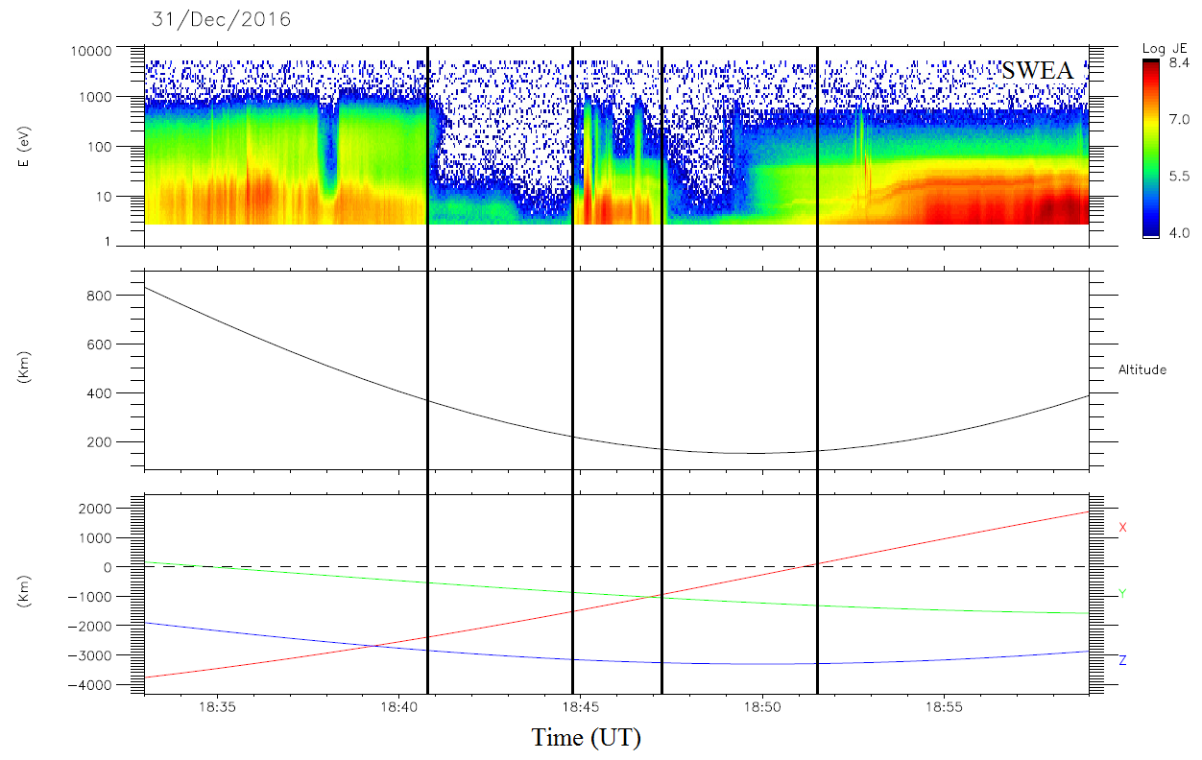

Figure 83. An example of the dripping of an electron depletion detected by criterion (1) due to spacecraft charging.

*Panel 1: SWEA energy-time spectrogram of omnidirectional electron energy flux (ENGY mode). Panel 2: Altitude of the MAVEN spacecraft. Panel 3: Position of the MAVEN spacecraft in the MSO coordinates. The black vertical lines highlight the boundaries of the electron depletions detected with criterion (1).*

On the first panel is plotted SWEA electron spectrogram and the boundaries of the electron depletions detected by criterion (1) are represented as the vertical black lines. Two electron depletions have been detected in the nightside and close to the terminator ( $X_{MSO}$ reverses at ~18:51 UT). We can observe the presence of a spacecraft charging event between ~18:50 UT and ~18:53 UT. As the first electron depletion is roughly well delimited, the second one extend until 18:51:32 UT while it should stop at ~18:50 UT. The spacecraft charging event is detected as an electron depletion. As there is no boundary between both structures, from the point of view of the criterion, it results in a huge electron depletion, which drip toward the dayside.

Due to this specific configuration, a lot of electron depletions detected in December 2016/January 2017 are bigger than they truly are, even if they do not extend until the dayside. This issue does not have a great impact on the geographical maps presented in section 4.1 nor on the altitude distribution presented in section 4.3 due to the volume of data. We hence chose to include this period in those studies. However, as might be expected, it has a strong impact on the distribution of suprathermal electron depletions with SZA, as it is shown in section 5.2.2.

## Observation of the EUV terminator

[to complete]

### Definition of the nightside

In the previous sections of this manuscript we defined the nightside as $X_{MSO}<0$, which was good enough for the studies leaded. However this definition is simplistic. The terminator, which is the boundary between where sunlight is received and where it is not, is not located at the same altitude for all SZA. The nightside can be seen as the shadow of the planet.

The nightside can be defined as the **optical** **shadow** of the planet, and represented by a cylinder having for radius the radius of the planet (left part of Figure 78). The nightside is in this case defined as:

$$SZA>90+\operatorname{acos}\left(\frac{R_{Mars}}{r}\right)$$

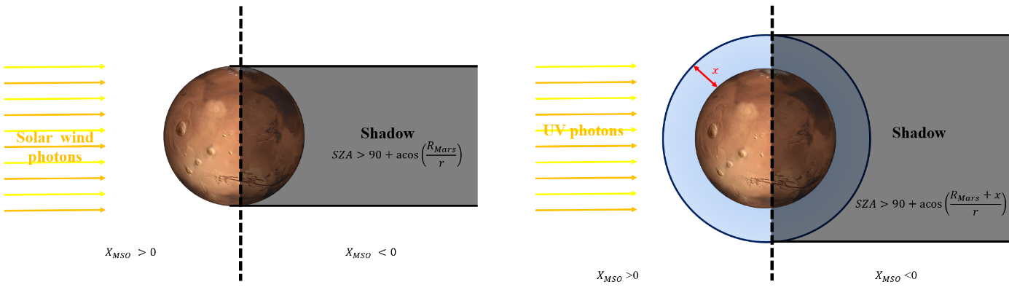

Figure 84. Definition of the nightside. On the left side is the optical shadow. On the right side is the UV shadow.

A conic shadow, taking into account the distance of Mars from the Sun, could also have been considered. However, this would result in a cone which angle is $\sim 8.5×{10}^{-4} °$. The difference between the cylindrical and the conic shadow at an altitude of 1000 km would be of ~65 m, which is far below the resolution of our data. The cylindrical shadow is sufficiently accurate for our purpose.

All the sunlight wavelengths does not reach the surface of Mars. Numerous of them interact with the atmosphere and are no more present below a certain thickness of atmosphere. One wavelength range in particular interests us in this study on the ionosphere: the EUV-UV wavelengths. We saw in section 1.2.1.1 that EUV and UV photons were the main particles involved in the photoionization of the atmosphere and the creation of the ionosphere. Hence, below some altitudes, EUV-UV photons are no more observed and we can define a EUV-UV shadow and EUV-UV terminator (called hereinafter UV shadow UV terminator for convenience). The **UV shadow** corresponds to the cylindrical shadow obtained with Mars surrounded by a layer of $x$ km of remaining atmosphere (right side of Figure 78), which do not interact with EUV-UV photons. In this case, the nightside is defined as:

$$SZA>90+\operatorname{acos}\left(\frac{R_{Mars}+x}{r}\right)$$

The UV shadow is illustrated in Figure 79. Assuming that total absorption occurs at 150 km altitude, the blue rays indicate the UV photons beams coming from the Sun (on the left). The black line is the surface of the planet and the green lines represent SZA from 85° to 115° in 5° increments. The red cross indicates 150 km altitude and the green crosses indicate the last light observable for each green line. From 95° to 115° SZA, the green cross are at approximated altitudes of 160, 195, 270, 370 and 500 km. Hence, no photoionization occur at low altitudes for SZA between 90° and 115°, but can still occur at higher altitudes, resulting in an increase in density at high altitudes.

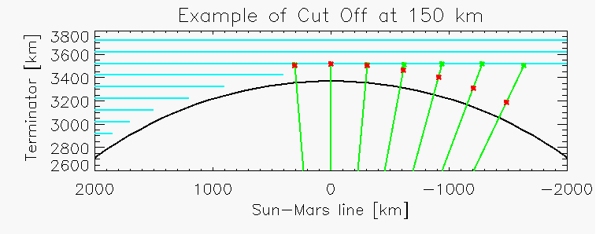

Figure 85. Illustration of how much of the ionosphere is in shadow past the terminator assuming total absorption at 150 km [Andersson et al., in preparation].

### Observation of the UV terminator with LPW

The UV terminator can be observed by the LPW instruments. In Figure 80 is plotted a MAVEN pass on the nightside, as observed by the LPW instrument. On the first panel is plotted the electron energy-time spectrogram recorded by SWEA, on the second panel is plotted the floating potential, on the third panel is the Current/Voltage spectrogram and on the two last panels are the altitude and position of the MAVEN spacecraft in the MSO coordinates.

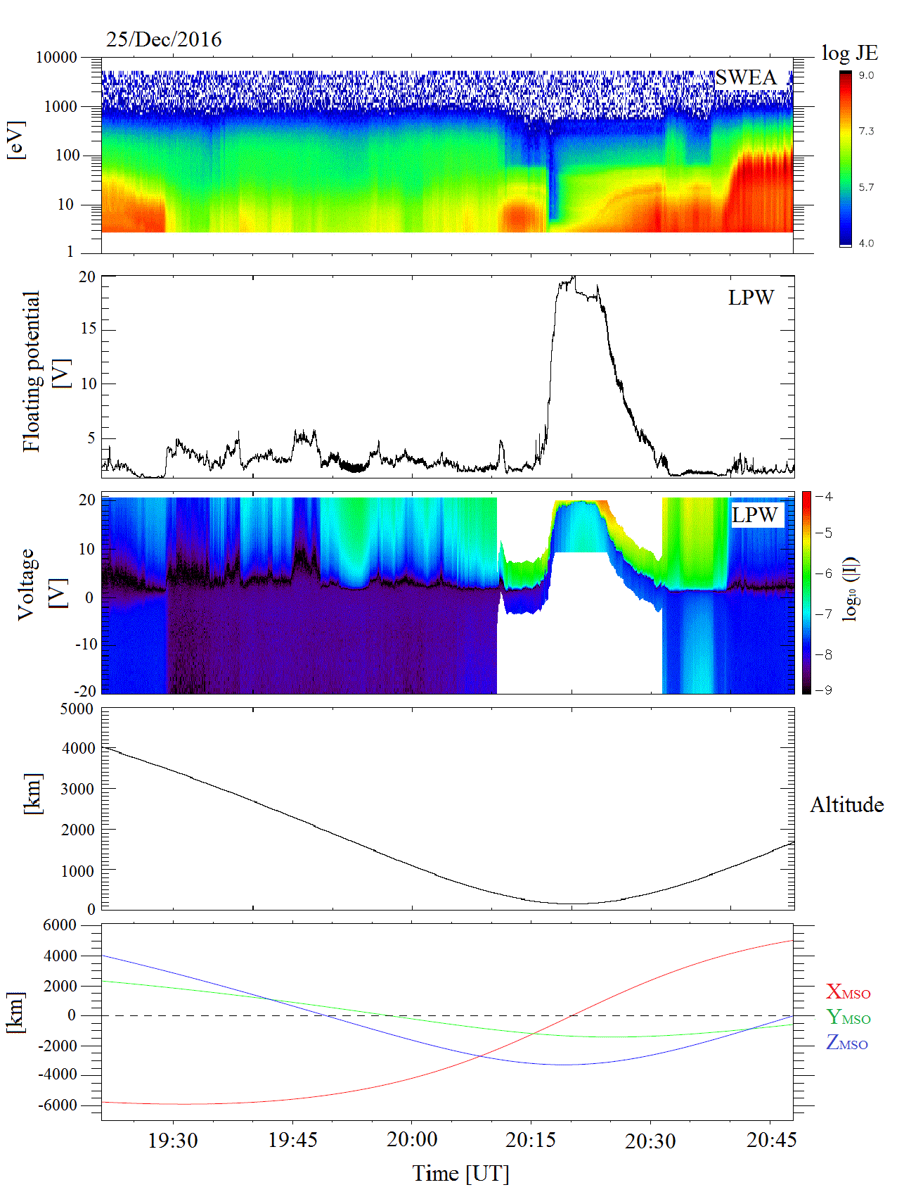

Figure 86. Observation of the UV terminator with the LPW instrument. Panel 1: SWEA energy-time spectrogram of omnidirectional electron energy flux (ENGY mode). Panel 2: Floating potential. Panel 3: Current-Voltage spectrogram. Panel 4: Altitude of the MAVEN spacecraft. Panel 5: Position of the MAVEN spacecraft in the MSO coordinates.

Depending on the plasma in which it is embedded, the Langmuir probe can measure two currents: the photoelectrons current and the ion current. At low plasma density, such as at high altitudes, the photoelectron currents dominates whereas a high plasma densities, such as in the ionosphere, the ion current dominates.

Two passages at the UV terminator are present in Figure 80. The first one is located at ~19:30 UT and can be observe both on SWEA spectrogram and on LPW I-V spectrogram. It is located at high enough altitudes so that the dominant current measured by LPW is the photoelectron current. As the spacecraft cross the UV terminator from dayside to nightside, no more photoelectrons are produced. The electron flux measured by SWEA and the current measured by LPW decrease suddenly, showing a clear boundary. As the spacecraft passes it periapsis, $X_{MSO}$ reverses at ~19:30 UT, so that the UV terminator should be crossed close to that point. However, as the spacecraft is at low altitude, the ion current dominates so that the identification of the UV terminator is more difficult. Identification of SWEA data at first glance is not easier.

Precise identification of the UV terminator is then only possible at high altitude with the measurements available on MAVEN. So as to obviate this issue, models (see section ??) are usually used to determine the altitude of the UV terminator.

### Distribution of the electron depletions regarding the SZA

In Figure 81 is plotted the percentage of electron depletions per MAVEN passage in function of the SZA and the altitude. The all five period have been used for this figure. Contrary to previous figures, we here use the areodetic altitude (varying with latitude) so as to gain precision.

The first thing we can observe is that the electron depletions are not globally scattered on the nightside defined as $X_{MSO}<0$. A clear boundary can be observed at SZA between 90° and 120°, between where electron depletions are observed and where they are not. Though this boundary looks like a terminator, it does not corresponds to the optical terminator (plotted in red), but to the UV terminator.

Indeed, in first approximation, electron depletions can be observed when no more photoelectrons are created in the ionosphere. As photoelectrons are mainly produced by photoionization of the neutral atmosphere by EUV and UV photons, the limit of detection of electron depletions corresponds roughly to the UV terminator.



Figure 87. Distribution of the percentage of electron depletions per MAVEN orbit in SZA versus altitude. All data from November 2014 to March 2017 have been taken into account. The areodetic altitude have been used. In red is plotted the optical terminator as defined in section 5.2.1.

A faint line at ~160 km altitude can be observed between 90° and 100° SZA, which seems not to be in agreement with the remaining distribution. This feature is the result of the spacecraft charging events effect discussed in section 5.1.2. The concerned electron depletions detection does not stop at the UV terminator, they drip too far in the dayside, polluting the data.

### Average altitude of the EUV terminator

Thanks to the distribution of electron depletions, the average altitude of the EUV terminator can be derived from SWEA data. The MAVEN data now cover more than one Martian year. As observed on Figure 82, each period can be related to a Martian season.

So as not to be biased by seasonal effects (see section ??), we chose to only use data obtained during the first four periods, which cover the four seasons. Thus, the pollution by spacecraft charging events is not susceptible to influence the result.



Figure 88

#### Distribution on one Martian year

The distribution of electron depletions over the first four periods is plotted in Figure 83.



Figure 89

#### Methodology

We only consider percentage greater than 10%. It’s arbitrary.

So as to be the more precise, we calculate with the areodetic altitude, and we calculate the terminator altitude at the mean latitude of the data.



Figure 90

### Evolution of the EUV terminator with seasons/dawn vs dusk

#### Model of Rob Lillis

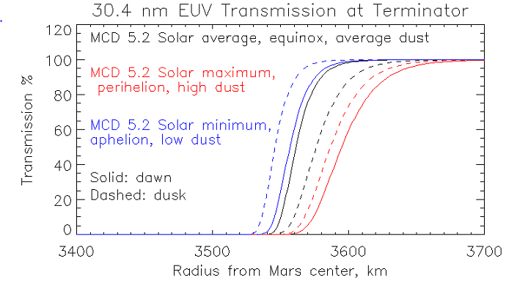

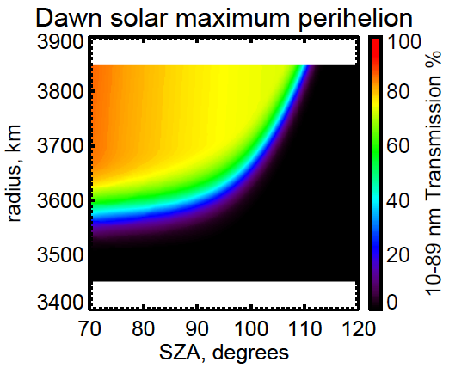



Papier Laila Te Ne dawn dusk

### Latitude dependence





#### Models

Model of Rob Lillis

Model of Dominique Toublanc

altitude

#### Results at the equinox

#### Neutral profiles

François

Observation of the EUV terminator with other instruments ?

## Desert of suprathermal electron depletions

### Different type of orbit with no depletions

### Location

### Evolution of the exobase with the SZA

### Gravity waves

# Conclusions

[to complete]

# Conclusions

[à completer]

# Table of figures

Figure 1. Illustration of the Parker spiral. 17

Figure 2. M-B diagram [Barabash et al., 2012]. 19

Figure 3. Illustration of the general features of the interaction of the solar wind with the Earth magnetic field [Luhmann et al., 1991]. Superimposed in dotted lines are the main features of the Mars-solar wind interaction. 20

Figure 4. Illustration of two different interactions of the solar wind with unmagnetized obstacles [Luhmann et al., 2004]. 21

Figure 5. Illustration of the steps leading to the formation of an ionospheric obstacle in the solar wind flow. Adapted from Kivelson and Russel [1995]. 22

Figure 6. Illustration of the magnetosphere of Mercury. The solar wind comes from the left side. 23

Figure 7. Neutral profiles obtained with the NGIMS instrument on MAVEN [Mahaffy et al., 2015]. 27

Figure 8. Altitude profiles of the averaged density of ionospheric ions measured by NGIMS at a solar zenith angle of 60° at altitudes between 150 and 500 km Benna et al. [2015]. The vertical profile of the total ion density $Ni$ is also plotted in black. 29

Figure 9. Illustration of the measurement of the crustal magnetic field by MGS [Acuña et al., 1998]. 31

Figure 10. Map of the magnetic field of Mars observed by the Mars Global Surveyor satellite at a nominal 400 km altitude. 32

Figure 11. Phase diagram of water 33

Figure 12. Vertical component of the MF6 model crustal magnetic field at the Earth surface, overlain with the isochrones of an ocean-age model and plate boundaries, http://geomag.org/models/MF6.html 35

Figure 13. Schematic of contemporary escape processes (rectangular boxes) relevant for atmospheric neutrals and ions, presented in a ‘decision tree’. Solar inputs shown at the lower right contribute to the energization of atmospheric particles [Brain et al., 2014]. 37

Figure 14. $O+$ fluxes and velocities for energies greater than 25 eV projected on the MSE X-Z plane. The arrows show flux and velocity directions, while the colors label the magnitudes. The two grey dotted lines set the approximate position of the bow shock and the MPB. Adapted from [Dong et al., 2015]. 39

Figure 15. Schematic of the Martian plasma interaction regions [Brain et al., 2014]. 41

Figure 16. Example of a MAVEN passage in the plasma environment of Mars with a periapsis on the dayside. 42

Figure 17. Electron energy spectra measured by SWEA in the **solar wind**, **magnetosheath**, **ionosphere** and the **lobe** on the orbit showed in Figure 16. 44

Figure 18. Comparison of the location of the bow shock and MPB calculated by Edberg et al., [2008] (plain line), Vignes et al., [2000] (dashed line) and Trotignon et al. [2006] (dashed-dotted). 45

Figure 19. Example of an ionospheric cavity observed by MAVEN. 50

Figure 20. Calculated magnetic field (left) and velocity (right) in the equatorial plane (up) and in the meridional pane (bottom) of Mars. The color plots show the magnitudes, the white lines marked with arrows indicate the vector direction of the magnetic field and the arrows show the direction (not the magnitude) of the velocity. The dashed lines represents the mean bow shock and the dash-dot line is the mean MPB locations from Vignes et al. [2000]. Adapted from Ma et al., [2004] 51

Figure 21. Left. Possible magnetic field topologies [Brain et al., 2007]. The Mars Global Surveyor Magnetometer and Electron Reflectometer (MGS MAG/ER) measures the local vector magnetic field near 400 km altitudes (arrows). Electron pitch angle distributions can be used to help identify whether the field angle is closed (curve a), open (curve b) or draped (curve c) in the ionosphere/atmosphere, or draped above the ionosphere/atmosphere (curve d). Right. Plane projection of the magnetic field geometry above the intensely magnetized southern highlands [Connerney et al., 2015] based on the crustal magnetic field model of Connerney et al. [1999]. This figure illustrates the field geometry that would be encountered during periapsis passes along a line of constant longitude (near 150° East) and centered at 50°S. Similar ‘mini-magnetosphere’ may be encountered above much of the magnetized crust, depending on spacecraft altitude and solar wind conditions. 53

Figure 22. Illustration (not to scale) of how the interplanetary magnetic field may penetrate into the Martian ionosphere (stippled). The stream lines of plasma flow are those that are diverted around the planetary obstacle, while the cross-flow lines are magnetic field lines. Adapted from [Luhmann et al., 1991]. 55

Figure 23. Example of a MAVEN passage in the plasma environment of Mars with a periapsis on the nightside. 58

Figure 24. First photograph made by the lander Viking 1 of the Martian surface 61

Figure 25. Summary of all the missions ever sent toward Mars. 63

Figure 26. MGS orbit period during its aerobreaking phase. [Albee et al., 2001] 65

Figure 27. Global view of the MGS spacecraft showing the main components and instruments [Albee et al., 2001] 67

Figure 28. Orbit of MGS, MEX and Phobos on March 10, 2005 in the ($XMSO$; $YMSO$) plane. Created with 3D view. 70

Figure 29. Exploded view of the MEX orbiter, revealing the arrangement of the scientific instruments. 71

Figure 30. 3D picture of the Gale crater obtained with HRSC 72

Figure 31. Overall timeline of MAVEN mission, from launch through end of primary mission and into a possible extended mission [Jakosky et al., 2015]. 74

Figure 32. Precession of the MAVEN orbit for the primary mission and the first extension (left) and for the second extension (right). Location of the spacecraft at periapsis is shown as in geographical coordinates [Jakosky et al., 2016]. 75

Figure 33. Orbit of MAVEN, MEX and Phobos on March 10, 2016 in the ($XMSO$; $YMSO$) plane. Created with 3D view. 76

Figure 34. Instrument accommodation on the MAVEN spacecraft. It shows the locations of the science instruments on the body of the spacecraft and on the APP [Jakosky et al., 2015]. 77

Figure 35. Schematic of the Electron Reflectometer showing the concentric hemispherical deflection plates, the microchannel plate (MCP) and the position-sensing resistive anode. Adapted from Mitchell et al. [2001]. 80

Figure 36. Electron and magnetic field observed by MGS. Panel 1: Electron fluxes (in units of $cm-2s-1sr-1eV-1$) measured by ER are shown as a color spectrogram. Panel 2: Magnetic field amplitude measured by MAG. Vertical lines indicate the position of the bow shock (BS), of the MPB, of the ionopause (IP), and of the ionospheric main peak ($Nm$). Adapted from [Acuña et al., 1998]. 81

Figure 37. a) The MEX/ELS sensor b) Cross section of the IMA sensor c) The ASPERA-3 mechanical model during vibration testing [adapted from Barabash et al., 2004]. 82

Figure 38. Panel 1: Energy-time spectrogram of the electron fluxes with the superimposed curve of the magnetic field value determined by MARSIS. Panel 2: Energy-time spectrogram of the ion fluxes. Adapted from Dubinin et al. [2008b]. 84

Figure 39. MAVEN science instruments used in this PhD. Adapted from Jakosky et al. [2015]. 85

Figure 40. STATIC energy-mass spectrogram of omnidirectional ion energy flux (C6 mode) at a specific time in the nightside ionosphere. 86

Figure 41. A projection of the MAVEN spacecraft trajectory and observed magnetic field onto a plane perpendicular to the Mars orbit plane and the Mars-Sun line for two specific periapsis (presented by J. E. P. Connerney at a MAVEN meeting). 87

Figure 42. Left: Cross-sectional view of SWEA, defining the instrument frame regarding the payload (PL) frame. Right: Top view of the anodes. Simulated electron trajectories (blue) are shown for a deflection of $θ=-45°$. 89

Figure 43. Left: SWEA is on the end of a 1.5-meter boom, with its symmetry axis ($ZSWEA$) aligned with the spacecraft Z axis ($ZPL$). SWEA has a FOV (blue shading indicates the instruments blind spots). Middle: SWEA’s field of view at all energies below 2 keV, mapped in SWEA coordinates over the full sky with an Aitoff projection. The FOV is subdivided into 96 angular bins (16 azimuths 6 deflections). SWEA’s blind spots are two oppositely directed cones. Ten of the angular bin, shown in white, are blocked by the spacecraft. Right: SWEA’s field of view at an energy of 4.6 keV. At this energy, four angular bins are blocked by the spacecraft. Adapted from [Mitchell et al., 2016]. 90

Figure 44. Comparison of LPW and SWEA densities. Panel 1: SWEA time-energy spectrogram of omnidirectional electron energy flux. Panel 2: Electron density calculated with SWEA (**black**) superimposed with the density calculated with LPW (**red**). 91

Figure 45. Electron energy spectra corresponding to the instrument background. Adapted from Mitchell et al. [2001]. 93

Figure 46. Solar cycle between 1995 and 2017 as observed by the number of sunspots observed on the Sun. The duration of the MGS, MEX and MAVEN missions are delineated by the blue, green and purple dashed lines, respectively. 96

Figure 47. Amplitude of the crustal magnetic field calculated thanks to the Morschhauser model at 400 km altitude. 101

Figure 48. Amplitude of the crustal magnetic field calculated thanks to the Morschhauser model at 170 km altitude. 102

Figure 49. Example of a plasma void observed by MGS on June 27, 1999. 104

Figure 50. Electron energy spectra observed in different regions crossed by MGS in Figure 49. 105

Figure 51. Example of a plasma void observed by MEX on June 17, 2004. 106

Figure 52. Geographic map of dominant PAD types recorded by MGS ER at 400 km on the nightside: plasma voids (red); trapped (orange); fully isotropic (green); incident isotropic, return loss cone (blue); incident field-aligned beam, return loss cone (purple); conic (yellow); and other (black). [Brain et al., 2007] 108

Figure 53. Example of electron depletion observed with MAVEN on July 11, 2015. 112

Figure 54. Example of electron depletion observed by MEX on June 23, 2012. 113

Figure 55. Concatenated spectrum of STATIC and SWEA during the electron depletion on July 11, 2015, between 16:38:28 and 16:45:20. All data are corrected from the spacecraft potential measured by LPW. 114

Figure 56 116

Figure 57 117

Figure 58 118

Figure 59. 119

Figure 60. Example of current sheet crossing observed by MAVEN during an electron depletion. 120

Figure 61. Example of current sheet crossing observed by MAVEN during an electron depletion. 121

Figure 62. Example of electron depletion observed with MAVEN on February 16, 2015. 122

Figure 63. Example of electron depletion observed with MAVEN on February 02, 2015. 123

Figure 64. Example of a strong spacecraft charging observed on November 10, 2016. 125

Figure 65. Example of electron depletion observed by MGS on April 26, 2005. 129

Figure 66. Example of electron depletion observed with MAVEN. 130

Figure 67. MAVEN coverage of the nightside low altitudes (<900km) (**blue**) superimposed with the location of the detected electron depletions (**red**). 132

Figure 68. Example of electron depletion observed by MEX on June 23, 2012. 134

Figure 69. Example of a tail crossing by MEX on June 29, 2013. 135

Figure 70. In color, the number of electron depletions detected by criterion (3) from MGS data on a geographic map of the Martian surface with a constant bin size of 1° per 1°. 138

Figure 71. In color, the percentages of electron depletions detected with criterion (3) from MGS data per MGS passage on the nightside on a geographic map of the Martian surface with constant bin size of 1° by 1°. In black, the horizontal magnetic field contour lines calculated from the model of Morschhauser at an altitude of 400 km. The contour lines have been plotted for horizontal crustal fields of 10, 13, 16, 20, 25, 32, 40, 50, 63, 79, and 100 nT. 139

Figure 72. In color, the percentages of electron depletions detected with criterion (2) from MEX data per MEX passage on the nightside on a geographic map of the Martian surface with constant bin size of 2° by 2°. In black, the horizontal magnetic field contour lines calculated from the model of Morschhauser at an altitude of 400 km. The contour lines have been plotted for horizontal crustal fields of 10, 13, 16, 20, 25, 32, 40, 50, 63, 79, and 100 nT. 140

Figure 73. Electron hole occurrence normalized by orbital coverage ($Nnorm$) at altitudes less than 1300 km above the surface of Mars. The map has a spatial resolution of 15° $×$ 15° latitude ($φ$) and east longitude ($λE$). Adapted from Hall et al., [2016]. 142

Figure 74. In color, the percentages of electron depletions detected above 250 km with criterion (1) from MAVEN data per MAVEN passage on the nightside on a geographic map of the Martian surface with constant bin size of 2° by 2°. In black, the horizontal magnetic field contour lines calculated from the model of Morschhauser at an altitude of 400 km. The contour lines have been plotted for horizontal crustal fields of 10, 13, 16, 20, 25, 32, 40, 50, 63, 79, and 100 nT. 143

Figure 75. In color, the percentages of electron depletions detected above 170 km and below 250 km with criterion (1) from MAVEN data per MAVEN passage on the nightside on a geographic map of the Martian surface with constant bin size of 3° by 3°. In black, the horizontal magnetic field contour lines calculated from the model of Morschhauser at an altitude of 170 km. The contour lines have been plotted for horizontal crustal fields of 10, 18, 32, 56, 100, 178, 316, 562 and 1000 nT. 144

Figure 76. In color, the percentages of electron depletions detected below 170 km with criterion (1) from MAVEN data per MAVEN passage on the nightside on a geographic map of the Martian surface with constant bin size of 3° by 3°. In black, the horizontal magnetic field contour lines calculated from the model of Morschhauser at an altitude of 170 km. The contour lines have been plotted for horizontal crustal fields of 10, 18, 32, 56, 100, 178, 316, 562 and 1000 nT. 146

# Table of tables

Table 1. Typical observed properties of the solar wind at the orbit of the Earth [Kivelson and Russel, 1995] and at the orbit of Mars [Brain, 2006; Fränz et al., 2007] 18

Table 2. Spacecraft missions to Mars that have provided measurements relevant for describing the plasma environment of Mars [Brain et al., 2014]. 73

Table 3. Summary of the characteristics of the magnetometer, electron spectrometer, ion spectrometer and Langmuir probe onboard MGS, MEX and MAVEN. 92

Table 4. Characteristics of the three dataset used. 96

Table 5. For each mission are reported here the number of orbits under study (for MEX it corresponds to the number of time intervals longer than one hour when ELS was in the survey mode. It corresponds approximately to the number of orbits studied), the number of depletions detected by criterion (3) for MGS, criterion (2) for MEX and criterion (1) for MAVEN, the number of orbits containing depletions and the median number of depletions per orbit. 135

# Bibliography

Acuña, M. H., J. E. P. Connerney, P. Walilewski, R. P. Lin, K. A. Anderson, C. W. Carlson, J. McFadden, D. W. Curtis, H. Rème, A. Cros, J. L. Médale, J. A. Sauvaud, C. d'Uston, S. J. Bauer, P. Cloutier, M. Mayhew, and N. F. Ness (1992), Mars Observer Magnetic Fields Investigation, *Journal of Geophysical Research,* 97, n° E5, 7799-7814, doi: 10.1029/92JE00344

Acuña, M. H., et al. (1998), Magnetic field and plasma observations at Mars : Initial results of the Mars Global Surveyor mission, *Science,* vol. 279, issue 5357, pp. 1676-1680, doi: 10.1126/science.279.5357.1676

Acuña, M. H., et al. (1999), Global distribution of crustal magnetization discovered by the Mars Global Surveyor MAG/ER Experiment, *Science*, 284: 790-793, doi: 10.1126/science.284.5415.790

Acuña, M. H., et al. (2001), Magnetic field of Mars: Summary of results from the aerobreaking and mapping orbits, *Journal of Geophysical Research,* 106, E10, pp: 23403-23417, doi: 10.1029/2000JE001404

Albee, A. L., R. E. Arvidson, F. Palluconi and T. Thorpe (2001), Overview of the Mars Global Surveyor mission, *Journal of Geophysical Research,* 106, n° E10, 23291-23316, doi: 10.1029/2000JE001306

Anderson, D. E. Jr, and C. W. Hord (1971), Mariner 6 and 7 ultraviolet spectrometer experiment: Analysis of hydrogen Lyman-alpha data, *Journal of Geophysical Research,* vol. 76, no. 28, doi: 10.1029/JA076i028p06666

Andersson, L., R. E. Ergun, G. T. Delory, A. I. Eriksson, J. Westfall, H. Reed, J. McCauly, D. Summers, and D. Meyers (2015), The Langmuir Probe and Waves instrument for MAVEN, *Space Sci. Rev., 195*: 173-198, doi: 10.1007/s11214-015-0194-3

Andersson, L., C. M. Fowler, T. M. Chamandy, R. E. Ergun, A. Eriksson, G. Delory, D. Andrews, A. K. Woodson, J. E. P. Connerney, B. M. Jakosky (in preparation), Electron temperature and density profiles from the Martian ionosphere: A statistical analysis.

Barabash, S., Lundin, R., & Andersson, H. et al. (2004), ASPERA-3: Analyser of Space Plasmas and Energetic Ions for Mars Express, Mars Express: the Scientific Payload (ESA SP-1240), ed. A. Wilson & A. Chicarro (Noordwijk: ESA), 121

Barabash, S. (2012), Classes of the solar wind interactions in the solar system, *Earth Planets Space*, 64, 57-59, doi: 10.5047/eps.2012.01.005

Benna, M., P. R.Mahaffy, J. M. Grebowsky, J. L. Fox, R. V. Yelle, and B. M. Jakosky (2015), First measurements of composition and dynamics of the Martian ionosphere by MAVEN’s Neutral Gas and Ion Mass Spectrometer, *Geophys. Res. Lett.*, 42, 8958–8965, doi: 10.1002/2015GL066146

Bertaux, J.-L., et al. (2004), SPICAM: Studying the Global Structure and Composition of the Martian Atmosphere, *Planetary Missions Division, Research & Scientific Support Department, ESA/ESTEC, PO box 299, 2200 AG Noordwijk, The Netherlands*

Bertucci, C., et al. (2003), Magnetic field draping enhancement at the Martian magnetic pileup boundary from Mars Global Surveyor observations, *Geophysical Research Letters,* 30, 2, doi: 10.1029/2002GL015713

Bertucci, C., et al. (2004), MGS MAG/ER observations at the magnetic pileup boundary of Mars: draping enhancement and low frequency waves, *Advances in Space Research*, 33, 11, pp. 1938-1944, doi: 10.1016/j.asr.2003.04.054

Bertucci, C., F. Duru, N. Edberg, M. Fraenz, C. Martinecz, K. Szego, and O. Vaisberg (2011), The induced magnetospheres of Mars, Venus, and Titan, *Space Sci. Rev.*, 162:113-171, doi: 10.1007/s1124-011-9845-1

Bibring, J-P., et al. (2004), OMEGA: Observatoire pour la Minéralogie, l’Eau, les Glaces et l’Activité, *Planetary Missions Division, Research & Scientific Support Department, ESA/ESTEC, PO box 299, 2200 AG Noordwijk, The Netherlands*

Bougher, S. W. (1995), Comparative thermospheres: Venus and Mars, *Adv. Space Res.*, 15 (4), 21–25, doi: 10.1016/0273-1177(94)00062-6

Bougher, S. W., Engel, S., Roble, R. G., and Foster, B. (2000), Comparative terrestrial planet thermospheres 3. Solar cycle variation of global structure and winds at solstices, *J. Geophys. Res.*, 105, 17669–17692, doi: 10.1029/1999JE001232.

Bougher, S. W., McDunn, T. M., Zoldak, K. A., and Forbes, J. M. (2009), Solar cycle variability of Mars dayside exospheric temperatures: Model evaluation of underlying thermal balances, *Geophys. Res. Lett.*, 36, L05201, doi: 10.1029/2008GL036376.

Bougher, S. W., Brain, D. A., Fox, J. L., Gonzalez-Galindo, F., Simon-Wedlund, C., and Withers, P. G. (2014), Upper Neutral Atmosphere and Ionosphere, *in Mars Book II* (Cambridge University Press, Cambridge, 2014), Chap. 14

Bougher, S. et al., (2015), Early MAVEN Deep Dip Campaigns: First Results and Implications, *Sciences, Vol. 350, Issue 6261,* doi: 10.1126/science.aad0459

Brace, L. H., R. F. Theis, H. G. Mayr, S. A. Curtis, and J. G. Luhmann (1982), Holes in the nightside ionosphere of Venus, J. Geophys. Res., 87, 199–211, doi:10.1029/JA087iA01p00199

Brain, D. A., and B. M. Jakosky (1998), Atmospheric loss since the onset of the Martian geologic record: Combined role of impact erosion and sputtering, *Journal of Geophysical Research,* vol. 103, no. E10, 22689-22694, doi: 10.1029/98JE02074

Brain, D. A., F. Bagenal, M. H. Acuña, and J. E. P. Connerney (2003), Martian magnetic morphology: Contributions from the solar wind and crust, *Journal of Geophysical Research*, 108(A12), 1424, doi: 10.1029/2002JA009482

Brain, D. A. (2006), Mars Global Surveyor measurements of the Martian Solar wind interaction, *Space Science Review,* 126: 77-112, doi: 10.1007/s11214-006-9122-x

Brain, D. A., R. J. Lillis, D. L. Mitchell, J. S. Halekas, and R. P. Lin (2007), Electron pitch angle distributions as indicators of magnetic field topology near Mars, *Journal of Geophysical Research,* 112(A09201), doi: 10.1029/2007JA012435

Brain, D. A., et al. (2010), A comparison of global models for the solar wind interaction with Mars, *Icarus*, 206, 139-151, doi: 10.1016/j.icarus.2009.06.030

Brain, D. A., S. Barabash, S. W. bougher, F. Duru, B. M. Jakosky and R. Modolo (2014), Solar wind interaction and atmospheric escape (Chapter 15), *in Atmosphere and Climate of Mars*, eds. R. Haberle, T. Clancy, F. Forget, M. Smith, R. Zurek (Cambridge University Press, 2014)

Brecht, S. H., and S. A. Ledvina (2006), The Solar Wind Interaction With the Martian Ionosphere/Atmosphere, *Space Sci. Rev.*, 126(1), 15–38, doi:10.1007/s11214-006-9084-z

Breus, T. K., A. M. Krymskii, R. Lundin, E. M. Dubinin, J. G. Luhmann, Ye G. Yeroshenko, S. V. Barabash, V. Ya Mitnitskii, N. F. Pissarenko, and V. A. Styashkin (1991), The solar wind interaction with Mars: Consideration of Phobos 2 mission observations of an ion composition boundary on the dayside, *Journal of Geophysical Research,* 96(A7), 11165-11174, doi: 10.1029/91JA01131

Cain, J. C., B. B. Ferguson, and D. Mozzoni (2003), An n=90 internal potential function of the Martian crustal magnetic field, *Journal of Geophysical Research*, vol. 108, No. E2, 5008, doi: 10.1029/2000JE001487

Chicarro, A., P. Martin, and R. Trautner (2004), The Mars Express Mission: An overview, *Planetary Missions Division, Research & Scientific Support Department, ESA/ESTEC, PO box 299, 2200 AG Noordwijk, The Netherlands*

Christensen, P. R., et al., Thermal EmissionS pectrometer experiment: The Mars Observer mission, *Journal of Geophysical Research, 97*, 7719-7734, doi: 10.1029/92JE00453

Collison, G. A., et al. (2014), The extension of ionospheric holes into the tail of Venus, *J. Geophys. Res. Space Physics*, *119*, 6940-6953, doi: 10.1002/2014JA019851

Connerney, J. E. P., et al. (1999), Magnetic lineations in the Ancient crust of Mars, *Nature*, 284, 5415, pp. 794-798, doi: 10.1126/sience.284.5415.794

Connerney, J. E. P., M. H. Acuña, N. F. Ness, G. Kletetschka, D.L. Mitchell, R. P. Lin, and H. Rème (2005), Tectonic implications of Mars crustal magnetism, *PNAS,* 102, 42, doi: 10.1073/pnas.0507469102

Connerney, J. E. P., J. Espley, P. Lawton, S. Murphy, J. Odom, R. Oliverson, and D. Sheppard (2015), The MAVEN magnetic field investigation, *Space Sci. Rev.*, doi:10.1007/s11214-015-0169-4

Crider, D. H. et al. (2002), Observations of the latitude dependence of the location of the Martian magnetic pileup boundary, *Geophys. Res. Lett.*, 29(8), 11–1, doi: 10.1029/2001GL013860.

Crider, D. H., et al. (2004), Mars Global Surveyor Observations of Solar Wind Magnetic Field Draping Around Mars, *Space Sci. Rev.*, 111(1), 203–221, doi:10.1023/B:SPAC.0000032714.66124.4e

Delory G. T., J. G. Luhmann, D. Brain, R. J. Lillis, D. L. Mitchell, R. A. Mewaldt, T. Vilstrup Falkenberg, Energetic particles detected by the Electron Reflectometer instrument on the Mars Global Surveyor, 1999-2006, *Space Weather* **10**, S06003 (2012). doi: 10.1029/2012SW000781

Dolginov, Sh. Sh., Ye. G. Yeroshenko, and L. N. Zhuzgov (1973), Magnetic field in the very close neighborhood of Mars according to data from the Mars 2 and Mars 3 spacecraft, *Journal of Geophysical Research,* 78, 22, doi: 10.1029/JA078i022p04779

Dolginov, Sh. Sh., and L. N. Zhuzgov (1991), The magnetic field and the magnetosphere of the planet Mars, *Planet. Space Sci.*, vol. 39, no. 11, pp. 1493-1510, doi: 10.1016/0032-0633(91)90077-N

Dong, C. F., S. W. Bougher, Y. J. Ma, G. Toth, A. F. Nagy, and D. Najib (2014), Solar wind interaction with Mars upper atmosphere: Results from the one-way coupling between the multi-fluid MHD model and the MTGCM model, *Geophys. Res. Lett.*, doi: 10.1002/2014GL059515

Dong, Y., X. Fang, D. A. Brain, J. P. McFadden, J. S. Halekas, J. E. P. Connerney, S. M. Curry, Y. Harada, J. G. Luhmann, and B. M. Jakosky (2015), Strong plume fluxes at Mars observed by MAVEN: An important planetary ion escape channel, *Geoph. Res. Lett.*, 42, 8942-8950, doi: 10.1002/2015GL065346

Dubinin, E., K. Sauer, M. Delva, and A. Skalsky (1998), The IMF bending upstream of the Martian bow shock, *Earth, Planets and Space*, doi: 10.1186/BF03352116

Dubinin, E, R. Lundin, O. Norberg, and N. Pissarenko (1993), Ion acceleration in the Martian tail: Phobos observations, *Journal of Geophysical Research,* 98(A3), pp. 3991-3997, doi: 10.1029/92JA02233

Dubinin, E., M. Fränz, J. Woch, E. Roussos, S. Barabash, R. Lundin, J. D. Winningham, R. A. Frahm, and M. Acuña (2006), Plasma morphology at Mars. Aspera-3 observations, *Space Science Reviews,* 126: 209-238, doi: 10.1007/s11214-006-9039-4

Dubinin, E., et al. (2008a), Structure and dynamics of the solar wind/ionosphere interface on Mars: MEX-ASPERA-3 and MEX-MARSIS observations, *Geophys. Res. Lett., 35(1),* 11103, doi: 10.1029/2008GL033730

Dubinin, E., et al. (2008b), Plasma environment of Mars as observed by simultaneous MEX-ASPERA-3 and MEX-MARSIS observations, *Journal of Geophysical Research*, 113(A10217), doi: 10.1029/2008JA013355

Duru, F., D. A. Gurnett, J. D. Winningham, R. Frahm, and R. Modolo (2010), A plasma flow velocity boundary at Mars from the disappearance of electron plasma oscillations, *Icarus*, 206(1), 74–82, doi: 10.1016/j.icarus.2009.04.012

Duru, F., D. A. Gurnett, D. D. Morgan, J. D. Winningham, R. A. Frahm, and A. F. Nagy (2011), Nightside ionosphere of Mars studied with local electron densities: A general overview and electron density depressions, *J. Geophys. Res., 116(A10316),* doi: 10.1029/2011JA016835

Edberg, N. J. T., M. Lester, S. W. H. Cowley, and A. I. Eriksson (2008), Statistical analysis of the location of the Martian magnetic pileup boundary and bow shock and the influence of crustal magnetic fields, *Journal of Geophysical Research,* 113, A08206, doi: 10.1029/2008JA013096

Edberg, N. J. T., D. A. Brain, M. Lester, S. W. H. Cowley, R. Modolo, M. Fränz, and S. Barabash (2009), Plasma boundary variability at Mars as observed by Mars Global Surveyor and Mars Express, *Ann Geophys-Germany*, 27(9), 3537–3550, doi: 10.5194/angeo-27-3537-2009

Eparvier, F. G., P. C. Chamberlin, T. N. Woods, E. M. B. Thiemann (2015), The Solar Extreme Ultraviolet Monitor for MAVEN, *Space Science Reviews*, 195(1), pp. 293-301, doi: 10.1007/s11214-015-0195-2

Fang, X., M. W. Liemohn, A. F. Nagy, J. G. Luhmann, and Y. Ma (2010), Escape probability of Martian atmospheric ions: Controlling effects of the electromagnetic fields, *J. Geophys. Res.*, 115(A), 04308, doi: 10.1029/2009JA014929

Ferguson, B. B., J. C. Cain, D. H. Crider, D. A. Brain, and E. M. Harnett (2005), External fields on the nightside of Mars at Mars Global Surveyor mapping altitudes, *Geophysical Research Letters,* 32, L16105, doi: 10.1029/2004GL021964

Fillingim, M. O., L. M. PetiColas, R. J. Lillis, D. A. Brain, J. S. Halekas, D. Lummerzheim, and S. W. Bougher (2010), Localized ionization patches in the nighttime ionosphere of Mars and their electrodynamic consequences, *Icarus*, 206, 112–119, doi: 10.1016/j.icarus.2009.03.005

Formissano, V., et al. (2004), The Planetary Fourier Spectrometer (PFS) onboard the European Mars Express mission, *Planetary Missions Division, Research & Scientific Support Department, ESA/ESTEC, PO box 299, 2200 AG Noordwijk, The Netherlands*

Frahm, R. A., et al. (2006), Locations of atmospheric photoelectron energy peaks within the Mars environment, *Space Science Reviews,* 126 : 389-402, doi : 10.1007/s11214-006-9119-5

Fränz, M., E. Dubinin, E. Roussos, J. Woch, J. D. Winningham, R. Frahm, A. J. Coates, A. Fedorov, S. Barabash, and R. Lundin (2006), Plasma Moments in the Environment of Mars, *Space Sci Rev*, *126*(1-4), 165–207, doi:10.1007/s11214-006-9115-9.

Fränz, M., E. Dubinin, E. Nielsen, J. Woch, S. Barabash, R. Lundin, and A. Fedorov (2010), Transterminator ion flow in the Martian ionosphere, *Planet. Space Sci.*, 58, 1442–1454, doi: 10.1016/j.pss.2010.06.009

Garnier, et al. (in preparation), The Martian Photoelectron boundary as seen by MAVEN.

Genot, V., et al. (2010), Space Weather applications with CDPP/AMDA, *Advances in Space Research,* vol. 45, issue 9, pp. 1145-1155, doi: 10.1016/j.asr.2009.11.010

Genot, V., et al. (2014), Joining the yellow hub: Uses of the simple application messaging protocol in space physics analysis tools, *Astronomy and Computing*, vol. 7, doi: 10.1016/j.ascom.2014.07.007

Genot, V., et al. (submitted in 2016), Science data visualization in planetary and heliospheric contexts with 3DViews, *PSS*

Gringauz, K. I. (1976), Interaction of Solar wind with Mars as seen by charged particle traps on Mars 2, 3 and 5 satellites, *Reviews of geophysics and space physics,* 14, 3, doi: 10.1029/RG014i003p00391

Gringauz, K. I., Verigin, M., Luhmann, J., Russell, C. T. and Mihalov, J. D. (1993), On the Compressibility of the Magnetic Tails of Mars and Venus, in *Plasma Environments of Non-magnetic Planets*, Pergammon, New York, pp. 265–270

Haider, S. A., B. M. Pandya, and G. J. Molina-Cuberos (2013), Nighttime ionosphere caused by meteoroid ablation and solar wind electron-proton-hydrogen impact on Mars: MEX observation and modeling, *J. Geophys. Res. Space Physics*, *118*, 6786–6794, doi:10.1002/jgra.50590

Halekas, J. S., D. A. Brain, R. J. Lillis, M. O. Fillingim, D. L. Mitchell, and R. P. Lin (2006), Current sheets at low altitudes in the Martian magnetotail, *Geophysical Research Letter,* 33(L13101), doi: 10.1029/2006GL026229

Halekas, J. S., E. R. Taylor, G. Dalton, G. Johnson, D. W. Curtis, J. P. McFadden, D. L. Mitchell, R. P. Lin, and B. M. Jakosky (2013), The Solar Wind Ion Analyzer for MAVEN, Space Sci. Rev., 1-27, doi: 10.1007/s11214-013-0029-z

Hall, B. E. S., M. Lester, J. D. Nichols, B. Sànchez-Cano, D. J. Andrews, H. J. Opgenoorth, and M. Fränz (2016), A survey of suprathermal electron flux depressions, or ‘electron holes’, within the illuminated Martian induced magnetosphere, *Journal of Geophysical Research,* 121(5), pp. 4835-4857, doi: 10.1002/2015JA021866

Han, X., et al. (2014), Discrepancy between ionopause and photoelectron boundary determined from Mars Express measurements, *Geophysical Research Letters*, 41, 8221-8227, doi: 10.1002/2014GL062287

Harnett, E. M., and R. M. Winglee (2006), Three-dimensional multifluid simulations of ionospheric loss at Mars from nominal solar wind conditions to magnetic cloud events, *J. Geophys. Res.*, 111(A), 09213, doi: 10.1029/2006JA011724

Huebner, W. F., Carpenter, C. W. (1979) Solar Photo Rate Coefficients, *Los Alamos Scientific Laboratory report,* LA-8085-MS

Huebner, W. F., Keady, J. J., Lyon, S. P. (1992), Solar Photo Rates for Planetary Atmospheres and atmospheric pollutants, *Astrophys. Space Sci.,* 195, 1-294

Huebner, W. F., Mukherjee, J. (2015), Photoionization and photodissociation rates in solar and blackbody radiation fields, *Planetary and Space Science,* <http://dx.doi.org/10.1016/j.pss.2014.11.022>

Itikawa, Y. (2002), Cross sections for electron collisions with carbon dioxide, *J. Phys. Chem. Ref. Data*, 31(3), doi:10.1063/1.1481879.

Itikawa, Y., and A. Ichimura (1990), Cross section for collisions of electrons and photons with atomic oxygen, *J. Phys. Chem. Ref. Data*, 19(3), 637–651.

Itikawa, Y., M. Hayashi, A. Ichimura, K. Onda, K. Sakimoto, K. Takayanagi, M. Nakamura, H. Nishimura, and T. Takayanagi (1986), Cross sections for collisions of electrons and photons with nitrogen molecules, *J. Phys. Chem. Ref. Data*, 15(3), 985–1010.

Itikawa, Y., A. Ichimura, K. Onda, K. Sakimoto, T. Takayanagi, Y. Hatano, M. Hayashi, H. Nishimura, and S. Tsurubuchi (1989), Cross sections for collisions of electrons and photons with oxygen molecules, *J. Phys. Chem. Ref. Data*, 18(1), 23–42.

Jacquey, C., et al. (2010), AMDA, Automated Multi-Dataset Analysis: A web-Based Service Provided by the CDPP, *In: Laasko H., Taylor M., Escoubet C. (eds) The Cluster Active Archive. Astrophysics and Space Science Proceedings, Springer, Dordrecht,* doi: 10.1007/978-90-481-3499-1_16

Jakosky, B. M., and R. J. Phillips (2001), Mars’ volatile and climate history, *Nature*, 412, 6843, pp. 237-244

Jakosky, B. M., et al. (2015), The Mars Atmosphere and Volatile Evolution (MAVEN) mission, *Space Sci. Rev.*, 195:3-48, doi: 10.1007/s11214-015-0139-x

Jakosky, B. M., J. M. Grebowsky, J. G. Luhmann, and D. A. Brain (2017), The MAVEN mission to Mars at the end of one Mars year of science observations, *J. Geophys. Res.*, (to be submitted)

Jakosky, B. M., J. M. Grebowsky, J. G. Luhmann, and D. A. Brain (2015), Initial results from the MAVEN mission to Mars, *Geophys. Res. Lett.*, *42* 8791-8802, doi: 10.1002/2015GL065271

Kallio, E., R. A. Frahm, Y. Futaana, A. Fedorov, and P. Janhunen (2008), Morphology of the magnetic field near Mars and the role of the magnetic crustal anomalies: Dayside region, *Planetary and Space Science*, 56(6), 852–855, doi: 10.1016/j.pss.2007.12.002

Kallio, E., J.-Y. Chaufray, R. Modolo, D. Snowden, and R. Winglee (2011), Modeling of Venus, Mars, and Titan, *Space Sci Rev*, *162*(1), 267–307, doi:10.1007/s11214-011-9814-8

Kivelson, M. G., and C. T. Russel (1995), Introduction to space physics, *Cambridge University Press*.

Krasnopolsky, V. A. (1993), Solar cycle variations of the hydrogen escape rate and the CO mixing ratio on Mars, *Icarus (ISSN 0019-1035)*, *101*, 33–41, doi: 10.1006/icar.1993.1003

Krasnopolsky, V. A. (2002), Mars’ upper atmosphere and ionosphere at low, medium and high solar activities: Implications for evolution of water, *J. Geophys. Res.*, *107(E12)*, 5128, doi: 10.1029/2001JE001809

Krymskii, A. M., T. K. Breus, N. F. Ness, M. H. Acuña, J. E. P. Connerney, D. H. Crider, D. L. Mitchell, and S. Bauer (2002), Structure of the magnetic field fluxes connected with crustal magnetization and topside ionosphere at Mars, *Journal of Geophysical Research,* *107(*A9), 1245, doi: 10.1029/2001JA000239

Kotova, G. et al. (1997), Study of the solar wind deceleration upstream of the Martian terminator bow shock, *J. Geophys. Res.*, *102*(A), 2165–2174, doi: 10.1029/96JA01533.

Larson, D. E., et al. (2015), The MAVEN Solar Energetic Particle Investigation, *Space Science Reviews*, 195(1), pp. 153-172, doi: 10.1007/s11214-015-0218-z

Ledvina, S. A., Y. J. Ma, and E. Kallio (2008), Modeling and Simulating Flowing Plasmas and Related Phenomena*, Space Sci Rev*, 139(1), 143–189, doi:10.1007/s11214-008-9384-6

Lillis, R. J., H. V. Frey, and M. Manga (2008), Rapid decrease in Martian crustal magnetization in the Noachian era: implications for the dynamo and climate of early Mars, *Geophysical Research Letter,* 35, L14203, doi: 10.1029/2008GL034338

Lillis, R. J., M. O. Fillingim, and D. A. Brain (2011), Three-dimensional structure of the Martian nightside ionosphere: Predicted rates of impact ionization from Mars Global Surveyor magnetometer and Electron Reflectometer measurements of precipitating electrons, *J. Geophys. Res.*, 116, A12317, doi: 10.1029/2011JA016982.

Lillis, R. J., S. Robbins, M. Manga, J. S. Halekas and H. V. Frey (2013a), Time history of the Martian dynamo from crater magnetic field analysis, *Journal of Geophysical Research,* 118, 1488-1511, doi: 10.1002/jgre.20105

Lillis, R. J., and D. A. Brain (2013b), Nightside electron precipitation at Mars: Geographic variability and dependence on solar wind conditions, *J. Geophys. Res. Space Physics*, 118, 3546–3556, doi: 10.1002/jgra.50171.

Luhmann, J. G. and L. H. Brace (1991), Near-Mars space, *Review of Geophysics,* 29, 2, pages 121-140, doi: 10.1029/91RG00066

Luhmann, J. G. (1992), Comparative studies of the solar wind interaction with weakly magnetized planets, *Adv. Space Res.*, 12, 9, pp. (9)191-(9)203, doi: 10.1016/0273-1177(92)90331-Q

Luhmann, J. G. (1995), Plasma interactions with unmagnetized bodies, in Introduction to Space Physics, *Cambridge University Press*.

Luhmann, J. G., S. A. Ledvina, and C. T. Russell, (2004), Induced magnetosphere, *Advances in Space Reasearch,* doi: 10.1016/j.asr.1003.03.031

Lundin, R., A. Zakharov, R. Pellinen, H. Borg, B. Hultqvist, N. Pissarenko, E. M. Dubinin, S. W. Barabash, I. Liede, and H. Koskinen (1989), First measurements of the ionospheric plasma escape from Mars, *Nature,*341, 609-612, doi: 10.1038/341609a0

Ma, Y., A. F. Nagy, K. C. Hansen, D. L. DeZeeuw, T. I. Gombosi, and K. G. Powell (2002), Three-dimensional multispecies MHD studies of the solar wind interaction with Mars in the presence of crustal fields, *Journal of Geophysical Research-Space*, 107(A), 1282, doi:10.1029/2002JA009293

Ma, Y., A. F. Nagy, I. V. Sokolov, and K. C. Hansen (2004), Three-dimensional, multispecies, high spatial resolution MHD studies of the solar wind interaction with Mars, *Journal of Geophysical Research*, vol. 109, A07211, doi: 10.1029/2004JA010367

Ma, Y., and A. F. Nagy (2007), Ion escape fluxes from Mars, *Geophys. Res. Lett.*, 34(8), 08201, doi: 10.1029/2006GL029208

Ma, Y., X. Fang, C. T. Russell, A. F. Nagy, G. Toth, J. G. Luhmann, D. A. Brain, and C. Dong (2014), Effects of crustal field rotation on the solar wind plasma interaction with Mars, *Geophys. Res. Lett.*, 41, 6563–6569, doi: 10.1002/2014GL060785.

Mahaffy, P. R., et al. (2015), The Neutral Gas and Ion Mass Spectrometer on the Mars Atmosphere and Volatile Evolution Mission, *Space Sci. Rev.*, 195:49-73, doi: 10.1007/s11214-014-0091-1

Mahaffy, P. R., M. Benna, M. Elrod, R. V. Yelle, S. W. Bougher, S. W. Stone, and B. M. Jakosky (2015), Structure and composition of the neutral upper atmosphere of Mars from the MAVEN NGIMS investigation, *Geophysical Research Letter, 42*, 8951-8957, doi:10.1002/2015GL065329

Malin, M. C., G.E. Danielson, A. P. Ingersoll, H. Masursky, J. Veverka, M. A. Ravine, and T. A. Soulanille (1992), Mars Observer Camera, *Journal of Geophysical Research,* 97, n° E5, 7699-7718, doi: 10.1029/92JE00340

Martin-Torres, F. J., et al. (2015), Transient liquid water and water activity at Gale crater on Mars, *Nature Geoscience*, 8, 357-361, doi: 10.1038/ngeo2412

McClintock, W. E., et al. (2014), The Imaging Ultraviolet Spectrograph (IUVS) for the MAVEN mission, *Space Sci. Rev.,* 195(1), pp. 75-124, doi: 10.1007/s11214-014-0098-7

McFadden, J. P., et al. (2015), MAVEN SuparThermal and Thermal Ion Composition (STATIC) Instrument, *Space Sci. Rev., 195(1-4)* 199-256, doi: 10.1007/s11214-015-0175-6

Melosh, H. J., and A. M. Vickery (1989), Impact erosion of the primordial atmosphere of Mars, *Nature (ISSN 0028-0836)*, *338*, 487–489, doi: 10.1038/338487a0

Mitchell, D. L., R. P. Lin, H. Rème, D. H. Crider, P. A. Cloutier, J. E. P. Connerney, M. H. Acuña, and N. F. Ness (2000), Oxygen Auger electrons observed in Mars’ ionosphere, *Geophysical Research Letter,* 27, 13, pp. 1871-1874, doi: 10.1029/1999GL010754

Mitchell, D. L., et al. (2001), Probing Mars’ crustal magnetic field and ionosphere with the MGS Electron Reflectometer

Mitchell, D. L., R. J. Lillis, R. P. Lin, J. E. P. Connerney, and M. H. Acuña (2007), A global map of Mars’ crustal magnetic field based on electron reflectometry, *Journal of Geophysical Research*, *112*, E01002, doi: 10.1029/2005JE002564

Mitchell, D. L., et al. (2016), The MAVEN Solar Wind Electron Analyzer, *Space Sci. Rev.,*1-34doi: 10.1007/s11214-015-0232-1

Modolo, R., G. M. Chanteur, E. Dubinin, and A. P. Matthews (2005), Influence of the solar EUV flux on the Martian plasma environment, *Ann Geophys-Germany*, 23(2), 433–444, doi: 10.5194/angeo-23-433-2005

Modolo, R., G. M. Chanteur, E. Dubinin, and A. P. Matthews (2006), Simulated solar wind plasma interaction with the Martian exosphere: influence of the solar EUV flux on the bow shock and the magnetic pile-up boundary, *Ann Geophys-Germany*, 24(12), 3403–3410

Modolo, R., G. M. Chanteur, and E. Dubinin (2012), Dynamic Martian magnetosphere: Transient twist induced by a rotation of the IMF, *Geophys. Res. Lett.*, 39(1), 01106, doi:10.1029/2011GL049895

Möhlmann, D., W. Riedler, J. Rustenbach, K. Schwingenschuh, J. Kurths, U. Motschmann, T. Roatsch, K. Sauer, and H. T. M. Lichtenegger (1991), The question of an internal Martian magnetic field, *Planetary and Space Science,* 39 (1-2), pp. 83-88, doi: 10.1016/0032-0633(91)90130-3

Morschhauser, A., V. Lesur, and M. Grott (2014), A spherical harmonic model of the lithospheric magnetic field of Mars, *Journal of Geophysical Research: Planets*, *119*, 1162-1188, doi: 10.1002/2013JE004555

Nagy, A. F., M. W. Liemohn, J. L. Fox, and J. Kim (2001), Hot carbon densities in the exosphere of Mars, *J. Geophys. Res.*, *106*(A), 21565–21568, doi:10.1029/2001JA000007

Nagy, A. F., et al. (2004), The plasma environment of Mars, *Space Science Reviews,* 111: 33-114, doi: 10.1023/B:SPAC.0000032718.47512.92

Najib, D., A. F. Nagy, G. Tóth, and Y. Ma (2011), Three-dimensional, multifluid, high spatial resolution MHD model studies of the solar wind interaction with Mars, *J. Geophys. Res.-Space*, 116(A), –, doi: 10.1029/2010JA016272

Němec, F., D. D. Morgan, D. A. Gurnett, and F. Duru (2010), Nightside ionosphere of Mars: Radar soundings by the Mars Express spacecraft, *J. of Geophys. Res., 115,* E12009, doi: 10.1029/2010JE003663

Neukum, G., et al. (2004), HRSC: the High Resolution Stereo Camera of Mars Express, *Planetary Missions Division, Research & Scientific Support Department, ESA/ESTEC, PO box 299, 2200 AG Noordwijk, The Netherlands*

Nier, A. O., and M. B. McElroy (1976), Structure of the Neutral upper atmosphere of Mars: results from Viking 1 and Viking 2, *Science,* vol. 194, issue 4271, pp. 1298-1300, doi: 10.1126/science.194.4271.1298

Nier, A. O., W. B. Hanson, A. Seiff, M. B. McElroy, N. W. Spencer, R. J. Duckett, T. C. D. Knight, and W. S. Cook (1976), Composition and Structure of the Martian atmosphere: Preliminary results from Viking 1, *Science,* vol. 193, issue 4255, pp. 786-788, doi: 10.1126/science.193.4255.786

Pätzold, M., et al. (2004), MaRS: Mars Express Orbiter Radio Science, *Planetary Missions Division, Research & Scientific Support Department, ESA/ESTEC, PO box 299, 2200 AG Noordwijk, The Netherlands*

Parker, E. N. (1958), Dynamics of the interplanetary gas and magnetic fields, *Astrophysical Journal*, vol. 128, p. 664, doi:10.1086/146579

Phillips, J. L., J. G. Luhmann, W. C. Knudsen, and L. H. Brace (1988), Asymmetries in the location of the Venus ionopause, *Journal of Geophysical Research (ISSN 0148-0227)*, *93*, 3927–3941, doi:10.1029/JA093iA05p03927

Picardi, G., et al. (2004), MARSIS: Mars Advanced Radar for Subsurface and Ionosphere Sounding, *Planetary Missions Division, Research & Scientific Support Department, ESA/ESTEC, PO box 299, 2200 AG Noordwijk, The Netherlands*

Pullan, D., M. R. Sims, I. P. Wright, C. T. Pillinger, and R. Trautner (2004), Beagle 2: the Exobiological Lander of Mars Express, *Planetary Missions Division, Research & Scientific Support Department, ESA/ESTEC, PO box 299, 2200 AG Noordwijk, The Netherlands*

Riedler, W., et al. (1989), Magnetic fields near Mars: first results, *Nature*, 341, 604-607, doi: 10.1038/341604a0

Rosenbauer, H., et al. (1989), Ions of Martian origin and plasma sheet in the Martian magnetosphere: initial results of the TAUS experiment, *Nature*, 341, 612-614, doi: 10.1038/341612a0

Russell, C. T., J. G. Luhmann, J. R. Spreiter, and S. S. Stahara (1984), The magnetic field of Mars: Implications from gas dynamic modeling, *Journal of geophysical research,* 89 (A5), pp. 2997-3003, doi: 10.1029/JA089iA05p02997

Russell, C. T., T. Mulligan, M. Delva, T. L. Zhang, and K. Schwingenschuh (1995), A simple test of the induced nature of the Martian tail, *Advances in Space Research,* 16 (6), pp. 69-73, doi: 10.1016/0273-1177(95)00251-9

Sauer, K., A. Bogdanov, and K. Baumgärtel (1994), Evidence of an ion composition boundary (protonopause) in bi-ion fluid simulations of solar wind mass loading, *Geophysical Research Letter*, 21, 20, pp. 2255-2258, doi: 10.1029/94GL01691

Sauvaud, J.-A., D. Larson, C. Aoustin, J.-L. Médale, A. Fedorov, J. Rouzaud, J. G. Luhmann, T. Moreau, P. Schröder, P. Louarn, I. Dandouras, E. Penou (2008), The IMPACT Solar Wind Electron Analyzer (SWEA), *Space Science Reviews*, 136(1), pp. 227-239, doi: 10.1007/s11214-007-9174-6

Slavin, J. A., K. Schwingenschuh, W. Riedler, and Ye. Yeroshenko (1991), The solar wind interaction with Mars: Mariner 4, Mars 2, Mars 3, Mars 5, and Phobos 2 observations of bow shock position and shape, *Journal of Geophys. Research,* 96, A7, pp 11235-11241, doi: 10.1029/91JA00439

Smith, E. J., L. Davis Jr, P. J. Coleman Jr, and D. E. Jones (1965), Magnetic field measurements near Mars, *Science,* vol. 149, issue 3689, pp. 1241-1242, doi: 10.1126/science.149.3689.1241

Smith, D. E., et al. (2001), Mars Orbiter Laser Altimeter: Experiment summary after the first year of global mapping of Mars, *Journal of Geophysical Research,* 106(E10), 23689-23722, doi: 10.1029/2000JE001364

Soobiah, Y., et al. (2006), Observations of magnetic anomaly signatures in Mars Express ASPERA-3 ELS data, *Icarus, 182(396-405)*, doi: 10.1016/j.icarus.2005.10.034

Soobiah, Y. I. J. (2009), The investigation of crustal magnetic field signatures at Mars by the Mars Express ASPERA-3 Electron Spectrometer (ELS), Doctoral thesis, Department of Space and Climate Physics, Mullard Space Science Laboratory, UCL (Univ. College London), London, U. K.

Steckiewicz, M., et al. (2015), Altitude dependence of nightside Martian suprathermal electron depletions as revealed by MAVEN observations, *Geophysical Research Letters,* *42*, 8877-8884, doi: 10.1002/2015GL065257

Steckiewicz, M., et al. (2016), Comparative study of the Martian suprathermal electron depletions based on Mars Global Surveyor, Mars Express and the Mars Atmosphere and Volatile Evolution mission observations, *Journal of Geophysical Research: Space Physics*, *121*, doi: 10.1002/2016JA023205

Stewart, A. I. F. (1987) Revised time dependent model of the martian atmosphere for use in orbit lifetime and sustenance studies, *LASP-JPL Internal Report*, NQ-802429, Jet Propulsion Lab, Pasadena, California

Trotignon, J. G., E. Dubinin, R. Grard, S. Barabash, and R. Lundin (1996), Martian planetopause as seen by the plasma wave system onboard Phobos 2, *Journal of Geophysical Research,* 101(A11), 24965-24977, doi: 10.1029/96JA01898

Trotignon, J. G., et al. (2006), Martian shock and magnetic pile-up boundary positions and shpaes determined from Phobos 2 and Mars Global Surveyor data sets, *Planetary and Space Science*, 54, 357-369, doi: 10.1016/j.pss.2006.01.003

Ulusen, D., and I. R. Linscott (2008), Low-energy electron current in the Martian tail due to reconnection of draped interplanetary magnetic field and crustal magnetic fields, *J. Geophys. Res.*, 113, E06001, doi: 10.1029/2007JE002916

Vaisberg, O. L., A. V. Bogdanov, N. F. Borodin, A. A. Zertzalov, B. V. Polenov, and S. Romanov (1973), Solar Plasma Interaction with Mars: Preliminary results, *Icarus*, 18, 59-63, doi: 10.1016/0019-1035(73)90172-3

Vaisberg, O. L. (1992), The solar wind interaction with Mars: a review of results from previous soviet missions to Mars, *Adv. Space Res.*, 12, 9, pp. (9)137-(9)161, doi: 10.1016/0273-1177(92)90328-U

Verigin, M. I., N. M. Shuttle, A. A. Galeev, K. I. Gringauz, G. A. Kotova, and A. P. Reminoz (1991), Ions of planetary origin in the Martian magnetosphere (Phobos 2/TAUS experiment), *Planetary and Space Science,* 39 (1-2), pp. 131-137, doi: 10.1016/0032-0633(91)90135-W

Vignes, D., et al. (2000), The solar wind interaction with Mars: locations and shapes of the bow shock and the magnetic pile-up boundary from the observations of the MAG/ER experiment onboard Mars Global Surveyor, *Geophysical Research Letter,* 27, 1, pp. 49-52, doi: 10.1029/1999GL010703

Vignes, D., et al. (2002), Factors controlling the location of the bow shock at Mars, *Geophysical Research Letters,* 29, 9, 1328, doi: 10.1029/2001GL014513

Withers, P., M. O. Fillingim, R. J. Lillis, B. Häusler, D. P. Hinson, G. L. Tyler, M. Pätzold, K. Peter, S. Tellmann, and O. Witasse (2012), Observations of the nightside ionosphere of Mars by the Mars Express Radio Science Experiement (MaRS), *J. Geophys. Res., 117(A12307),* doi: 10.1029/2012JA018185

Xu, S., et al. (2016), Martian low-altitude magnetic topology deduced from MAVEN/SWEA observations, *Journal of Geophysical Research Space Physics*, *122*, doi: 10.1002/2016JA023467

Yeroshenko, Y., W. Riedler, K. Schwingenschuh, J. G. Luhmann, and M. Ong (1990), The magnetotail of Mars - PHOBOS observations, *Geophysical Research Letters (ISSN 0094-8276)*, *17*, 885–888, doi:10.1029/GL017i006p00885

Zahnle, K. J., and J. F. Kasting (1986), Mass fractionation during transonic escape and implications for loss of water from Mars and Venus, *Icarus (ISSN 0019-1035)*, *68*, 462–480, doi: 10.1016/0019-1035(86)90051-5

Zhang, M. H. G., J. G. Luhmann, A. J. Kliore (1990), An observational study of the nightside ionospheres of Mars and Venus with radio occultation methods, *J. Geophys. Res., 95(A10),* (17095-17102)doi: 10.1029/JA095iA10p17095

Zuber, M. T., D. E. Smith, S.C. Solomon, D. O. Muhleman, J. W. Head, J. B. Garvin, J. B. Abshire, and J. L. Bufton (1992), The Mars Observer Laser Altimeter investigation, *Journal of Geophysical Research,97*, 7781-7798, doi: 10.1029/92JE00341